Traditional Pembrokeshire

CHIMNEYS

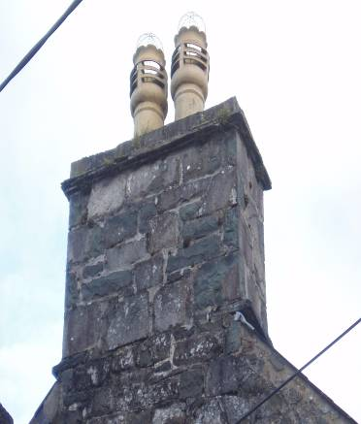 | 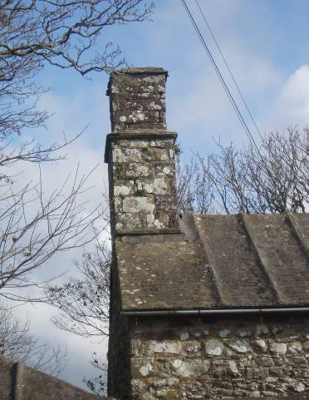 | 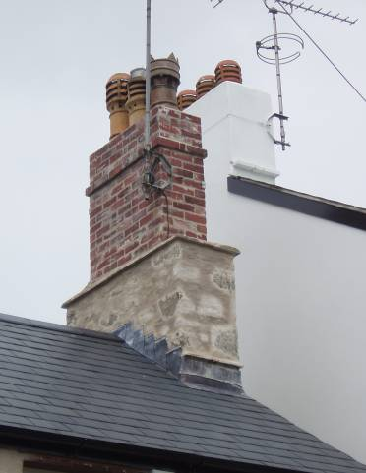
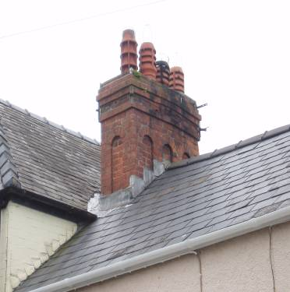 | 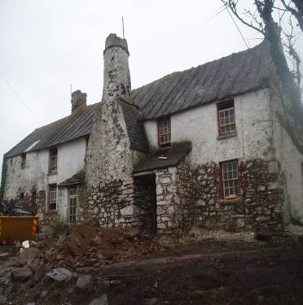 | 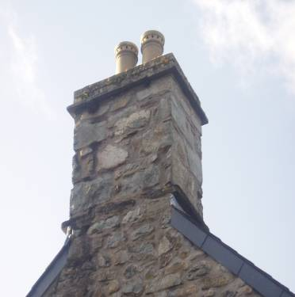

TRADITIONAL PEMBROKESHIRE CHIMNEYS

Virtually all of Pembrokeshire’s old houses have chimneys. They are an important feature of the county’s skyline – their removal can destroy the look of even the simplest building.

- Save Tradition and Character

Chimneys are an important part of Pembrokeshire’s building tradition. They were first seen in medieval castles - their shape and design evolved over a long period following improvements in domestic living and fashion. They give important clues as to the date of a building and to the character of our towns and villages.

Changing traditional copings, pots and other details of chimneys, removes the historic character of buildings.

- Save Money and Jobs

Chimneys can usually be repaired and maintained relatively easily (without removal or rebuilding) and require little ongoing maintenance.

Traditional chimneys were built by local craftsmen and their care helps provide jobs and keep skills alive.

Please note in some areas you may be able to get a grant towards the cost of repair or restoration of an old chimney.

- Health and Sustainability

Chimneys draw fresh air into a house, providing ventilation and reducing condensation and mould growth. Open fires or stoves provide an even warmth and are better for historic buildings than other forms of intermittent heating. Using fuel from sustainable sources is to be encouraged rather then relying on dwindling international stocks of gas and oil.

HISTORY

Log and coal fires have been a Pembrokeshire tradition from the oldest houses in the County until about fifty years ago.

Before about 1450 the smoke from open fires rose up into the roof of a house and then percolated out through the roof.

From about 1450 to about 1750 the use of chimneys to remove smoke from open fires became widespread. In Pembrokeshire there are few chimneys of this age remaining, but chimneys at the Bishop’s Palace at St Davids and Manorbier Castle are good examples.

These chimneys are tall and round, sometimes straight (cylindrical) and sometimes tapered (conical) and they are often positioned on the front wall of a house (e.g. Rhosson, St Davids).

Most of Pembrokeshire’s chimneys date from 1750 onwards and are almost always located at the ends of a roof and at the highest point. These are usually not as large as the early chimneys but even in smaller buildings there was often a large stone fireplace at one end (the simne fawr) with a large chimney above, and a smaller fireplace and chimney at the other end. This often leads to the outside of the house looking asymmetrical.

By about 1850 coal was plentiful as were bricks, and so houses often had several brick chimneys. The chimneys often used multicoloured bricks and used elaborate pots.

By about 1900 the stacks and pots became simpler.

From the 1960s on, increased used of oil and gas meant less use of coal, and chimney stacks became redundant with many new houses built without them, as well as old ones being taken down.
KEEPING THE TRADITION ALIVE

Here are some useful messages from the past.

Position:-

Usually astride the ridge and at the extreme gable ends of the house.

Materials:-

Usually of stone or brick, sometimes rendered or colour washed to match the main house.

Size:-

Both stacks are usually the same size and wide enough for a good sized flue. Chimneys should never be “mean” but large enough to show substance when viewed from the ground.

Details:-

Usually simple but sometimes with corbel drips or slate slab tabling at high level for weatherproofing. Leadwork is relatively modern but sometimes slates were incorporated to create drips to encourage surface water run off: later mortar flaunchings were added for the same reason.

Pots:-

Usually simple clay - red or yellow.
The most beautiful parts of England, Wales and Scotland have been specially chosen as our National Parks. There are three in Wales – Snowdonia, Brecon Beacons and the Pembrokeshire Coast. They are a wonderful inheritance of countryside, towns and villages and deserve special care so that the pleasure we derive from them will be available to the generations to come after us.

“They are not ours but ours to look after”.

Changes which affect these special places need to be carefully considered and formal consent from the National Park Authority will be needed for development.

Park Staff are always pleased to offer guidance and advice.

Please contact:

Pembrokeshire Coast National Park Authority
Llanion Park,
Pembroke Dock,
Pembrokeshire,
SA72 6DY

Tel: (0845) 3457275
Fax: (01646) 689076
email: pcnp@pembrokeshirecoast.org.uk

For advice on chimneys and historic buildings ask for the

Building Conservation Officer

For advice on new buildings and extensions ask for the

Development Control Officer

