Traditional
Pembrokeshire
Exterior

COLOUR
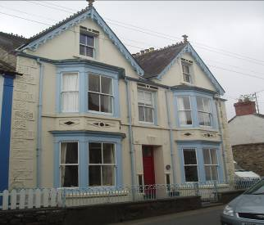 | 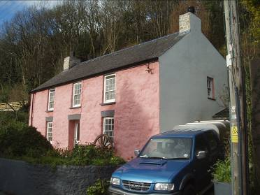 | 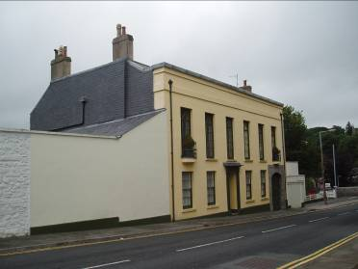
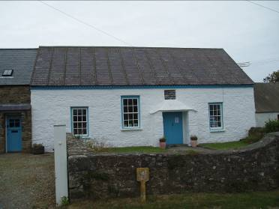 | 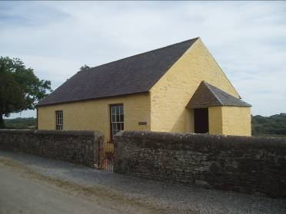 | 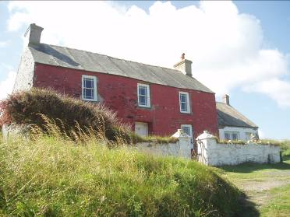

TRADITIONAL PEMBROKESHIRE BUILDINGS

Exterior Colour Schemes

The colours we paint the outside of our buildings will have a strong impact on their appearance - and value - and can make a real impression on our neighbours and visitors.

This note aims to offer owners a better understanding on how the use of colour has developed over the years and what to think about when choosing an external colour scheme - especially for older buildings.

Walls

Most old buildings in Pembrokeshire are built of stone because this was cheaply available locally.

The quality of stone in Pembrokeshire varies considerably. For some buildings (usually the bigger “smarter” buildings) the stone was carefully cut into standard squared blocks and carefully laid with very narrow joints.

But most buildings used rough local stone which was probably never meant to be seen. These buildings were covered with colour washes and renders to both hide the poor quality stones beneath and help keep the buildings more watertight. Sometimes the renders were marked with block patterns to create the impression of high quality cut stonework. Some renders were never painted.

Stone walls were usually held together using lime based mortars which allowed them to move and breathe. Limestone was imported into the area and burnt in one of the many (usually) coastal lime kilns for use as a neutraliser for the county’s generally acidic soils but it also formed the basis of making mortar, render and colour washes.

Water could be added to the lime to create “lime-wash” and this was often used as an outside paint on stone to create bright, white walls.

Variety was provided by adding to the limewash earth pigments to create “reds” (from the palest pink to the deepest maroons) and “yellows” (providing a range of subtle creams). These colours have been used for centuries and sit well in the Pembrokeshire landscape.

Using modern “chemically” based synthetic paints can cause problems to old buildings – they contain resins, solvents and biocides - and can lead to water being trapped within the masonry. Ideally lime based mortars, renders and colour washes should be used or alternatively a “microporous mineral based paint” which is more likely to be durable and allow the building to breathe.

Generally if a building has been traditionally colour washed with a lime wash (or rendered with a lime mortar) then those products should be continued. Hacking off lime mortar renders can result in a loss of this historic feature, and of course its character will be fundamentally changed.

Cement is a relatively modern product, it is hard and brittle and can lead to problems in old buildings.

Colour in the Countryside

While limewash provided a bright white colour, variety was created by adding to the limewash pigments to create pinks and yellows.

These three colour ranges (white, pink and yellow) are often used in a strict “hierarchy” with for example the farmhouse coloured red or yellow, the principal outbuildings in white, and the lesser buildings left as stone.

The modern fashion of “showing off” or “picking out” the stonework in simple old buildings is usually inappropriate both practically and visually.

Town Colours

Town houses tended to closely follow the fashion of the time and were often “dressed” to look like the latest architecture in places like Bath or Brighton. Houses of this time were often rendered smooth, the render would then be marked to resemble stone blocks and then often painted cream to look like Bath stone. Terraces were often designed to be seen as one larger piece of architecture so each house was painted the same colour not as several smaller units.

Raised plaster patterns and features such as pillars, arches or window surrounds would usually be painted the same as the rest of the walls but sometimes a paler shade of the same colour as the walls, or white, was used. These raised features were never painted a shade darker than the adjoining walls.

Generally the simpler the colour scheme the more effective it is.

Windows, Doors and Woodwork

Most old windows and doors in Pembrokeshire buildings are made of wood. In our damp climate wood quickly rots, so it was usually painted as a means of protection. Woodwork was usually painted using lead based paint which is no longer readily available. Again the use of microporous “breathing” joinery paints is to be preferred over the modern synthetic paints.

Before about 1880 windows were often painted a dark colour (brown, maroon or green) and sometimes “grained” to imitate hardwood.

After about 1880 white was popular for most woodwork but traditional lead paints give an “off-white” or “broken white” effect. Brilliant white is very cold and modern and best avoided for historic woodwork.

In the countryside houses and cottages often had their window frames (sash-boxes) painted in a strong rich colour in contrast to the “off-white” colour of the moving parts (sashes).

Doors were often painted in strong, deep colours to act as a visual focus to the house and the same applies to shop fronts. Even in uniform terraces where walls were painted the same colour, doors provided an opportunity for variety and personality.

Ironwork

Ironwork can be “wrought” (these are iron bars beaten into shapes and joined together with rivets or welds) or later “cast” (molten iron poured into standard moulds to create repeated patterns). To prevent rusting, ironwork was usually painted.

Rainwater goods (gutters and downpipes) were usually painted to match the colour of the house although black became popular after about 1880 with railings often painted the same dark colour as the front door.

KEEPING THE TRADITION ALIVE

By respecting these few simple lessons from history, the character of our old buildings can be conserved and they will continue to sit well in our landscape, their fabric will be protected, and the special qualities of the buildings of Pembrokeshire will be shown off to the very best effect.

So please remember

- Use traditional paints for walls - either lime based or microporous.
- Use traditional colours for walls. In towns usually creams or pastels and in the countryside whites, yellows or pinks.
- Respect the traditional hierarchy of colours with the most prominent building in a range painted the most prominent colour.
- Remember to keep your colour scheme simple.
- Remember to paint your windows off white.

The most beautiful parts of England, Wales and Scotland have been specially chosen as our National Parks. There are three in Wales – Snowdonia, Brecon Beacons and the Pembrokeshire Coast. They are a wonderful inheritance of countryside, towns and villages and deserve special care so that the pleasure we derive from them will be available to the generations that come after us.

“They are not ours, but ours to look after”.

Changes which affect these special places need to be carefully considered and formal consent from the National Park Authority will be needed for development.

Park Staff are always pleased to offer guidance and advice.

Please contact:

Pembrokeshire Coast National Park Authority
Llanion Park,
Pembroke Dock,
Pembrokeshire,
SA72 6DY

Tel: (0845) 3457275
Fax: (01646) 689076
email: pcnp@pembrokeshirecoast.org.uk

For advice on historic buildings ask for the

Building Conservation Officer

For advice on new buildings and extensions ask for the

Development Control Officer

