Pembrokeshire Coast National Park

Management Plan (2008-2012)
Local Development Plan
(2006-2021)

Background Paper No *: Housing

update March 2010

PEMBROKESHIRE COAST NATIONAL PARK AUTHORITY
Contents Page

Aim of this Paper 4
Overview of how this Paper fits into Plan preparation 4
National 4
Ministerial Interim Planning Policy Statement 01/2006 Housing June 2006 4
Technical Advice Note 6 – Agricultural and Rural Development 5
National Parks Statement Final (March 2007) 5
Planning Policy Wales Companion Guide February 2006 5
Welsh Assembly Government - Consultation Paper- Planning Policy Changes to Support Sustainable Development in Rural Areas July 2008 – Consultation ended 10th October 2008 6
Technical Advice Note 6 Planning for Sustainable Rural Communities (Draft) July 2009 6
Technical Advice Note 1: Housing Land Availability June 2006 6
Technical Advice Note 2: Planning and Affordable Housing June 2006 6
Technical Advice Note 18: Transport March 2007 6
Better Homes for People in Wales. A National Housing Strategy for Wales 6
One Wales, A progressive agenda for the government of Wales 27th June 2007 7
Wales Spatial Plan 7
Regional 7
Spatial Plan Key Settlement Framework (agreed Ministerial Meeting 23rd November 2006 7
Wales Spatial Plan People, Places, Futures 2008 7
Local 8
Pembrokeshire Coast National Park Youth Conference, Visitors and Residents Survey, 6th Form Conference 2006/7 8
Pembrokeshire Community Strategy 2003 to 2008 9
Joint Housing Land Availability Study April 2008 9
Housing and Planning Group 10
Rural Housing Enabler 10
Research into Low Impact Development 10
Joint Unitary Development Plan Adopted June 2006 11
Affordable Housing Supplementary Planning Guidance May 2006 11
Affordable Housing Delivery Statement 14
Joint Unitary Development Plan Inquiry Inspector’s Report – Local Needs Policy 15
Local Housing Strategy Final April 2008 16
Local Housing Market Assessment 2007 (Final) 16
Welsh Assembly Government Housing Projections 17
Identifying needs for Gypsy Traveller Sites 19
Development Appraisal Toolkit 20
House Prices 21
Housing Density and Number of Bedrooms 25
Implications of meeting the standards of the Code for Sustainable Homes 26
Identifying Affordable Housing Need 27
Housing Land Supply versus Need 32
Housing Land Supply versus Completion Rates 33
Thresholds for Affordable Housing Provision 33
References 35
Appendices – see separate documents

Appendix 1 Housing Land Supply, Affordable Housing Provision, Social Housing Grant
Appendix 2 Planning obligation variants
Appendix 2a The impact of phasing (new for March 2010 update)
Appendix 3 Market Place Variants
Appendix 4 Land Supply at 31 March 2007
Appendix 5 Windfall sites
Appendix 6 Newly Arising Need

Aim of this Paper
- To set out the background to help identify objectives, issues, options, preferred options and policies for plan preparation.

Overview of how this Paper fits into Plan preparation
- These papers will provide information for Officers and Members of the Authority, stakeholders, members of the public and the Inspector and those attending Local Development Plan examination to help explain the approach being taken.

- These papers will be updated through the Plan preparation process to take account of new information emerging.

- Changes after Submission are shown as track changes.

National

Ministerial Interim Planning Policy Statement 01/2006 Housing June 2006
- New housing should have a mix of affordable and market housing (paragraph 9.1.1)
- Local planning authorities should promote: mixed tenure communities; mixed use development; safe, attractive, usable areas around dwellings; greater emphasis on quality, good design; the most efficient use of land; construction of housing with low environmental impact and ‘barrier free’ housing developments, for example built to Lifetime Homes standards. (paragraph 9.1.2)
- Local authorities’ planning and housing functions must combine in partnership with local stakeholders, including private house builders, to produce Local Housing Market Assessments (LHMAs). (paragraph 9.1.4)
- In planning the provision for new housing, local planning authorities must work in collaboration with housing authorities, registered social landlords, house builders, developers, land owners and the community. (paragraph 9.2.1)
- Local planning authorities must ensure that sufficient land is genuinely available or will become available to provide a 5-year supply of land for housing judged against the general objectives and the scale and location of development provided for in the development plan. (paragraph 9.2.3)
- Restricting to local needs housing will require robust evidence (paragraph 9.2.4)
- Higher densities should be encouraged on easily accessible sites, where appropriate, but these will need to be carefully designed to ensure a high quality environment. (paragraph 9.2.12)
- ‘Tandem’ development, consisting of one house immediately behind another and sharing the same access, may cause difficulties of access to the house at the back and disturbance and lack of privacy to the house in front and should be avoided. (paragraph 9.2.13)
- A community’s need for affordable housing is a material planning consideration which must be taken into account in formulating development plan policies. (paragraph 9.2.14)
- Plans should include site thresholds or a combination of thresholds and site-specific targets for the delivery of affordable housing (paragraph 9.2.16)
- 100% affordable housing allocations are allowed (paragraph 9.2.17)
- Policies must indicate that an authority will seek to negotiate with developers where it is intended to include an element of affordable housing in proposed developments. Policies should also state what the authority would regard as affordable housing and what arrangements it would expect to ensure that such housing remains reserved for those who need it. (Paragraph 9.2.18)
- There is special provision for rural exceptions sites for affordable housing. (Paragraph 9.2.22)
- Applications for agricultural and forestry dwellings will only be permitted if special justification is given to meet the functional and financial tests and an occupancy condition applied. (Paragraph 9.3.7 to 9.3.10)

Technical Advice Note 6 – Agricultural and Rural Development

- Provides advice on

- Agricultural considerations
- Re-use and adaptation of rural buildings
- Development related to farm diversification
- Development related to agriculture and forestry
- Agricultural and forestry dwellings
- Development involving horses

National Parks Statement Final (March 2007)
- The Authority is not a housing authority but it should work closely with the housing authority when the local housing market assessment and housing strategy is being prepared. In terms securing the social and economic well being of local Park communities, appropriate and affordable housing provision are clearly vital ingredients. Collaborative working is important for the effective delivery of affordable housing. (page 11 first paragraph).

Planning Policy Wales Companion Guide February 2006
- Planning Policy Wales Planning Policy Wales specifies the following aspects to be considered for inclusion in topic-based policies, although in some cases the detail may be given more appropriately in Supplementary Planning Guidance:

- Sustainable residential environments (paragraph 9.1.2)
- Design and density of housing (paragraph 9.2.12)
- Affordable housing, including rural exception sites (paragraph 9.2.14)

- Planning Policy Wales sets out clear statements of national development control policy which should not need to be repeated as a local policy in Local Development Plans. Instead topics relevant to the local area could simply be mentioned with a cross-reference to Planning Policy Wales.

- Tandem development (paragraph 9.2.13)
- Agricultural dwellings (paragraph 9.3.10)

Welsh Assembly Government - Consultation Paper- Planning Policy Changes to Support Sustainable Development in Rural Areas July 2008 – Consultation ended 10th October 2008
- See Scale & Location of Growth Background Paper.

Technical Advice Note 6 Planning for Sustainable Rural Communities (Draft) July 2009
- See Scale & Location of Growth Background Background Paper.

Technical Advice Note 1: Housing Land Availability June 2006
- Local planning authorities must ensure that sufficient land is genuinely available or will become available to provide a 5-year supply of land for housing judged against the general objectives and the scale and location of development provided for in the development plan. (paragraph 9.2.3)

Technical Advice Note 2: Planning and Affordable Housing June 2006
- Provides practical guidance in securing affordable housing.

Technical Advice Note 18: Transport March 2007
- Include policies and standards on density to achieve higher residential densities in places with good public transport accessibility and capacity.

Better Homes for People in Wales. A National Housing Strategy for Wales
- Welsh Assembly Government's vision for housing in Wales: "We want everyone in Wales to have the opportunity to live in good quality, affordable, housing; to be able to choose where they live and decide whether buying or renting is best for them and their families."

One Wales, A progressive agenda for the government of Wales 27th June 2007
- Housing action points relevant to this Authority are highlighted under the ‘Living Communities’ Chapter:

- Suspend the Right to Buy in areas of housing pressure
- More guidance to be provided on Language Impact Assessments
- Aim to provide controls on converting to second homes in areas of housing pressure
- Extend the agricultural and forestry worker dwelling category in Technical Advice Note 6 to include rural enterprise dwellings in the countryside.
- Revisiting the term ‘affordability’ and ‘local’ criteria for use in S106 agreements.

Wales Spatial Plan
- See Scale & Location of Growth Background Paper

Regional

Spatial Plan Key Settlement Framework (agreed Ministerial Meeting 23rd November 2006

- The key issue identified for housing is affordable housing provision. High house prices and low incomes result in problems of affordability and that need to be addressed. The pool of accommodation to meet the needs of the homeless needs to be expanded.

- This is to be addressed by the following objective:

‘H4) Affordable Housing – There is a need for a programme to be established and continually updated to assess the scale of needs, including the role of the Rural Housing Enabler and new build low cost home ownership schemes. When the scale has been established a series of delivery mechanisms including social housing grants, low cost home ownership schemes, developer contributions/ planning obligations, etc. are to be implemented as a means of addressing the issues.’

- It is particularly difficult to achieve the development of affordable housing in the National Park where environmental capacity constraints restrict the opportunities to provide for building additional homes.

Wales Spatial Plan People, Places, Futures 2008
- This document provides an update to the Wales Spatial Plan.

- This document is based on the Wales Spatial Plan Key Settlement Framework.

- Nationally, a lack of good quality housing affects people’s health and wellbeing and influences their long-term life chances. The scale of population growth that needs to be accommodated is challenging, with a projected growth of 330,000 persons across Wales between 2006 and 2031. Equally important is the need to maintain a mix of tenure and size of housing to ensure balanced communities. To address this the Welsh Assembly Government is committed to delivering 6,500 new affordable homes by 2011. (page 22)

- The general principles for new housing growth are: it should be linked to public transport nodes, including walking and cycling networks; it should take account of environmental constraints, including flood risk; and it should meet high standards of energy efficiency. Housing developed near public transport nodes should be at higher than current densities to promote use of public transport and to increase opportunities for combined heat and power systems. Accommodating appropriate development in smaller settlements and rural areas is vital for supporting the development of more rural communities. (page 23)

- One of the key priorities for the Pembrokeshire Haven area is: sustaining and strengthening communities by taking focused action to address both rural and urban deprivation and economic inactivity and to ensure housing provision appropriate to all. (page 83)

- New provision of housing is likely to reflect the historical pattern of development in the area commensurate with the settlement approach identified in the Framework with a continued emphasis on settlements within the strategic hubs along the urban corridor linking the M4 to the Area’s ports. Notwithstanding the emphasis on key settlements, it is important that housing growth also seeks to revitalise and sustain smaller centres and communities. Housing provision in the National Park should be at a scale which aims to meet the needs of the local population in line with the Park's statutory purposes and duty. (page 88)

- Housing projections are being worked on under the auspices of the South West Wales Regional Planning Group. Further work by the local authorities and the National Park Authority linked to on-going assessments of local housing needs will be undertaken as a priority to ensure the future supply of affordable housing to support a local workforce and to achieve a socially inclusive and balanced population. (page 88)

Local

Pembrokeshire Coast National Park Youth Conference, Visitors and Residents Survey, 6th Form Conference 2006/7
- Housing issues were prominent in the returns from these surveys. A flavour of the responses is provided below.
- Sympathetic development control was appreciated, for example keeping housing development within villages.
- There is a need for housing which is both sustainable and affordable.
- Housing should only be sold to people to live in, not as holiday homes as these create ghost villages.
- Create new communities with sympathetic housing, where people live/work.
- Second homes make communities less vibrant, and would in future result in a loss of society, as well as sapping livelihoods. The cultural effect was noted when Welsh people are unable to live amongst their relatives because they are priced out.
- Uneven distribution of wealth in Pembrokeshire - 'gin palace' developments of nondescript architecture versus poor social housing flats in some areas.
- The National Park planning authority is failing to insist on a percentage of low cost housing in the National Park.
- Delegates to the 6th Form Conference recorded what their issues were which included a number for Housing: Affordable Housing; People moving out of area; People move into area; Council housing; Planning system too slow; Higher taxes; Second homes; Rented accommodation; Renovation of existing properties; Energy efficient housing; House prices rising; Grants for energy efficiency; Fairplay policy; Cut down or apply laws for unused tourist homes.

Pembrokeshire Community Strategy 2003 to 2008
- Pembrokeshire’s first Community Plan was launched in 2004 and covers the period to 2008. It was updated in 2006. There are 5 broad priorities:
A Developing vibrant communities
B Improving communication links to, from and within the County
C Delivering economic growth based on local need
D Encouraging people to reach their potential
E Promoting a clean, healthy and valued environment
- Within Priority A, the role of housing in sustaining vibrant communities has been recognised as a key part of the plan. Key Aim A1 identifies “Developing an Enterprising Culture and Regenerating Communities” and within this the long-term aim is to “Widen Housing Choices within Communities”.
- In the review of the Plan in 2006 it was recognised that
“A continued increase in house prices, relative to average earnings, will cause further problems for local people trying to find affordable housing.”
- Work has commenced on reviewing the Community Plan and preliminary considerations have already identified that Housing will remain one of the key areas to be addressed within the new plan.

Joint Housing Land Availability Study April 2008
- Such studies are prepared for Pembrokeshire but include a section on the National Park. This is the latest Joint Housing Land Availability Study to be prepared under the new Technical Advice Note 1 guidance and has a base date of 1st April 2008.

- The Pembrokeshire Coast National Park has land available, on large sites, for 178 units. At the base date of the study all of these were Private Sector. A further 186 units were categorised in 3(i). Completions in Pembrokeshire Coast National Park on large sites amounted to 68 units between 1st April 2007 and 1st April 2008.

- The anticipated contribution by small sites of 165 dwellings represents a 48% contribution to the overall land supply in the National Park area. (paragraphs 4.61-4.62)

- The Study looks at the adequacy of supply across the two planning authority areas. It indicates that using the residual method, based on the adopted Joint Unitary Development Plan forecast of need, the supply of readily available land for the County of Pembrokeshire and Pembrokeshire Coast National Park Area at 1st April 2008 stood at 5.05 years.

- Development of sites for fewer than five dwellings remains an important component of the housing supply. Small sites currently contribute 42% of the overall dwelling provision in the Pembrokeshire area. Given this high proportionate contribution, there continues to be a need for this to be closely monitored in future studies.

- The next study for the County of Pembrokeshire and Pembrokeshire Coast National Park Area will have a base date of 1st April 2009.

Housing and Planning Group
- The Housing and Planning Group was formed in 2004/5 and is well established. It takes its membership from representatives of the Housing and Planning Divisions of Pembrokeshire County Council, Forward Planning in Pembrokeshire Coast National Park Authority, Cabinet Member for Housing and Community Safety, the Rural Housing Enabler and each of the Registered Social Landlords with development status in the County. The remit of the group is to focus on delivering a programme of affordable housing in the county.

Rural Housing Enabler
- The Rural Housing Enabler works with Community Councils, local landowners, Planning Officers, Housing Associations, National Parks and other relevant individuals, organisations and associations to help communities assess the need for affordable housing in their area and by helping identify sites for affordable housing development.

- To date 18 surveys have been carried out which provide information for the National Park area.

- The results are shown in the Table 12 below.

Research into Low Impact Development
- Research into the subject in Wales was initiated originally through the Assembly’s Planning Forum.

- Two reports have been prepared specifically on the subject of Low Impact Development and are listed as references to this document, the Land Use Consultants report and Baker Associates report.

- The Baker Report forms the basis of the Joint Unitary Development Plan policy on Low Impact Development which was endorsed at the Joint Unitary Development Plan Inquiry.

- The policy in the Plan asks that the proposal makes a positive environmental, social and/or economic contribution with public benefit, where the activities and structures on site are low impact’ a countryside location is essential and the proposal provides sufficient livelihood for the residents of the site.

- Supplementary Planning Guidance in support of the policy has also been prepared.

Joint Unitary Development Plan Adopted June 2006
- The overall objective for Pembrokeshire is to make appropriate provision for housing to complement economic growth and to accommodate local needs. (paragraph 4.2.1 bullet 5) Given its limited capacity housing growth within the National Park is to meet local needs. (paragraph 4.3.8)

- Overall the requirement for Pembrokeshire is the delivery of 9,000 units for the Plan area. The National Park area contributed an estimated 1,000 units to the supply in the form of greenfield, brownfield and conversion opportunities. Local evidence suggested that 1800 of the 9000 dwellings should be affordable housing. The time frame for the Joint Unitary Development Plan is 2000 to 2016.

- In the National Park affordable housing is sought on the following allocations:

- Bay View Terrace; Dinas Cross, Rear of the Sir Benfro Hotel, The Boatyard Little Haven and at Brynhir Tenby and on other sites considered appropriate for the development of affordable housing. There is no minimum threshold for considering affordable housing provision in the National Park. The Authority uses a figure of 3 or more units as a guide to developers as to where affordable housing may be negotiated.

- The table below identifies the level of provision since the base date of the Joint Unitary Development Plan on affordable housing in the National Park. Since the Plan’s modifications were published in January 2006 the Authority has been able to apply its affordable housing policies.

Table 1 Delivering Affordable Housing in Pembrokeshire Coast National Park

 | Social | Private | Total | Percent Social
2000-01 | 20 | 101 | 121 | 16.53
2001-02 | 0 | 84 | 84 | 0
2002-03 | 0 | 73 | 73 | 0
2003-04 | 0 | 50 | 50 | 0
2004-05 | 4 | 105 | 109 | 3.67
2005-06 | 4 | 83 | 87 | 4.6
2006-07 | 3 | 49 | 52 | 5.77
Total 2000-07 | 31 | 545 | 576 | 5.38
Total 2001-06 | 8 | 395 | 403 | 1.99
Total 2001-07 | 11 | 444 | 455 | 2.42

Affordable Housing Supplementary Planning Guidance May 2006
- The authorities have also adopted Supplementary Planning Guidance on affordable housing provision for Pembrokeshire. The Guidance sets out details on the delivery of affordable housing, who the affordable housing will be for and how it will be kept affordable, design issues, issues of viability and a step by step guide to delivery.

- The guidance, approved in May 2006 sets out the following options for management (shown in italics for ease of reference):

- Rented: The developer may retain ownership and management responsibility for the affordable housing provided or may appoint an agent to manage on its behalf.

- The developer may sell the affordable housing for rent to a registered RSL which would then own and manage the properties. Social Housing Grant is available to support this option.

- If the affordable housing for rent is sold to a RSL the maximum selling price will be the Acceptable Cost Guidance (ACG) for the relevant property types.’

- ACG is the WAG assessment of value for money in determining grant funding for RSL development projects. These figures are calculated to represent costs of development i.e. land, works and on-costs. They are reviewed at least annually and are available from the Registered Social Landlord. The current figures (2005/06) are (see second column):

Table 2 Rent and Low Cost Home Ownership 2005/2006 Prices

Property type | RSL Purchase (ACG) | Low Cost Home Ownership - Initial Sale Price
1 bed 2 person flat | £74,300 | £52,010
2 bed 3 person flat | £85,900 | £60,130
2 bed 3 person house | £93,800 | £65,660
2 bed 4 person house | £113,500 | £79,450
3 bed 4 person house | £119,200 | £83,440
3 bed 5 person house | £126,100 | £88,270

- All affordable housing for rent will be provided at rent levels within the WAG Rent Benchmark. The Rent Benchmark for a 3 bed 5 person house for 2005/06 is £57.85 per week. Rent for smaller properties will be at correspondingly lower prices. Affordable housing for rent where Social Housing Grant is used will be required to meet the Welsh Assembly Government (WAG) Design Quality Requirements (DQR).These set out minimum space standards and technical specifications and are available from the Registered Social Landlord.

- The other type of affordable housing to be provided is Low Cost Home Ownership.

- The same property types as detailed in the table above will be provided and will be sold at 70% of the ACG for the relevant property type (see final column). DQR will not be necessary for Low Cost Home Ownership properties.

- This approach is similar to the well established WAG Low Cost Home Ownership model of Homebuy Option properties.

- Provision of Land: Instead of providing affordable housing a developer may sell the area of land required for affordable housing to a RSL. The sale price of the land at a level that enables the RSL to develop the required affordable housing provision at the ACG. The disposal must be agreed by the LPA as part of the S.106 Planning Agreement.

- This Housing Background Paper for the Local Development Plan proposes to modify the above approach taken in relation to the provision of rented accommodation for the Local Development Plan in the following way:

- The viability of sites proposed in the Plan were assessed (see Appendix 1 to Appendix 3 of this paper) whereby the full Social Housing Grant only needed to be ‘awarded’ for an estimated 65 units (see Appendix 1 and the Housing Land Supply versus Need section of this Paper). It was also assumed that 125 of the estimated 250 windfall opportunities would also need social housing grant support – i.e., a total estimate of 190 units over the Plan period needing Social Housing Grant Support.

- The assumption is that the remainder of the affordable housing provision - an estimated 439 (412 on housing allocations + 92 on mixed use sites (minus 65 –see above)) would be provided with no Social Housing Grant support. The support from Social Housing Grant (SHG) normally amounts to 58% of the ACG value of a unit, so the developer would be expected to transfer properties for rent to an RSL for the remaining proportion of the ACG value i.e. a maximum of 42% of ACG.)

- Since these calculations were done Pembrokeshire Housing (which is the predominant housing association operating in Pembrokeshire) has advised that given the current national financial circumstances, and the forecast reduction in public expenditure there will undoubtedly be a reduction in the availability of Social Housing Grant, though the scale is yet unknown. The SHG available for Pembrokeshire for 2010/11 has already been committed and at present WAG is not in a position to advise of any budget forward indicators for 2011/12 onward.

- Pembrokeshire Housing Association is committed to the provision of affordable housing and having considered it's position and undertaken the necessary financial modelling, the Association is in a position to deliver some affordable housing for rent without the use of SHG.

- In order to do this, to fund the increased borrowing, the rent levels will need to be increased above the WAG Benchmark Rent. In order to maintain consistency it is proposed that the other elements of the current Supplementary Planning Guidance (SPG) remain; i.e. properties delivered to WAG's DQR standards at the relevant ACG.

- The rent charged by the Association will be well within the Local Housing Allowance (LHA); i.e. the ceiling level set by WAG for the payment of Housing Benefit for example:

Table 3 PCNP Intermediate Rent - example

Property Type | 3b 5p house
Price ACG Band 2 – at 2009/10 level | £126,900 (2009/10 level)
Local Housing Allowance at April 2009 | £132/wk
Intermediate Rent at 2009/10 level | £110/wk
Benchmark Rent at 2009/10 level | £70/wk

- This option is therefore available for implementation as a substitute ‘A option’ above in those instances where Social Housing Grant is expected and may no longer be available. Developers if renting privately could also avail of this option on any development. In terms of impacts on development scheme viability the outcomes would be the same as the assessments where Social Housing Grant was assumed.

- To summarise the change in options proposed for the provision of rented properties are therefore:

- PCNP Social Housing Grant Model: Where social housing grant is available and required to support development (See Appendix 1 to 3 for an assessment of sites that may require Social Housing Grant) then continue with the 2006 Supplementary Planning Guidance approach to rented property provision, i.e., the sale of the properties to an RSL where benchmark rents will be charged and the properties will be developed to DQR standard.
- PCNP Intermediate Rent Model: Properties are sold at ACG values to a Registered Social Landlord on sites that would have required Social Housing Grant (but is not available) (as with previous option - See Appendix 1 to 3 for likely sites). DQR standards will be required on RSL properties.
- PCNP 42% of ACG Model: Properties sold at ACG minus the Social Housing Grant element to a Registered Social Landlord on sites that do not require Social Housing Grant support to be viable options. The benchmark rent approach will be applied. DQR standards will be required.
- Developers can choose to retain or arrange for the management of properties privately using the intermediate rent model approach. Such properties would not be required to be to DQR standard.

- Low cost home ownership provision and the provision of land would remain as per the 2006 Supplementary Planning Guidance. For ease of reference the current ACG values are set out below:

Table 4 ACG 2009/2010 Band 2

Property type | RSL Purchase (ACG) | Low Cost Home Ownership - Initial Sale Price
1 bed 2 person flat | £77,000 | £53,900
2 bed 3 person flat | £89,500 | £62,650
2 bed 3 person house | £93,800 | £65,660
2 bed 4 person house | £113,800 | £79,760
3 bed 4 person house | £120,100 | £84,070
3 bed 5 person house | £126,900 | £88,830

Affordable Housing Delivery Statement
- Pembrokeshire County Council and the Pembrokeshire Coast National Park Authority have adopted new requirements for affordable housing.

- The Affordable Housing Delivery Statement was agreed by the Council at its meeting on 22nd October 2009 and by the National Park Authority on the 14th October 2009.

- The Council’s policy sets out new thresholds for seeking affordable housing on development sites. They include:

- sites with more than 10 proposed new homes in the towns of Fishguard, Haverfordwest, Milford Haven, Pembroke, Pembroke Dock, Neyland and Narberth.

- in all other places where there is a net gain of five or more dwellings.

- Where Social Housing Grant is available, 40% of the dwellings on the site should be affordable housing, while on sites where no grant is available, 20% of dwellings should be affordable.

- The new thresholds, which replace the previous thresholds, will be implemented from 22nd October 2009 on all new residential planning applications.

- The National Park Authority’s policy is to seek to negotiate on sites for 2 or more residential units 50% affordable housing with the following exceptions where a higher percentage will be negotiated: Tenby (60%), Newport (70%), Saundersfoot (60%), Dale (80%), Dinas Cross (75%) and New Hedges (60%). One site at Crymych (the Depot site) is allocated for 100% affordable housing.

- In the National Park the new thresholds, which replace the previous thresholds, will be implemented from 2nd November 2009. Any applications received by the National Park Authority before then will be determined using the existing policy.

Joint Unitary Development Plan Inquiry Inspector’s Report – Local Needs Policy
- A policy was proposed through the Joint Unitary Development Plan to limit the provision of new housing to meet the needs of local people this to be secured by planning obligation.

- The policy attracted objections covering a variety of considerations from the Welsh Assembly Government and a wide range of other bodies, organisations and individuals.

- The approach failed in the eyes of the Inspector because:

- It made an artificial distinction between affordable housing for local people and housing for local people. The provision was in effect affordable housing provision.
- Shortfalls in provision were not to found across the National Park.
- The Park could rely on the strategy of the Plan to deliver a substantive increase in supply outside the National Park in the remainder of Pembrokeshire.
- The occupancy restrictions were too generous and did not represent the sort of judicious and appropriate use of a limited land supply that this policy purportedly intended to achieve.
- The amount of housing the Policy could provide was negligible.
- The operation of the policy would be complex and practically unworkable.
- The policy strays into areas that go beyond straight forward land use planning.
- Compared with other areas in the United Kingdom where these policies operate the Pembrokeshire Coast National Park is a coastal Park with land being provided in reasonable proximity to the Park itself.
- There might be a negligible impact on the price of houses affected by the policy and there may be a rise in prices in the general housing stock.
- As there was insufficient evidence to justify the inclusion of the Policy (known as ‘Policy 47’) in the Plan an Infringement of human rights would arise if the policy was adopted.
(paragraph 3.48.1 to 3.48.17)

Local Housing Strategy Final April 2008
- The Strategy identifies issues that planning can help address:

Planning

- Increase the amount of affordable housing delivered by private developers using the JUDP policies, polices in the emerging LDP’s and Supplementary Planning Guidance.

- Continue to support the work of the Rural Housing Enabler to help identify sites for affordable housing in rural areas.

- Reduce local opposition to rural exception sites for affordable housing by better engagement with communities.

- Ensure the mix of housing permitted reflects the needs and demands of the County’s residents in terms of type, size and tenure.

- Continue to work with infrastructure providers to ensure that land for housing can be developed when needed.

- Negotiate contributions from developers towards meeting infrastructure and community needs that arise from new development using the JUDP policies and the policies of the emerging LDP's and associated guidance.

- Use of compulsory purchase as a last resort in the Pembrokeshire Coast National Park.

- Needs for intermediate housing will be accurately identified. (page 37)

- The provision of affordable housing will increase. (page 37)

- The number of older people in the County continues to increase. Provision needed includes additional bungalow development using Social Housing Grant and providing extra care housing schemes. (page 85)

Local Housing Market Assessment 2007 (Final)
- The key issues for the local housing market are:
    - Large scale construction projects leading to inward migration of workers is placing pressure on private rental properties. Accommodation is needed for migrant workers in the vicinity of large projects.
    - The attractiveness of the area creates external pressure for second homes, holiday letting and retirement places. This is exacerbated by low local incomes being unable to compete with the purchasing power of those from away. Anecdotal evidence suggests that demand formerly focused on the Devon Cornwall area is now placing pressure on the study area.
    - Historically the market has been influenced by the outward migration of young people and the inward migration of people aged 40+. Population projections suggest that the current top-heavy population structure will continue to grow, an increase in the 20-25 years age range and a decline in the 30 to 40 years age bracket.
    - Household size is likely to reduce further to an estimated 2.02 in 2030 as a result primarily of an increase in one-person households.
    - Loss of council housing due to right to buy (forecast is for between 60 and 70 lost each year) is frustrating the area’s ability to maintain a permanent stock of affordable housing.
    - Affordable housing completions are not keeping pace with the Joint Unitary Development Plan target of 20% of provision (completions are approximately 550 per annum in the County below the target of 600 a year in the Plan).
    - Affordable housing is at a premium. Pembrokeshire is now the least affordable area in Wales. Using the lower quartile housing price a net annual income of between £31,000 and £35,000 is needed. Incomes are predominantly below this range in the County.
    - The demand for affordable housing exceeds supply and there is a backlog of need to be addressed. This is particularly acute in the National Park where environmental constraints means that mechanisms other than new build are needed.

Welsh Assembly Government Housing Projections
- The table below takes the overall population projection figures for the Park derived on a pro-rata basis from the overall Welsh Assembly Government population projection figures for Pembrokeshire and further breaks it down for the main towns and rural areas of the Park.

Table 5 Housing Projections for sub areas of the Park (2003 based)

Households | 2001 | 2006 | 2011 | 2016 | 2021 | Completions 01 to 07 | 07 to 21 Requirement | Annual Requirement
Tenby | 2300 | 2513 | 2618 | 2726 | 2821 | 100 | 421 | 30
Newport | 554 | 605 | 631 | 657 | 680 | 20 | 106 | 8
Saundersfoot | 1238 | 1353 | 1409 | 1467 | 1519 | 40 | 241 | 17
St Davids | 809 | 884 | 921 | 959 | 992 | 38 | 145 | 10
Rural Centres & Countryside | 4961 | 5,436 | 5,663 | 5,895 | 6,102 | 298 | 843 | 60
Total | 9862 | 10,791 | 11,242 | 11,704 | 12,114 | 496 | 1756 | 125

- The Welsh Assembly Government has issued 2006 based population and household projections for Local Authorities, including Pembrokeshire. The population projection for Pembrokeshire has been used to derive a pro-rata projection for the Pembrokeshire Coast National Park. This shows an increase in the National Park population from 22,300 in 2006 to 24,900 in 2021, an increase of around 2600. At the 2001 Census average household size was 2.26 persons. Using this figure, the population increase would roughly suggest an increase in households of about 1,150 over the period. Applying a similar pro-rata apportionment to the household projection the household numbers in the National Park are projected to change as shown in Table 6.
Table 6 Housing Projections for sub areas of the Park (2006 based)

Households | 2001 | 2006 | 2011 | 2016 | 2021 | Completions 01 to 07 | 07 to 21 Requirement | Annual Requirement
Tenby | 2300 | 2449 | 2612 | 2775 | 2927 | 100 | 527 | 38
Newport | 554 | 590 | 629 | 668 | 705 | 20 | 131 | 9
Saundersfoot | 1238 | 1318 | 1406 | 1494 | 1575 | 40 | 297 | 21
St Davids | 809 | 861 | 919 | 976 | 1030 | 38 | 183 | 13
Rural Centres & Countryside | 4961 | 5282 | 5634 | 5986 | 6313 | 298 | 1054 | 75
Total | 9862 | 10,500 | 11,200 | 11,900 | 12,550 | 496 | 2192 | 157

- However, a simple population based apportionment of growth from projections at a local authority or regional level is unlikely to result in a useful population forecast. The nature of the starting population and migrant population are different in the area in and outside the National Park. In short both groups tend to be older in the National Park than the rest of Pembrokeshire. A population forecast prepared for the National Park area by Pembrokeshire County Council indicates the total number of National Park residents and households remaining more or less as it was at the 2001 Census. Table 7 shows the change in household numbers predicted by the Pembrokeshire County Council projection.
Table 7 Pembrokeshire County Council Housing Projections for the Park (2008)

Households | 2001 | 2006 | 2011 | 2016 | 2021 | Completions 01 to 07 | 07 to 21 Requirement | Annual Requirement
Tenby | 2300 | 2293 | 2278 | 2283 | 2282 | 100 | -118 | -8
Newport | 554 | 552 | 549 | 550 | 550 | 20 | -24 | -2
Saundersfoot | 1238 | 1234 | 1226 | 1229 | 1228 | 40 | -50 | -4
St Davids | 809 | 807 | 801 | 803 | 803 | 38 | -44 | -3
Rural Centres & Countryside | 4961 | 4946 | 4914 | 4924 | 4922 | 298 | -337 | -24
Total | 9862 | 9,832 | 9,768 | 9,788 | 9,785 | 496 | -573 | -41

- The Welsh Assembly Government Statistical Directorate are currently producing population projections for the National Parks in Wales using the same method as the Local Authority projections (by entering National Park base population, fertility, mortality and migration data into the projection model). It is the expectation of officers of the National Park Authority that this projection will be more similar to the Pembrokeshire County Council projection, indicating a slight fall in population in the National Park, with household numbers remaining more or less stable.
- Update March 2010: Population projections using the method used for the 2006 based Local Authority projections have now been prepared by WAG for National Parks in Wales. WAG advise that these will be published at the end of March 2010. Preliminary consultation on the projection has confirmed the expectation in the previous paragraph. There is as yet no firm commitment from housing statisticians at WAG that these population projections will be used to generate household projections.
- Population and household forecasts normally provide the starting point for deciding on levels of growth but given the wide variation in forecasts they are proving difficult to rely on.

Identifying needs for Gypsy Traveller Sites
- Council’s are required to assess the accommodation needs of gypsies and travellers and a more detailed assessment of need is included in the LHMA.

- In the County Council’s Housing Strategy (2008) it is advised that in broad terms, due to the current levels of provision (five separate sites incorporating 84 pitches) and low levels of demand, a need for additional sites has not been identified at present.

- The JUDP for the County provides detail as to how applications for new sites will be dealt with under planning policies should requests be received, although none have been received to date.

- The key issue facing the Authority is in relation to its current sites. A condition survey has identified the need for capital investment to effect site improvements and the Authority will be bidding for funding to WAG to use the Gypsy Traveller Site Refurbishment Grant to undertake a programme of improvement over the next three years.

- In addition, in consultation with pitch holders on the Waterloo site, an ethnic minority housing scheme will be developed using SHG to replace the existing site at an alternative location. The need for alternative provision for other sites has not been identified.’

- More recently, Pembrokeshire County Council has commissioned a survey of accommodation need to be conducted with the Gypsy Traveller community in Pembrokeshire. The survey is due to commence week beginning 26th October 2009 and is expected to take 4 to 6 weeks to be completed. It is hoped that up to 70 surveys will be completed in this time, although this is clearly dependent on the engagement of the Gypsy Traveller community.

- The survey will be conducted by Azadeh, a company who manage local authority-owned Gypsy and Traveller sites and provide a range of support services across the UK, in conjunction with officers from the local authority who have established relationships with the community.

- Once the surveys have been completed the results will be analyzed by the Planning and Housing departments within Pembrokeshire County Council with input from Pembrokeshire Coast National Park Authority to produce the Gypsy Traveller Accommodation Needs Assessment for Pembrokeshire. There is a target date for completion of the report by end of December 2009.

- There is no opportunity left now for this Authority to act on the findings of the above study. The Plan has in any case a criteria based policy to deal with Gypsy Site proposals. If the Assessment is available at the time of submission then it can be submitted as a Background Document for the Inspector to consider and recommend any change to the Plan if considered necessary.

- Update 6 December 2009: Pembrokeshire County Council Officers have advised that there is insufficient progress to make any preliminary findings available in time for Submission.

- Update 26 February 2010: 13 surveys back. Hoping for more soon. Responses are concerned about the quality of their existing site rather than the need for more sites.

Development Appraisal Toolkit

- A ’Development Appraisal Toolkit’ (Three Dragons) which is operated elsewhere in Britain and has been tested at Inquiry is used where there is a dispute with an applicant about the provision of affordable housing on a site which is the subject of a planning application. Independent advice from Development Consultants can also be sought.

- The toolkit is software used to arrive at a residual value for the land by comparing the full cost of building a residential development with the revenue generated through house sales and any revenue generated by the affordable housing. The results can then be compared against information about commercial land values to determine whether an individual site is viable. A range of planning obligations, including affordable housing, can be added in to the calculation and their impact on the scheme’s residual value can be reviewed. In simple terms it calculates the level of profit a landowner and developer can expect according to different scenarios.

- The development mix used for viability testing the sites is based on the local need for affordable housing and past development patterns in the area. The affordable housing component of the development scheme is split 60% social rented (the developer receives 42% of the ACG value from an RSL, if Social Housing Grant is available the payment is 'topped up' so the developer receives 100% of the ACG value) and 40% Low Cost Home Ownership (LCHO) (the house is sold by the developer for 70% of the ACG value).

- The prices for market housing used in assessing viability are the default values in the April 2008 version of the Three Dragons Development Appraisal Toolkit for Wales. To reflect changes in the UK housing market in 2008 and 2009, viability tests were carried out assuming market values at 90, 80 and 70 percent of the default values (see Appendix 3). Investigation of changes in market housing values in the National Park using data from the Land Registry published on the www.houseprices.co.uk web site reveal that the median price for all house sales in the first half of 2009 was 92% of that for all sales in 2007 (median price for all sales in 2009 was 87% of that for all sales in 2007, see table 8). If only sales of detached houses are considered (this is the type of housing likely to provide the bulk of the market component of most developments in the National Park) then the median sale price in the first half of 2009 was 87% of that in 2007. At these levels of value decrease the allocation sites remain viable.

- To assess the impact of phasing the discounting function of the January 2010 version of the Three Dragons Development Appraisal Toolkit was used to assess the impact of developing a site over a period of a number of years. The impacts principally relate to the interest costs of financing the land purchase and the development costs. The results are included in Appendix 2a.

House Prices
- A survey of house prices in the Pembrokeshire Coast National Park and surrounding areas was conducted using data from the Land Registry for house sales completed between April 2001 and March 2008.

- House prices in the National Park and in the rest of Pembrokeshire have increased between 2002 and 2008 at a steady and significant rate leading to an increasing imbalance between incomes and house prices. There is some evidence in the data that the increase has stopped and house prices may be falling, echoing many National analyses of the housing market. In 2007 the lower quartile price of a 3 bedroom house in the National Park was over seven times the estimated median annual household income, though this is slightly less than in 2006. In Pembrokeshire outside the National Park it was nearly five times the estimated median household income.

- The most expensive areas for house sales in the National Park appear to be the North and Northwest, and the area around the Daugleddau. However there is some variation in which areas are most expensive at a given time (in 2006 the most expensive areas were found to be the west coast, the area of the border with Carmarthenshire, Newport and north Tenby).

- Since 2007 Land Registry data shows a fall in median house sale prices in the National Park (Chart 1). Chart 2 expands the years 2007 to 2009, showing quarterly median prices and 'year to quarter' prices.

Chart 1 Median house sale prices in the National Park (all sales) for each quarter and in the year to the end of the quarter 2007-2009
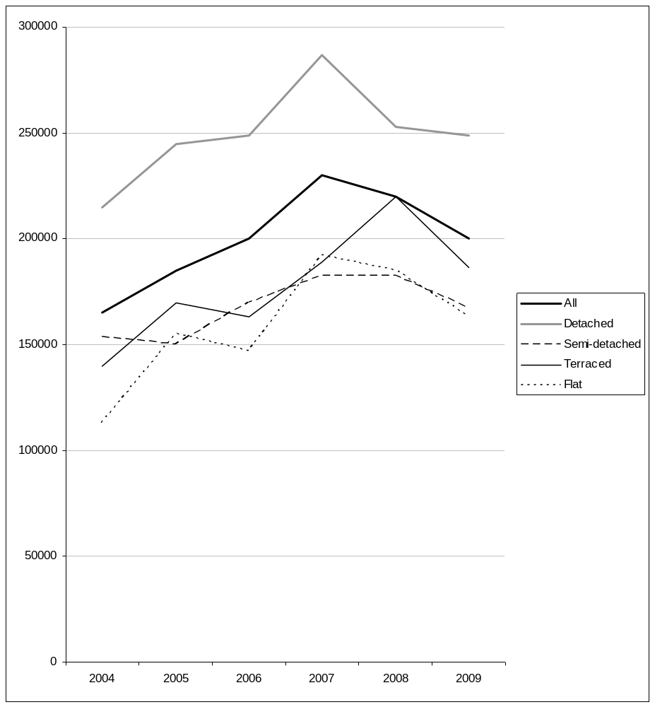

Chart 2 Median house sale prices in the National Park by house type in each year 2004-2009
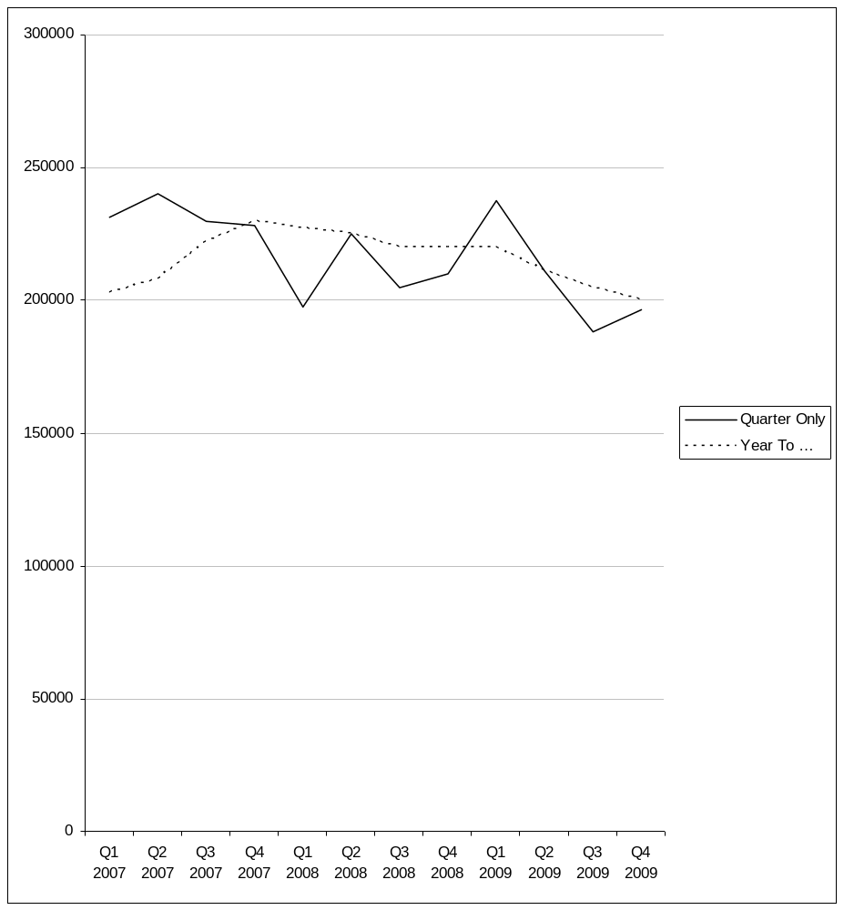
- Table 8 shows median sale prices for each house type in 2007 and 2009 and the 2009 price as a percentage of the 2007 prices

Table 8 Median sale price 2007 versus 2009

House type | Median sale price |  | 2009 price as percentage of 2007 price
House type | 2007 | 2009 | 2009 price as percentage of 2007 price
Detached | £287,000 | £249,000 | 87%
Semi-detached | £182,500 | £167,475 | 92%
Terraced | £189,000 | £186,250 | 99%
Flat | £192,000 | £163,000 | 85%
All types | £230,000 | £200,000 | 87%

- The nature of the housing market over the lifespan of the Local Development Plan is the subject of much conjecture and conflicting forecasts. A measure of the potential volatility can be taken from the decision of the Council of Mortgage Lenders decision not to make a public forecast of house prices for 2009 or 2010. Both mortgage lenders (Halifax and Nationwide) and the Land Registry reported that house prices rose nationally over most of 2009 (Charts 3 and 4), though many forecasters think this rise may slow, stop or even reverse over the next year or two.

Chart 3 UK House Prices Year on year % change

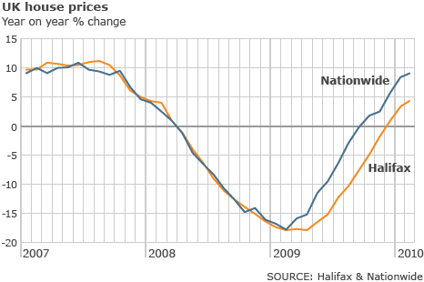

Chart 4 Mean house sale prices as reported by the Land Registry
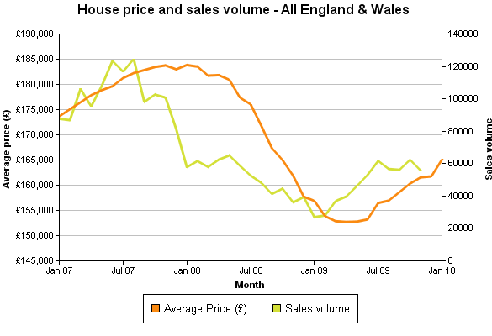
- Comparison of Charts 1 & 2 and 3 & 4 suggests that house price changes in the National Park are lagging behind National changes and possibly not changing as much. So we might expect an uplift during 2010, though probably not to 2007 levels possibly followed by a further drop comparable to that between 2007 and 2009, though there seem to be as many forecasts as forecasters (see http://www.housepricecrash.co.uk/#predictions for a flavour of this).

- In the context of the feasibility studies in Appendix 3, it is not unlikely that market prices could drop to between 80 and 85% of 2007 levels in the early years of the Plan (appendix 3 considers the implications of prices 70, 80 and 90% of 2007 levels). Experience of previous housing market recessions suggests that values will be at 2007 levels or higher later in the Plan period.

Housing Density and Number of Bedrooms
- In terms of density of development a look a sites completed or still active since 2004 shows the following:

Table 9 Average Densities

Sites with a Capacity of 5 or more units | Average Density per hectare
Greenfield Sites – New Build | 15.5
Brownfield Sites – New Build | 52.62

- The density proposed on greenfield sites including those currently allocated in the Joint Unitary Development Plan appear to be quite low by current expectations of the planning system.

Table 10 Number of Bedrooms in Completions 2001 to 2006

Number of Bedrooms | Unknown | 1 bed | 2 bed | 3 bed | 4 bed | 5 bed
Travel to Work Area
Fishguard and St David's | 19 | 7 (13%) | 14 (27%) | 23 (44%) | 8 (15%) | 0
Haverfordwest | 5 | 1 (1%) | 9 (13%) | 53 (75%) | 8 (11%) | 0
Pembroke and Tenby | 7 | 11 (9%) | 39 (33%) | 41 (34%) | 22 (18%) | 6 (5%)
All | 31 | 19 (8%) | 62 (26%) | 117 (48%) | 38 (16%) | 6 (2%)

- Looking at completions between 2001 and 2006 there was a reasonable range of provision in terms of number of bedrooms.

Implications of meeting the standards of the Code for Sustainable Homes
- The Authority has also considered the costs of the new Code for Sustainable Homes.

- The main findings of the research are that in order to address significant housing affordability problems, the emerging Local Development Plan for the Pembrokeshire Coast National Park requires a large proportion of affordable housing on housing allocations. This level of affordable housing is not on its own enough to make development of these sites economically unviable (though it will suppress land values). However, the new Code for Sustainable Homes has the potential to add significantly to development costs, particularly at the higher levels of the Code, corresponding to the Welsh Assembly and UK Governments' 'zero-carbon' homes aspirations.

- Applying the higher development costs of the Code for Sustainable Homes, a selection of allocation sites were assessed using a development appraisal model to estimate likely achievable levels of affordable housing and building sustainability. Applying the higher levels of the code (levels 5 and 6) is likely to mean that the target percentages of affordable housing in the Local Development Plan cannot be met, particularly in circumstances where the site has significant existing value, is likely to require significant infrastructure development, or when the owner will not sell at land values lower than would normally be paid by social housing developers. However, advice from the Welsh Assembly Government indicates that the expectation for new housing will be that it meets Code for Sustainable Homes level 3. At this level the allocation sites in the Local Development Plan would be viable at the target percentages of affordable housing.

Identifying Affordable Housing Need
- Need for affordable housing in the National Park can be considered through evidence emerging from:
    - The Local Housing Market Assessment
    - Housing Needs carried out the Rural Housing Enabler
    - Community Appraisals where appropriate
    - The Common Housing Register

Assessment of Need by the Local Housing Market Assessment 2007 (Final)
- The Local Housing Market Assesment provides figures for Pembrokeshire. The figures primarily took account of household growth of approximately 570 a year (2005 to 2015) for the County as a whole and data contained in the Common Housing Register. Currently residential completions equal 556 per annum in Pembrokeshire, 468 per annum outside the National Park and 89 per annum within a ratio of 84:16.
- If the figures of need identified in the Local Housing Market Assessment are shared using this ratio then the following requirements emerge. Whether the current backlog of need is addressed in 2 or 20 years, depending on the quota used, the provision of affordable housing is more than double the current overall completion rate.
Table 11 Number of dwellings per annum needed to address existing backlog of need over 2 to 20 years plus newly arising need

Step 11 Quota to reduce current backlog (% per annum) | Number of Years to address existing need | Number of dwellings to be provided per annum | Number of dwellings per annum in the National Park at 16% | As a % of total completions (National Park)
5 | 20 | 1406 | 225 | 253%
10 | 10 | 1539 | 246 | 277%
15 | 6.6 | 1672 | 268 | 301%
20 | 5 | 1806 | 289 | 325%
25 | 4 | 1939 | 310 | 349%
30 | 3.3 | 2072 | 332 | 372%
35 | 2.8 | 2205 | 353 | 396%
40 | 2.5 | 2338 | 374 | 420%
50 | 2 | 2605 | 417 | 468%

- The outputs from the Local Housing Market Assessment show a very high level of need which does not in anyway compare with development levels experienced in the County. This Authority has concerns about how accurate these calculations are.
- This Authority has a number of reservations regarding the reliability of the Local Housing Market Assessment. For the reasons set out below the Authority has chosen to base its assessment of the need for affordable housing on the current state of the housing register. It is recognised that this is not an ideal situation in that is does not create a picture of how need might change over the Plan period, but it is considered the most robust approach available.
- The Local Housing Market Assessment Guide advises that housing registers can be considered as a potential source of information on the extent of housing need. However, the guide identifies a number of prerequisites for housing registers to give a robust estimate of need:

- Operate a single register, for all providers of social housing and the whole housing authority area, to prevent double counting: This is the practice in Pembrokeshire, and figures for need in a locality only include applicants whose current address is in that locality.

- Ensure homeless households are included on the register: The practice in Pembrokeshire is to add households to the housing register when they register as homeless.

- Avoid restrictions on registering: The Pembrokeshire Housing Register does not restrict who can apply to the housing register, but does give 'reasonable preference' to certain categories of applicant who would be broadly defined as in need. Though the guidance suggests that this approach is good, this does mean that the register figure may include households that would not be defined as in need in the context of the planning policies. Even though there are no restrictions on registering, some households (including some in need) may choose not to register due to a belief that they won't have a chance of getting social housing.

- Data in the register should be maintained to allow identification of households by category of need, length of time on the register and current situation: The Pembrokeshire Register does record all of these and additional information and it is likely that it is sufficiently detailed to meet these requirements.

- Households on the register should be contacted at least annually to confirm that they are still seeking social housing: Households on the register in Pembrokeshire are contacted annually on the date of their initial registration for this purpose.

- Given the nature of the housing register in Pembrokeshire it is likely that it provides a good indication of the current need for social housing at a community level.

- The Local Housing Market Assessment was prepared in accordance with guidance from the Welsh Assembly Government, using the Stage 2a approach. The Local Housing Market Assessment identifies existing need (backlog need) as the number of households currently on the housing register (in the 'Gold' and 'Silver' categories of need). This does include applicants from outside the planning area (i.e. more than the need arising from within the National Park) but it does provide a reasonable estimate of a 'core' of need.

- The principle flaws in the model used to estimate housing need in the Local Housing Market Assessment surround the estimation of newly arising need. Newly arising need (the households that will be added to the need each year) is estimated as the number of new households applying to the housing authority for housing (and falling into the 'Gold' and 'Silver' categories), plus the number of new households forming and needing affordable housing as indicated by population and household projection models (as directed by the guidance). The estimate of households applying to the Housing Authority for Housing for each year of the Local Housing Market Assessment was based on a single year of actual data, with no reason to believe that this year was representative of either past or future years (only one year of reliable data was available). The tendency to over-estimate may aggravated as households who join the register and then leave it without being housed will be included in the figures, though they have met their needs in another tenure and/or Housing Authority area. The population and household projection figure was based on a pro-rata apportionment of a projection for Southwest Wales. There is good reason to believe that this is a seriously flawed approach, particularly in areas such as the Pembrokeshire Coast National Park, where the demographic pattern is markedly different from that of the surrounding wider area. Population and household projections subsequently produced by Pembrokeshire County Council specifically for the area of the National Park support this belief. Furthermore, adding the households applying to the Housing Authority to the number of households projected to form is likely to lead to double counting as many, or most, households projected to form and need affordable housing will also apply to the Housing Authority for housing.

- The model allows for supply of affordable housing due to re-lets of social housing and resale of LCHO type housing. However, this number of re-lets/resale's is fixed based on the years for which data is available to feed into the model, therefore it does not properly evaluate the impact of re-lets throughout the years covered by the Local Housing Market Assessment. If affordable housing is being delivered then the stock of affordable housing will increase and so, it is reasonable to assume, will the number of re-lets/resale's (as it is a function of the total housing stock). Therefore, if the housing need is being estimated over a number of years it is likely to underestimate the contribution to supply from re-lets/resale's.

- For these reasons the Local Housing Market Assessment is likely to overestimate need, possibly to a significant degree. therefore the Pembrokeshire Coast National Park Authority, in preparing its Local Development Plan has used data from the housing register on current need, as we can be confident that this provides a reasonable indication of the need for affordable housing, and is unlikely to be an over-estimate leading to an unnecessary burden on developers or the landscape of the National Park.

Local Needs Surveys
- The Rural Housing Enabler for Pembrokeshire has been carrying out surveys in various communities in the Park and the levels of need identified are set out below.

Table 12 Rural Housing Enabler Survey Results as at March 2010

Location |  | Local Housing Needs Study Result
 | Amroth / Summerhill | 15-23
 | Angle | 7-10
 | Bosherston
 | Broad Haven  Little Haven | 19 (The Havens)
 | Dale  Herbrandston  Marloes  St Ishmaels | 9  5-7  10-11  6-7
 | Dinas Cross | 13
 | Freshwater East | 16 (Lamphey)
Jameston
Manorbier
 | Mynachlog Ddu | 4-7
 | Newport | 23
 | Saundersfoot | 13 to 19
 | St Davids  Solva  Whitchurch | 26-39
 | Tenby | 50 – 76
 | Trefin
 | Sporadic & other settlements | 19 (Nolton and Roch)  10-15 (Martletwy)  7-11 (Nevern)  3-4 (Cwm Gwaun)

Common Housing Register
- The figures below are taken from the Common Housing Register as at 15 February 2010. The housing register is used to calculate the need for new affordable housing in the following way.

- Applicants on the waiting list are categorised according to need. There are three categories: gold, silver and bronze. Applicants in the gold and silver categories are deemed to be in sufficient need for the housing authority to have an obligation to attempt to house them. The current area of residence is also recorded for each applicant; these areas are relatively small within Pembrokeshire, relating to settlements or specific housing areas within the larger settlements. Additionally there is an outside Pembrokeshire code for applicants currently resident outside the county, and a code to denote applicants of no fixed abode. Therefore, it is possible to identify applicants to a fine degree of 'localness' within Pembrokeshire and determine if an application originates from outside the county. The current tenure of applicants is also recorded, allowing the identification of applicants currently in social housing, whose rehousing will result in a unit of affordable housing becoming available. The number of bedrooms required by each applicant is recorded, as is the number of bedrooms in their current accommodation.

- To assess gross need for an area the total number on the waiting list in the gold and silver need categories in the area is determined, broken down by the number of bedrooms required. Table 13 shows this for the Tenby Town Council area.

Table 13: Gross need in the Tenby Town Council area in July 2008

Bedrooms required | 1 | 2 | 3 | 4 | 5
Tenby | 81 | 95 | 35 | 2 | 1

- From the total applicants included in Table 13, the number currently living in social rented accommodation (local authority or RSL housing) is determined, broken down by the number of bedrooms in the current accommodation. This housing will effectively be returned to the affordable housing supply when the applicant household is rehoused. Table 14 shows this for the applicants included in Table 13.

Table 14: Qualifying applicants in affordable housing in the Tenby Town Council area in July 2008

Current bedrooms | 0 | 1 | 2 | 3 | 4
Tenby | 2 | 10 | 17 | 5 | 0

- Therefore Table 13 shows the gross need for affordable housing (all applicants) in the area. Table 11 shows the potential affordable housing supply in the area that would result from rehousing these applicants. Therefore the net housing need for the area can be determined by subtracting the potential supply in Table 14 from the gross need in Table 13. These figures shown in Table 15 amount to the shortfall (or surplus if the figures are negative) in affordable housing in the area.

Table 15: Shortfall in affordable housing (number of applicants minus the number already in affordable housing) in the Tenby Town Council area in July 2008

Number of bedrooms | 1 | 2 | 3 | 4 | 5
Tenby | 71 | 78 | 30 | 2 | 1

- Table 16 below shows what this means when figures are aggregated for the National Park. The table provides a count for ‘In the National Park’, ‘Not in the National Park’ and ‘Partly in the National Park’. Taking the figure of 384 (‘In the National Park’ need) and 32 (50% of the need that is ‘Partly in the National Park’) this gives a figure for the National Park of around 416 affordable dwellings being required. This does not take account of newly arising need.

Table 16 Common Housing Register Net Need as at 15 February 2010

Net housing need | Number of bedrooms
Area | 1 | 2 | 3 | 4 | 5 | Totals
Not in National Park | 937 853 | 1074 869 | 342 274 | 67 57 | 7 5 | 2427 2058
Partly in National Park | 19  21 | 24  27 | 13 16 | 4 1 | 0 0 | 60  65
In National Park | 163 162 | 175 140 | 69 70 | 18 11 | 1 1 | 426 384
Totals | 1119 1036 | 1273 1036 | 424 360 | 89 69 | 8 6 | 2913  2507

- To try to predict the rate of newly arising need an estimate technique based on population projections was used as outlined in Appendix 6. This suggests that we can expect around an additional 60 to 100 households arising and in need per year over the Plan period.

Housing Land Supply versus Need
- Bringing data on housing supply and need together Appendix 1 identifies:

- The need as identified in the Common Housing Register
- The need where known from the Rural Housing Enabler surveys
- The housing land supply for the Plan period
- The % of the supply needed to address the affordable housing need
- The anticipated affordable housing provision that is likely
- That part of the supply that is likely to need Social Housing Grant support using the Three Dragons Development Appraisal Toolkit

- These figures are broken down for sub areas for the National Park in the table.

- In terms of the total known affordable need (around 460) the housing land supply could deliver 412 units (from housing allocations) and 92 affordable units from mixed use sites. There is also potential for windfall sites (around 250) of which 50% could help to meet the newly arising need in the National Park. Appendix 4 explains. There is also currently planning permission for 22 affordable units.

- Social Housing Grant is likely to be needed for an estimated 65 units and it is likely that the smaller sites for 2 dwellings will also need support. This conclusion is based on the following assumptions made when using the Three Dragons Toolkit:

    - Market prices at the beginning of 2008
    - BREEAM Ecohomes 'excellent' standard
    - Planning obligation contribution of £11,365 on each market dwelling in the potential development (emerging draft supplementary planning guidance for the Joint Unitary Development Plan figure)
    - A mix of dwelling types and tenures based on past development of housing sites in Pembrokeshire and the need as identified by the Housing Register

- If all 250 units of windfall sites were on developments of 2 units then this would mean an additional 125 units are likely to need Social Housing Grant over the Plan period. Please note mixed use sites have not been assessed using Three Dragons.

- Appendix 2 shows possible variations in outcomes when using the Three Dragons Toolkit with changes to:

- The application of social housing grant used
- The application of planning obligation charges
- The percentage of affordable housing being negotiated.

- Alternative scenarios where house prices have dropped below the figure used in Appendix 2 have been tested using the Three Dragons Toolkit and these are also contained in Appendix 3.

- These scenarios show what the likely outcomes will be if market house prices were to fall to 90, 80 and 70 percent of their level at the beginning of 2008.

Housing Land Supply versus Completion Rates
- Using a completion rate of 89 per annum 1,246 units would need to be provided in the Plan period. The Plan provides for 1,358 units not counting windfall opportunities.

Thresholds for Affordable Housing Provision
- The table below shows how the housing land supply is distributed by site size, i.e. how much is on sites of 2 or more dwellings, 3 or more dwellings etc. The contribution from windfall sites is taken from looking at where the contribution to the supply since 2003 (i.e., the percentage that came from sites for 1 to 5+ uses).

Table 17 Housing Land Supply - Size of Sites
 | Supply | 2 or more units | % of supply | 3 or more units | % of supply | 4 or more units | % of supply | 5 or more units | % of supply | Annual Completion  Rate
Land with Planning Permission | 387 | 293 | 76% | 255 | 66% | 235 | 61% | 225 | 58% | 28
Housing Sites | 759 | 758 | 100% | 754 | 99% | 734 | 97% | 726 | 96% | 51
Employment & Mixed Use Sites | 212 | 212 | 100% | 212 | 100% | 212 | 100% | 208 | 98% | 14
Windfalls | 250 | 163 | 65% | 140 | 56% | 128 | 51% | 110 | 44% | 17
Total Land Supply | 1608 | 1426 | 89% | 1361 | 85% | 1309 | 81% | 1269 | 79% | 107

- The table below shows approximately how much affordable housing could be negotiated using different thresholds. The backlog of need alone is an estimated 460 units. The lower the threshold the greater opportunity there is to accommodate newly arising need as well.

Table 18 Affordable Housing Provision using different thresholds

 | Total supply | 2 or more units | 3 or more units | 4 or more units | 5 or more units
Supply (excluding land with permission) | 1221 | 1133 | 1106 | 1074 | 1044
50% for Affordable Housing | 611 | 566 | 553 | 537 | 522

References
National Planning Policy & Guidance

http://new.wales.gov.uk/topics/planning/policy/developplans/?lang=en

National Park Policy Statement

http://wales.gov.uk/topics/environmentcountryside/consmanagement/countrysidecoastalaccess/npwales/policystatement/?lang=en

One Wales A progressive agenda for the government of Wales

http://wag-en.custhelp.com/cgi-bin/wag_en.cfg/php/enduser/std_adp.php?p_faqid=185

Conferences and Surveys

CPRW Conference Background Paper
Sixth Form Conference Background Paper
Visitor and Residents Survey Background Paper

Web page for Background Papers

http://www.pcnpa.org.uk/website/default.asp?SID=1211&SkinID=5

Joint Unitary Development Plan – Inspectors Report –Extract from

http://www.pcnpa.org.uk/website/default.asp?SID=1243&SkinID=5

Low Impact Development

http://www.pcnpa.org.uk/website/default.asp?SID=1243&SkinID=5

Affordable Housing Supplementary Planning Guidance
Low Impact Supplementary Planning Guidance
Affordable Housing Delivery Statement

www.pcnpa.org.uk/website/default.asp?SID=234&SkinID=5

Pembrokeshire Local Housing Market Assessment Final 2007

http://www.pcnpa.org.uk/website/default.asp?SID=1243&SkinID=5

Pembrokeshire Local Housing Strategy April 2008

http://www.pcnpa.org.uk/website/default.asp?SID=1243&SkinID=5

Pembrokeshire County Council’s Population, Household and Labour Force Projections September 2008
http://www.pembrokeshire.gov.uk/content.asp?id=15863&Nav=109,141,1014

These weblinks were accessed on the 3 December 2009

March 5th 2010 WAG advice is that the publication of the revised TAN 6 is expected in the first half of 2010.
March 5th 2010 WAG advice is that the publication of the revised TAN 6 is expected in the first half of 2010.
Second Homes Table available on request from the National Park Authority file:F:\DevPlans\Subjects\Housing\SecHolHomesCCSummary.xls
Development unlikely within 5 years by virtue of major physical constraints or other constraints as may be agreed by the Housing Land Availability Study Group for the area.
March 2010.
Please note PCNPA Officers need to contact Cantref the second housing association operating a building programme in the Pembrokeshire Coast National Park to check if Cantref can still provide dwellings with the benefit of Social Housing Grant.
Local Housing Market Assessment Draft June 2007, pages 62-67
2003-Based National and Sub-National Population Projections for Wales http://www.statswales.wales.gov.uk/tableviewer/document.aspx?FileId=667
Local Authority Population Predictions for Wales (2006 based) - http://new.wales.gov.uk/topics/statistics/theme/population/pop-project/popprojla/?lang=en
Statistical Article: 2006-based Population Projections for National Parks in Wales. http://wales.gov.uk/docs/statistics/2009/090916sa29en.pdf
Note on Ageing Population Structure. Available on request from the Authority F:\DevPlans\Subjects\Statistics\Population\PembsAgeStructure.doc
Pembrokeshire County Council, September 2008 Population, Household and Labour Force Projections for the County of Pembrokeshire and Pembrokeshire Coast National Park (http://www.pembrokeshire.gov.uk/objview.asp?Language=&object_id=4136)
Page 22, Pembrokeshire County Council, Housing Strategy April 2008
House Prices 2008 Survey by the Pembrokeshire Coast National Park Authority. Report available on request from the Authority: File Reference is F:\DevPlans\Subjects\Housing\HousePrices\2008\Houseprice2008ReportFinal.doc
http://news.bbc.co.uk/1/hi/business/8386796.stm
For examples see: http://www.rics.org/site/scripts/press_article.aspx?pressreleaseID=200; http://news.bbc.co.uk/1/hi/business/8386796.stm
http://news.bbc.co.uk/1/hi/business/8549000.stm
http://www1.landregistry.gov.uk/houseprices/housepriceindex/report/default.asp?step=4&locationType=0&area=E%26W-ALL&reporttype=1&datetype=1&from1=01%2F2007&from2=01%2F2010&image2.x=16&image2.y=20)
Density Report available on request from the Authority: <file: F:\DevPlans\Subjects\Housing\LAW\HousingDensity.xls
Number of bedrooms are not included in the percentage calculations
Implications of meeting the standards of the Code for Sustainable Homes. Report available on request from the Authority F:\DevPlans\Subjects\Housing\AffordableHousing\Three DragonsToolkit\LatestVersion\Version7April2008\PotentialSitesAnalyses\CfSH_AffHousing_TradeOff.doc
PCNPA – LDP Officers Draft Deposit (Aug’08). WAG Informal Comments further to meeting on 23 September 2008
Affordable Housing in Pembrokeshire Supplementary Planning Guidance to the Joint Unitary Development Plan for Pembrokeshire 2000-2016, June 2006
Local Housing Market Assessment, Pembrokeshire County Council, page 73 – 74.
As above, page 43.
As above Figure 66, page 87.
Please see the Site Criteria Background Paper for details on how the land supply was derived.
March 2007
The approved Supplementary Planning Guidance Examination Library Reference LOC30 ask for a planning contribution that equals £10,472,66 per dwelling. The Supplementary Planning Guidance prioritises affordable housing delivery where viability issues emerge. See paragraph 27 of the Supplementary Planning Guidance.
The Community Infrastructure Levy England and Wales Draft Statutory Instrument will come into force on 6th April 2010. Our understanding locally is that we can continue with S106 obligations until such time as we choose to progress Community Infrastructure Levy.
1999 to 2009 completion rate

