LISTED BUILDINGS

A GUIDE FOR OWNERS & OCCUPIERS

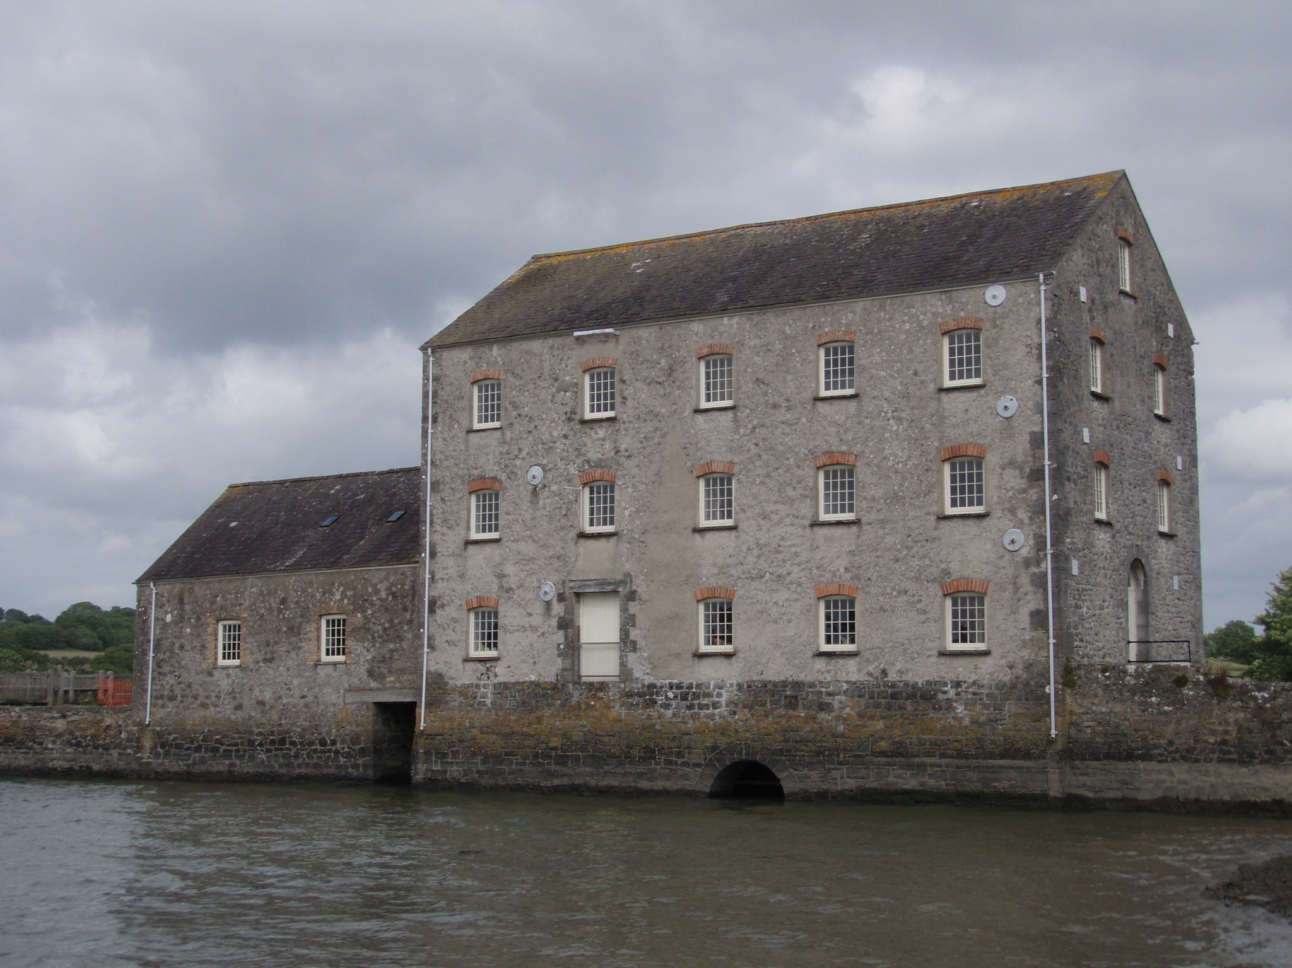 | 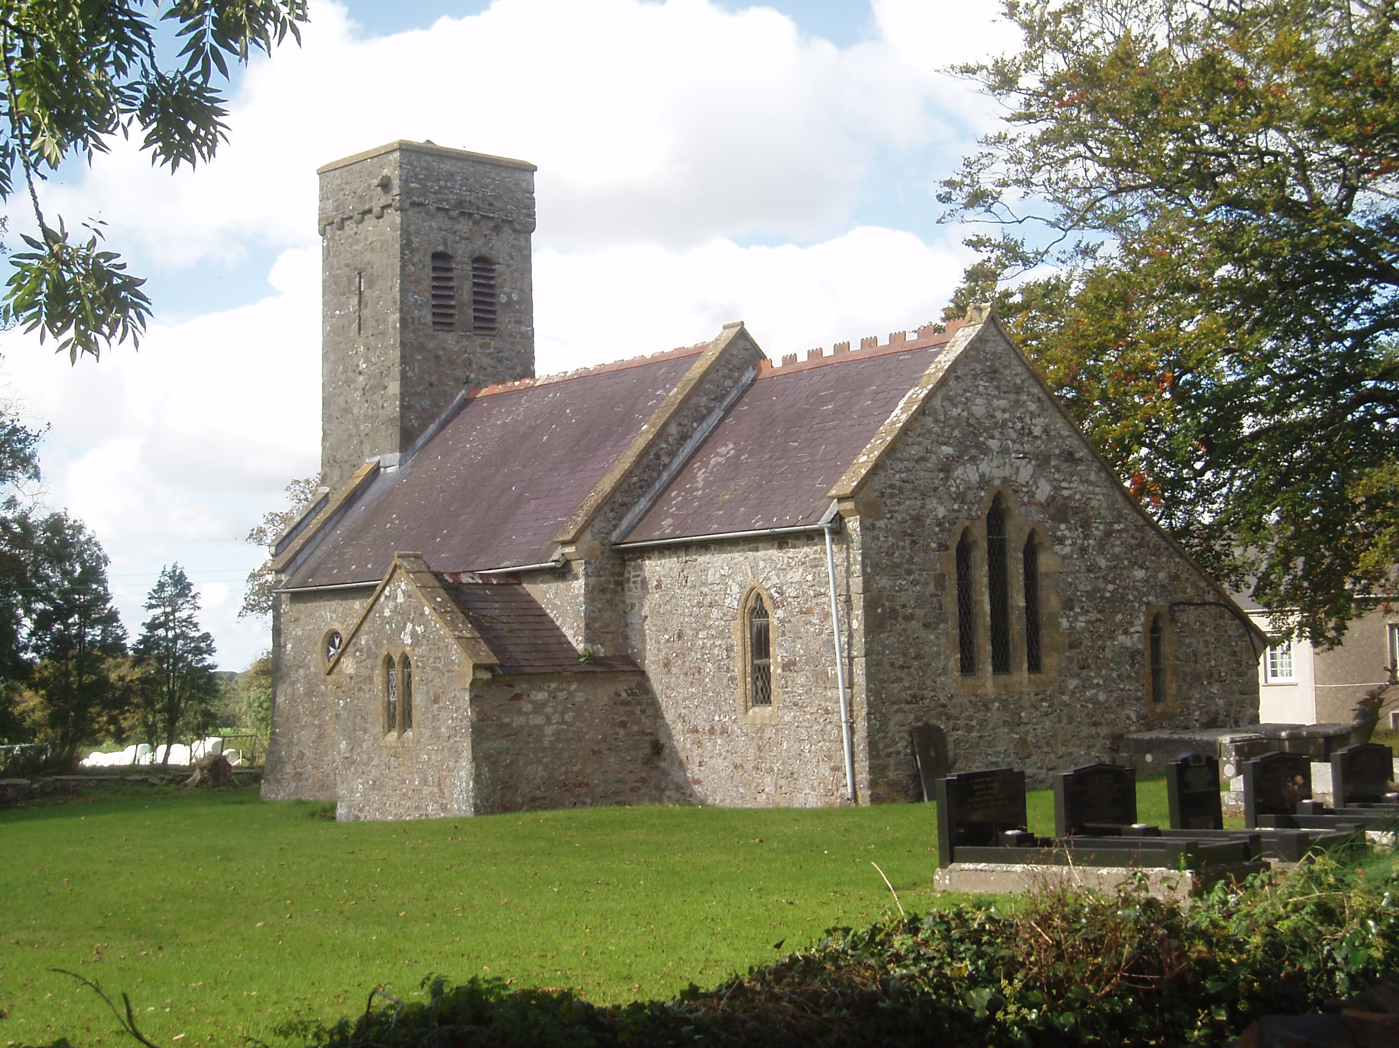 | 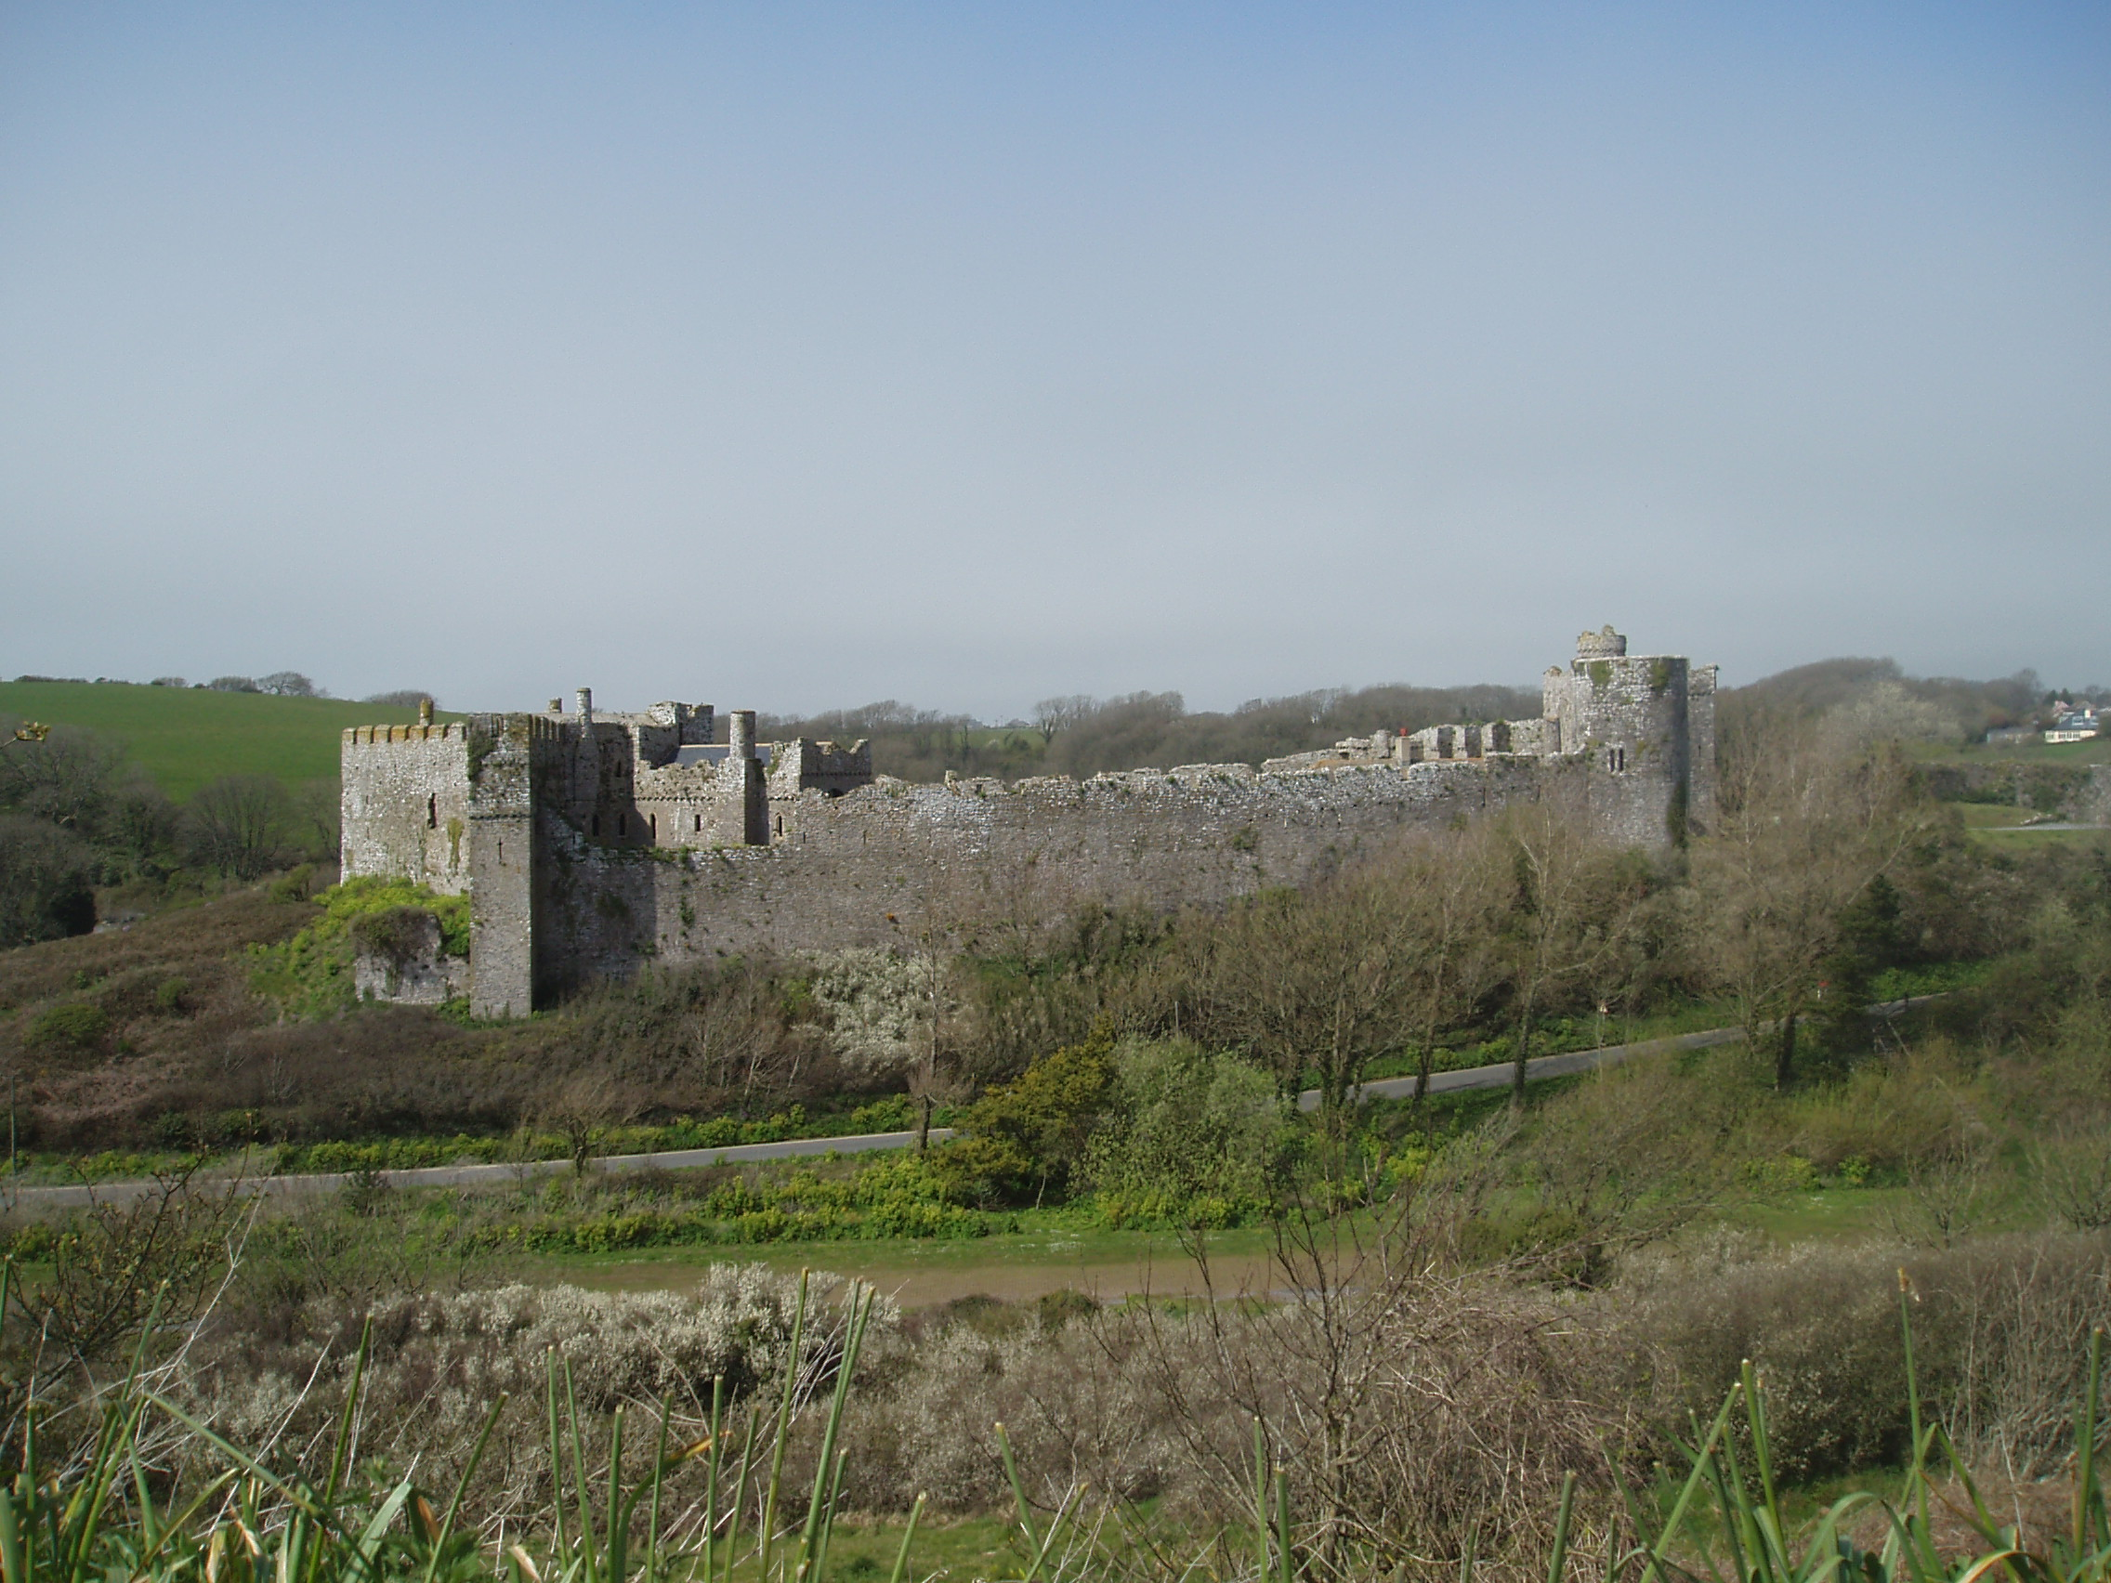
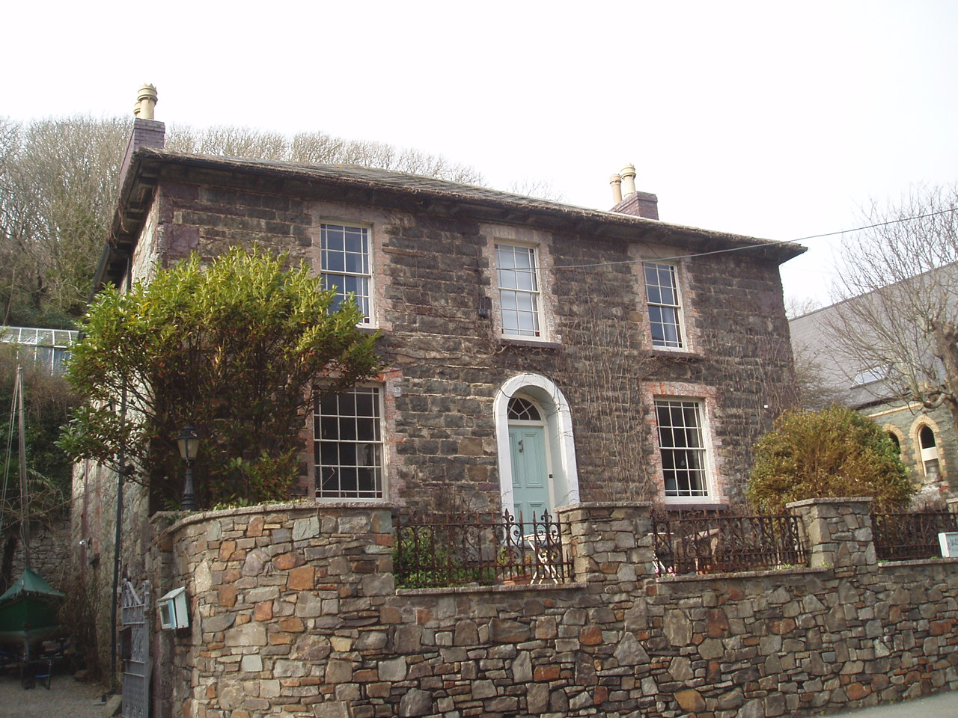 | 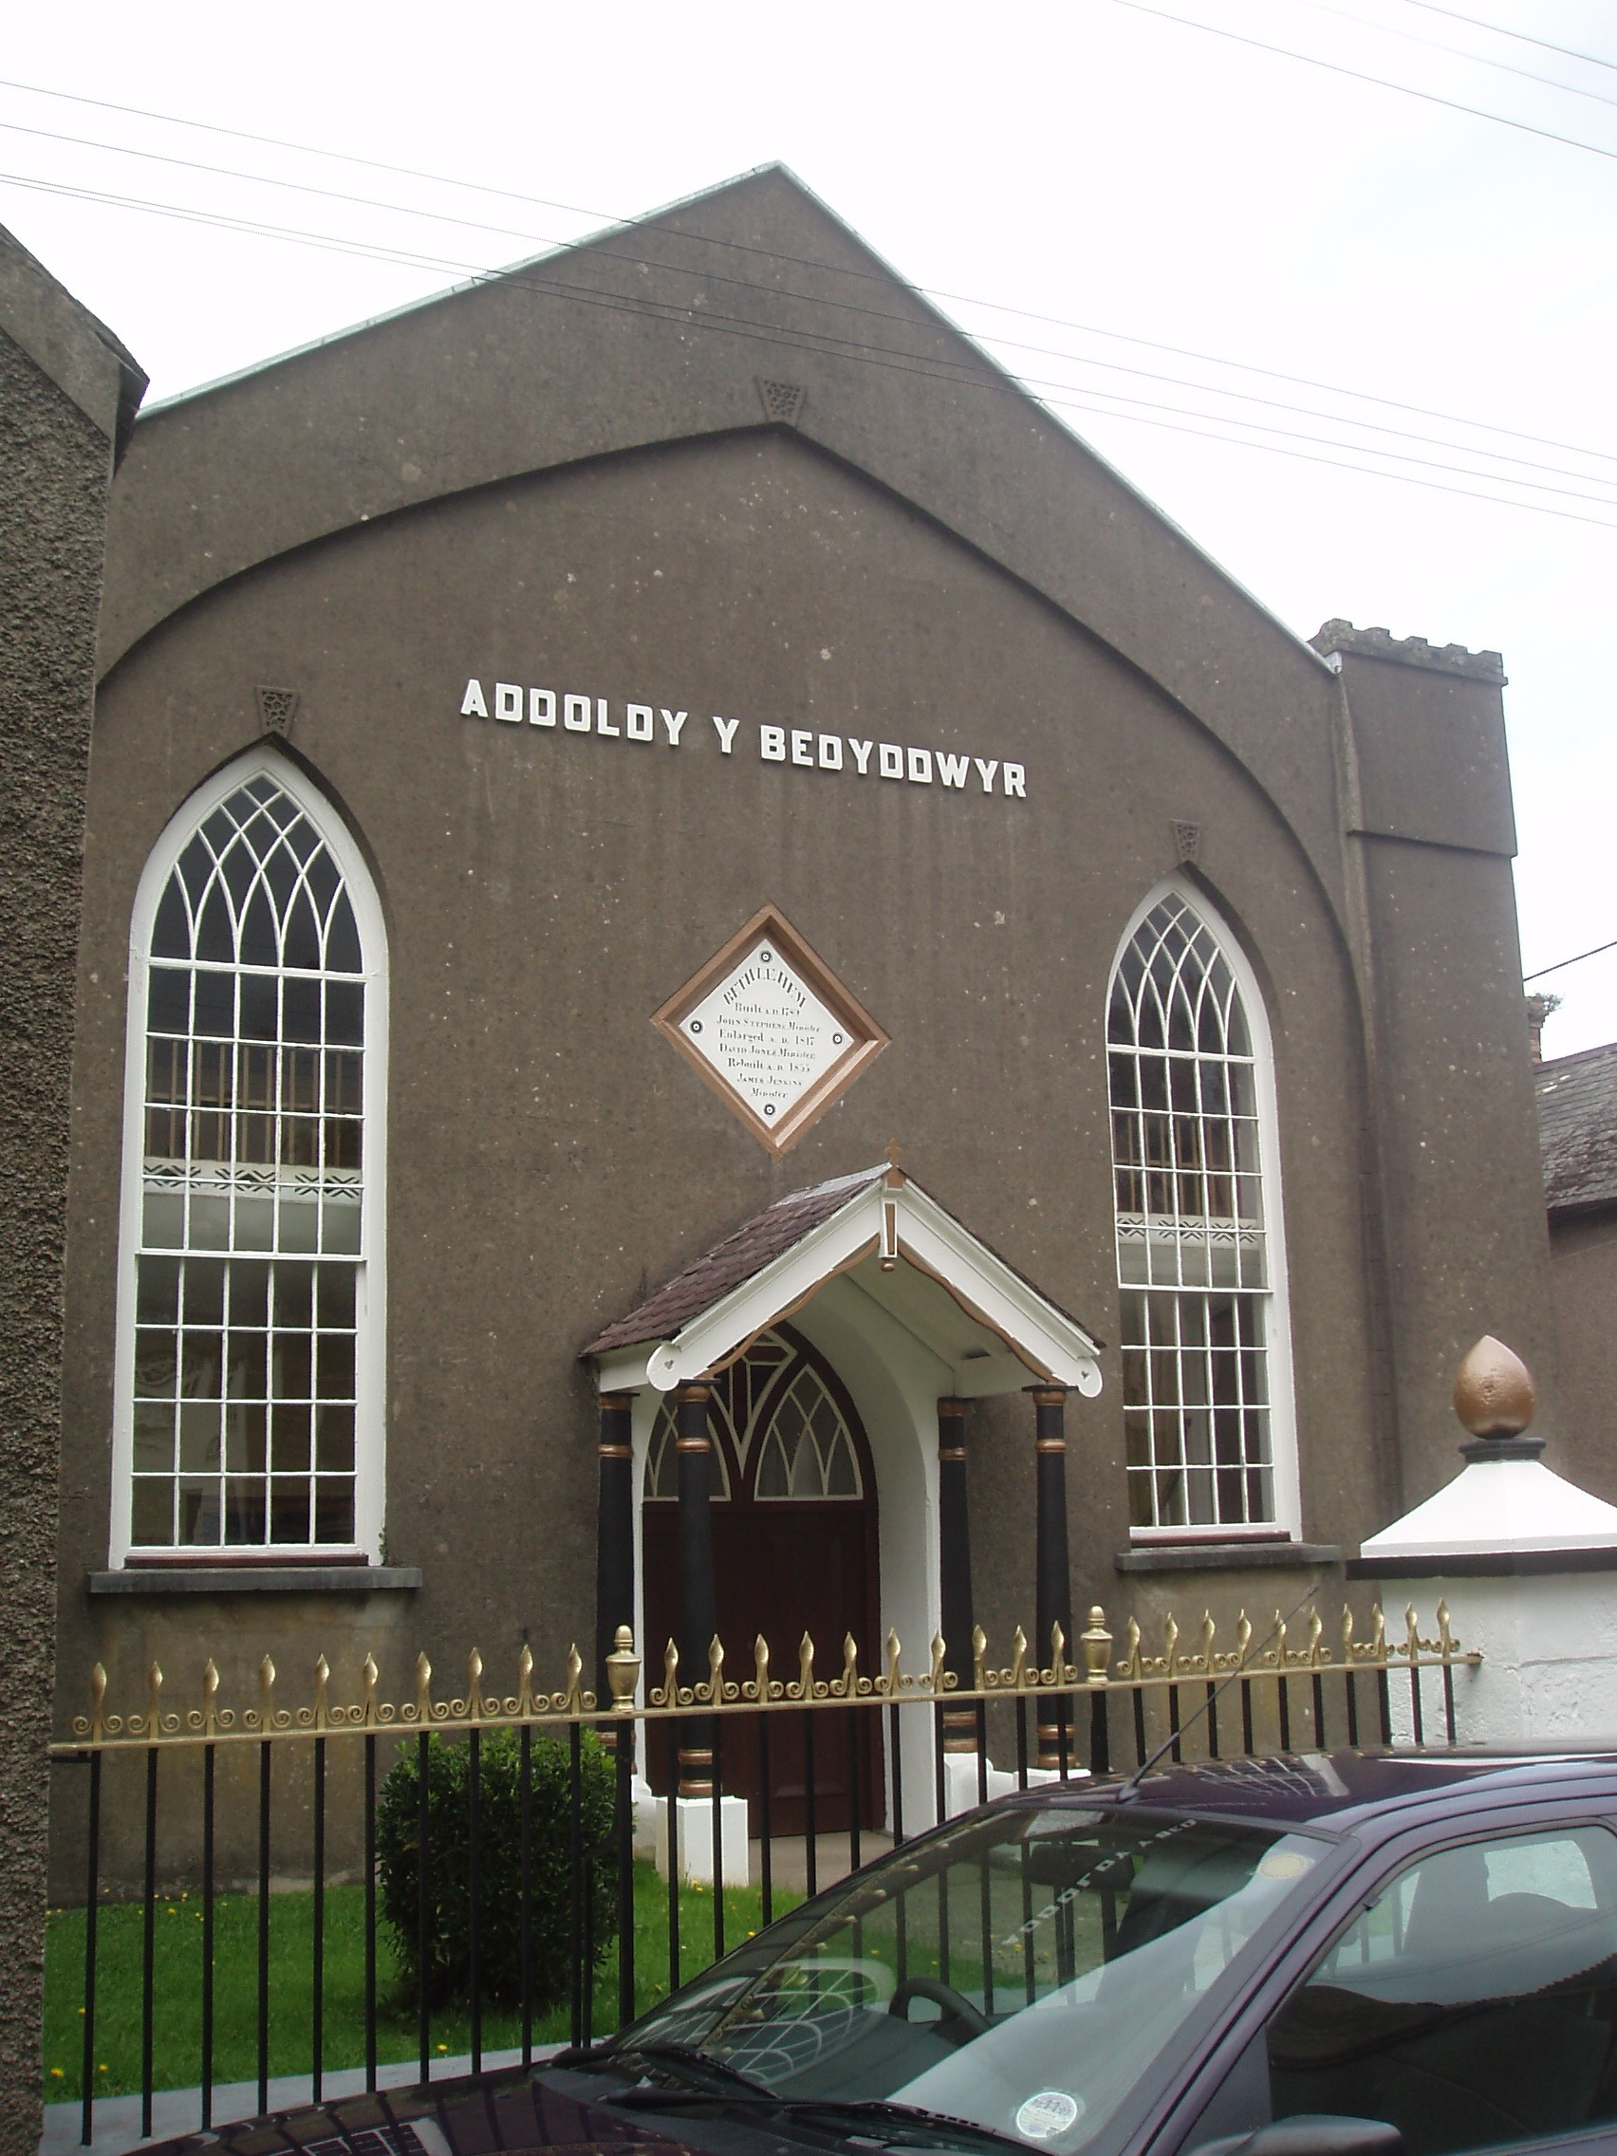 | 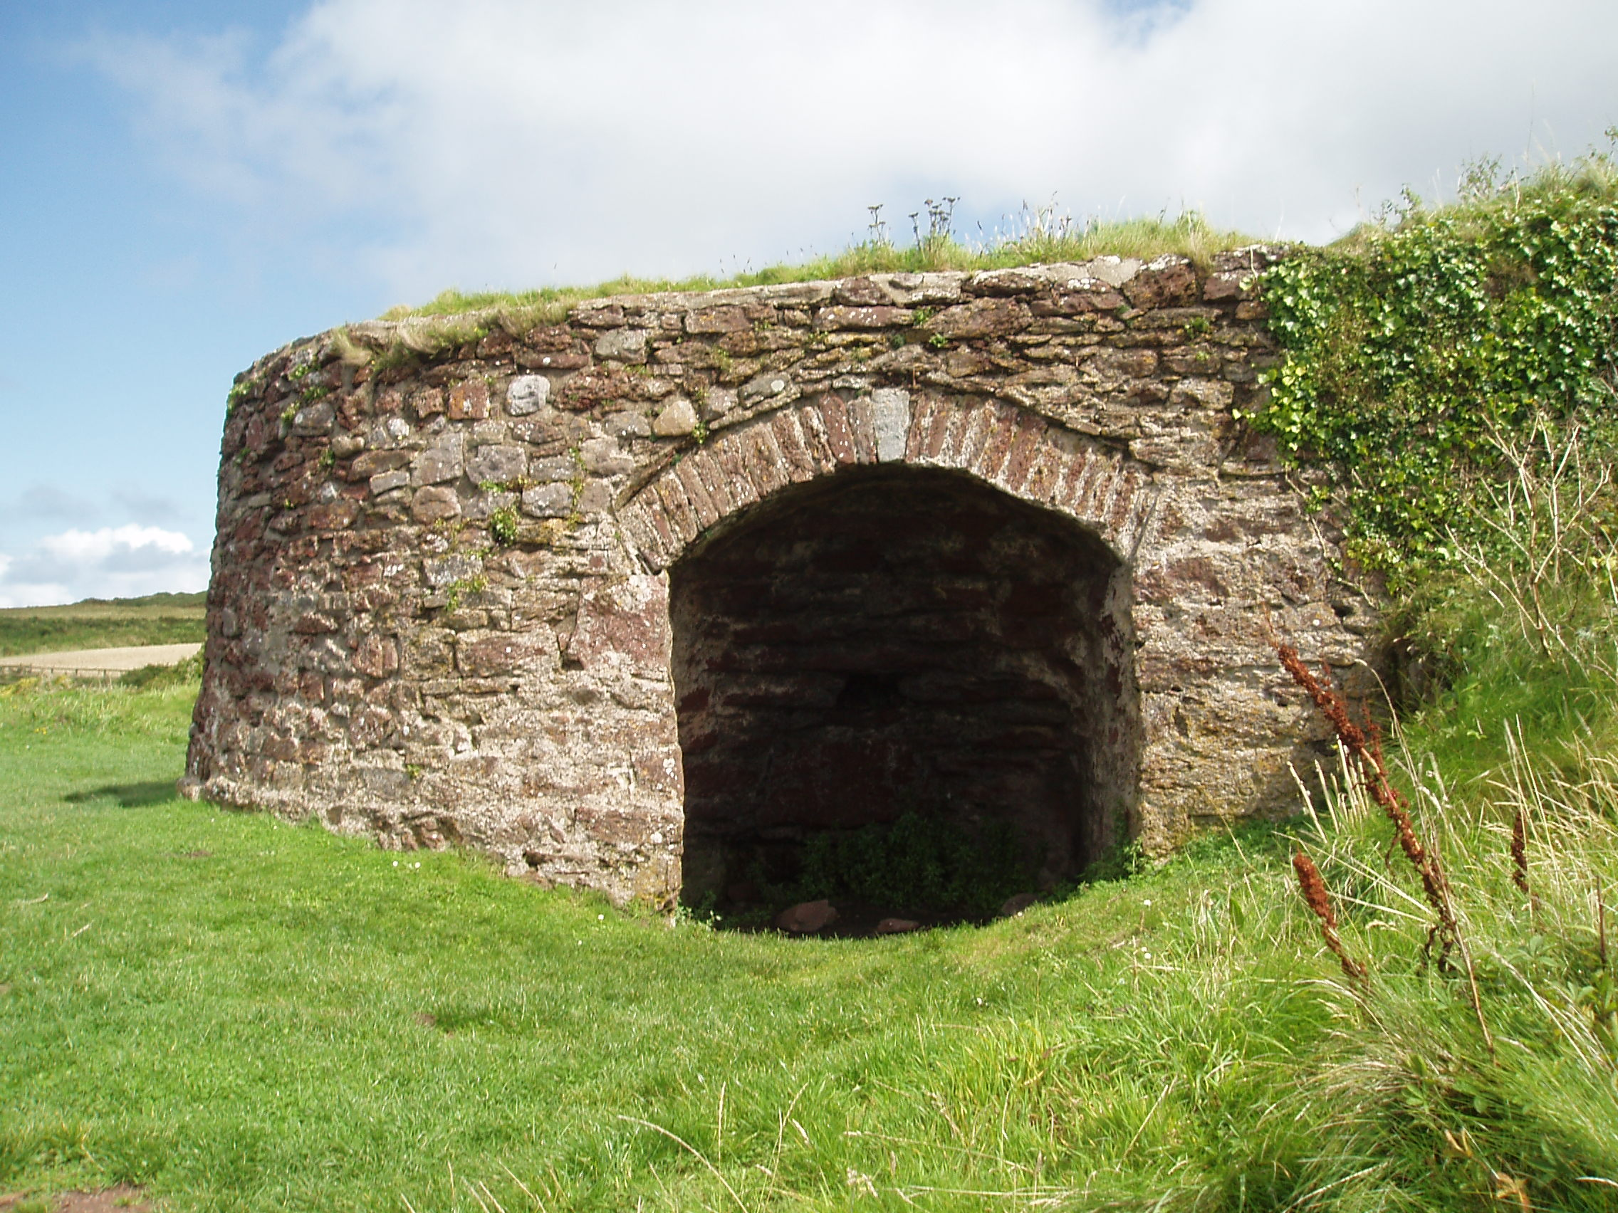

Parc Cenedlaethol Arfordir Penfro
Pembrokeshire Coast National Park Authority
August 2012

Contents: Page

The historic buildings of the Pembrokeshire Coast
National Park Authority 3

The role of the Royal Commission 4

The role of Cadw 4

Why are buildings listed? 5

Is the building listed? 6

What does listing mean? 6

How much of the building is listed? 7

When do I need listed building consent? 8

Do churches or chapels require listed building consent? 9

What are the legal responsibilities for owners of
listed buildings? 9

Can a building be de-listed? 10

How do I obtain listed building consent? 10

Can I get any financial help? 11

Appointing professional advisors 11

What about VAT? 12

What about insurance? 12

Who to contact 13

Useful addresses 14

The Historic Buildings of the Pembrokeshire Coast National Park Authority

There are nearly 1240 listed buildings within the Pembrokeshire Coast National Park Authority varying greatly in type and age including castles, Napoleonic forts, medieval churches, chapels, country houses, rural cottages, colliery structures and limekilns.

The important historic buildings within the Pembrokeshire Coast National Park Authority can be divided into three categories:

- Scheduled Ancient Monuments:

These are buildings, structures, or areas of land containing remains, which have been scheduled as ancient monuments by the Welsh Government under the Ancient Monuments and Archaeological Areas Act 1979.

Examples include Pentre Ifan. Some buildings are scheduled as ancient monuments as well as listed. Where this occurs scheduling, which introduces closer controls than does listing, takes priority and listed building controls do not apply.

- Listed Buildings:

A listed building is a building of special architectural or historic interest which is listed by the Welsh Government under the Planning (Listed Buildings and Conservation Areas) Act 1990.

About 30,000 buildings currently appear on this national list which is split into three categories according to their relative importance.

Grade I. Buildings of exceptional interest. In Wales only 493 of listed buildings are this grade. Within the Pembrokeshire Coast National Park there are 28 Grade I listed buildings including Carew Castle.

Grade II* Buildings of More than Special Interest. In Wales only 7% of listed buildings are this grade. With the Pembrokeshire Coast National Park there are 74 Grade II* listed buildings such as Nevern Church.

Grade II Buildings of Special Interest. The majority of listed buildings are this grade. Within the Pembrokeshire Coast National Park there are currently 1134 Grade II listed buildings.

- Historic Buildings of Local Importance

These are the buildings which are not listed but because of their locally distinct architecture and construction make a major contribution to the character and interest of the local area.

The main criteria applied in deciding which buildings are of local importance are the:
- Degree to which the building remains in its original condition;
- Quality of the individual buildings architecture;
- Position and influence on the townscape or landscape;
- Association with an important local figure or event.

The Role of the Royal Commission

The Royal Commission on the Ancient and Historic Monuments of Wales (RCAHMW) is the official investigation body and national archive for the historic environment of Wales. It maintains a unique collection of material within its archive, The National Monuments Record of Wales, which can be consulted online at www.coflein.gov.uk. The Royal Commission also provides a professional consultation service to local authorities and other heritage organisations as well as individuals.

The Role of Cadw

Cadw, the Welsh Government’s historic environment service, manages 128 monuments on behalf of the Welsh Government. It is also the decision making body for development proposals affecting scheduled ancient monuments. Scheduled monument consent is required in addition to any necessary planning permission from the Local Planning Authority.

In certain cases where a local planning authority intends to grant listed building consent, it must notify Cadw of the application before doing so. The notification process gives the Welsh Government, on the advice of Cadw, the opportunity to call-in the application for determination by the Welsh Ministers. Cadw has a statutory period of 28 days from receipt of the application to decide whether to refer the application back to the planning authority for determination or give notice that further time is required in which to consider if the application should be called in. Applications are called in where they give rise to issues of exceptional significance or controversy. In considering those criteria, Cadw is assessing whether the applicant has reasonably addressed all alternative options and if the local planning authority has had appropriate regard to published policy and circular guidance and come to a conclusion that could be supported by the evidence.

The decision on whether to call in an application is taken by the Welsh Government's Minister for Environment and Sustainable Development in the light of advice from his officials in the Welsh Government's Planning Division – the assessment made by Cadw and referred to above is taken into consideration by Planning Division in preparing its advice for the Minister.
Why are buildings listed?

Buildings are listed because the Welsh Government considers that they are of special architectural or historic interest, and statutory recognition of their importance is required.

Buildings are listed to protect and preserve them as part of our heritage for the benefit of future generations. This does not mean that listed buildings are not able to change as they respond to the needs and uses of the time. Listing is not intended to mothball a building. Certain listed structures need to be conserved ‘as found’, but underpinning the planning legislation is the belief that the long term interests of a historic building are best served by it remaining in use: although often the best use is the one for which it was designed. Listing tries to ensure that if any changes are necessary they respect and retain those qualities and characteristics that make the building special.

All buildings considered for listing are judged accordingly to a set of national standards. The main criteria applied in deciding which buildings to include in the statutory list are as follows:

- Architectural interest: the lists are meant to include all buildings which are of importance to the nation for the interest of their architectural design, decoration and craftsmanship; also important examples of particular building types and techniques (e.g. buildings displaying technological innovation or virtuosity) and significant plan forms;
- Historic interest: this includes buildings which illustrate important aspects of the nation’s social, economic, cultural or military history;
- Close Historical Association: with nationally important people or events;
- Group Value: especially where buildings comprise an important architectural or historic unity or a fine example of planning (e.g squares and terraces).
- Age and Rarity: generally buildings and structures in the following categories are listed:
- All buildings built before 1700 which survive in anything like original condition.
- Most buildings from 1700 to 1840, although selection is necessary.
- Buildings built between 1840 and 1914 which are of definite quality and character and are the best examples of particular building types. Greater selection is required due to the greatly increased number of buildings erected and the much larger numbers that have survived.
- Only selected buildings from the period after 1914. Buildings which are less than 30 years old are normally listed only if they are of outstanding quality and under threat.
Is the building listed?

The Local Planning Authority holds a record of all listed buildings, within its Listed Building Register, including a comprehensive photographic survey.
http://www.pembrokeshirecoast.org.uk/default.asp?PID=524

To determine if a building is listed you can contact the Authority’s Historic Building Conservation Officer who will be able to provide you with the information you require as well as copies of the lists. Alternatively, you can carry out your own search for listed buildings via the Authority’s website.

The lists are used to help planning authorities make decisions with the interests of the historic environment clearly identified. Whilst the assessment of buildings for listing is undertaken by Cadw, the Local Planning Authority has primary responsibility for decision making in relation to works to listed buildings.

What does listing mean?

Listing means that when a building is included on a Listed Building Register, it is necessary to apply for ‘Listed Building Consent’ from the National Park Authority before carrying out works which would affect the building’s character.
This includes works of demolition, in whole or in part, and for any works of alteration or extension which would affect its character as a building of special architectural or historic interest.

Even relatively minor works, such as painting, may affect the character of a listed building and it is therefore advisable to consult the National Park Authority before starting such works if there is any doubt. The points of contact within the department are listed at the end of this advice note.

Under Section 9 of the Planning (Listed Buildings and Conservation Areas) Act 1990 it is a criminal offence to demolish a listed building, or alter or extend such a building in a way which would affect its character, without consent, and the penalties for this can be heavy.
The current penalty for conviction in a magistrates’ court is a fine of up to £20,000 or imprisonment for up to 6 months (or both), whilst on conviction in the Crown Court, an unlimited fine or a prison sentence of up to two years (or both) may be imposed. In determining the amount of any fine, a magistrates’ court or the Crown Court must have regard to any financial benefit which has accrued or may accrue from the offence.

How much of the building is listed?

All of the building is listed including all the interior and exterior and any object within the grounds of the building which forms part of the land and has done since 1st July 1948.
It is a common misunderstanding that listing only applies to the outside of a building; this is not the case, for example the plan of a building is one of its most important characteristics and together with individual features such as staircases, panelling, doorcases etc. should be respected and left unaltered as far as possible. A listed building as described by the Planning (Listed Buildings and Conservation Areas) Act 1990 includes ‘any object or structure fixed to the building and any object or structure within the curtilage of the building which, although not fixed to the building, forms part of the land and has done so since before 1 July 1948.’ Although listing applies to the whole building, the list description is only intended to identify the property, and just because a feature of the building is not mentioned in the list description, this does not mean it is not listed.

When do I need Listed Building Consent?

Repairs:
Works of maintenance or repair do not usually need consent provided that the materials, detailing, and finished effect match the original work exactly.
With listed buildings emphasis should always be placed on repair rather than replacement. Where repair of an item is not feasible, replacement should be on a like for like basis using traditional methods and techniques, but this should be a last option and Listed Building Consent may be required.

Demolition:
Listed Building Consent is required for demolition work.
While it is an objective of Government policy to secure the preservation of historic buildings, there will very occasionally be cases where demolition is unavoidable. Listed building controls ensure that proposals for demolition are fully scrutinised before any decision is reached. There are many outstanding buildings for which it is inconceivable that consent for demolition would ever be granted. The demolition of any Grade I or Grade II* building should be wholly exceptional and should require the strongest justification.

Alterations:
Listed Building Consent is required for any work which is the opinion of the Authority, affects the character of a listed building.
A general principal is that alterations should aim to be reversible so that a building can be put back to it original form at a later date if necessary. Applicants for Listed Building Consent must be able to justify their proposals. They will need to show why works which would affect the character of a listed building are desirable or necessary.

General principles when considering alterations:
Generally the best way of securing the upkeep of historic buildings and areas is to be keep them in active use. The best use will very often be the use for which the building was originally designed, and the continuation or reinstatement of that use should certainly be the first option when the future of a building is considered. However, some adaptations may be required to historic buildings to keep them in use. In judging the effect of any alteration or extension it is essential to have assessed the elements that make up the special interest of the building in question and to justify the proposal and its likely impact on the special architectural and historic interest of the building.

A listed building may be capable of, or require, alterations and extension, but these must be sympathetic to the character of the building, and the Authority will treat this requirement as a priority when assessing applications and monitoring work in progress. Owners and their agents are advised to contact the Authority at an early stage to discuss any proposals affecting a listed building, and to find out whether or not Listed Building Consent is required.

Examples of works that may require Listed Building Consent:

Demolition of any part of a listed building including chimneys, internal walls and structures within the curtilage.

Extensions or additions including porches, conservatories.

Roof alterations including changes to roof materials, insertion/alteration/removal of rooflights or dormers.

Internal alterations including work to room layouts/partitions/walls, floors, fireplaces, doors, panelling, staircases, wood/plasterwork mouldings.

Window and door alterations including removal and replacement of any door or window.

Decorative alterations which can include changes to the cladding materials, changes of paint colours, use of non traditional finishes such as wood stain, painting previously unpainted surfaces, replacing original lime render with a cement based render, use of a different style of pointing or mortar mix to that existing, large areas of repointing.

Addition of fixtures including satellite dishes, shutters, alarm boxes, external meters, fire escapes, signs and advertisements, new soil/rainwater pipes and gutters, name plates and door furniture.

Introduction of services such as mains electricity, telephone or gas (e.g. switchgear, meter-boxes etc.)

For advice on applications for Listed Building Consent or Planning Permission
please contact the Pembrokeshire Coast National Park Authority.
The points of contact within the Department are listed at the end of this booklet.

Do churches or chapels require Listed Building Consent?

Ecclesiastical buildings are fully subject to planning control, but some ecclesiastical buildings which are for the time being used for ecclesiastical purposes and have an approved monitoring system are exempt from listed building controls, except in so far as the Secretary of State provides otherwise by Order under 60(5) and 75(7) of the Planning (Listed Buildings and Conservation Areas) Act 1990. Ecclesiastical exemption does not apply to the residences of ministers of religion. The context of the exemption is provided by an undertaking that historic church buildings are subject to a separate system of control which takes account of their historical and architectural importance. The “Ecclesiastic Exemption : What it is and how it works (September 1994)” provides full information on the subject.

The following denominations have exemption:-

The Church in Wales.

The Roman Catholic Church

The Methodist (Wesleyan) Church

The Baptist Union of Wales / Great Britain (only where buildings are held in trust by either Union).

The United Reformed Church

Other denominations (including Calvinistic Methodists/Presbyterians, Unitarians, Independents/Congregationists (and Baptist Chapels where either Baptist Union is not a trustee) are subject to full planning and listed building control.

What are the legal responsibilities of owners of listed buildings?

Most owners and occupiers recognise listed buildings as part of our heritage and are pleased and proud to maintain their properties. Owners of listed buildings have responsibilities for their upkeep and repair which are described under the Planning (Listed Buildings and Conservation Areas) Act 1990. Where it appears to the National Park Authority that the building is not being properly maintained, it can serve a notice (Building Repairs/Urgent Works Notice) on the owner requiring necessary works to be undertaken within a specific time.

Listed buildings that are deliberately neglected by their owners can ultimately be compulsorily purchased by the council and minimal compensation paid. If the property is unoccupied, the Authority can undertake the works to protect the building itself and then recover the costs from the owner. These measures are seen as last resorts by both the Welsh Government and the National Park Authority and it is hoped that through constructive dialogue they will be rarely necessary.

Can a building be de-listed?

The Welsh Government is prepared to review listings in the light of new evidence.
There is no formal appeal procedure, but owners or others who believe that a listing should be reconsidered should send the evidence to Cadw, together with photographs of the building and a location plan. The evidence must relate only to the special architectural or historic interest ascribed to the building.

How do I obtain listed building consent?

Application forms for Listed Building Consent are available from the Development Management Section at the address on the back cover of this leaflet or can be downloaded from our website.
Listed Building Consent will normally be required in addition to Planning Permission, although no fee is required for Listed Building Consent. The timescale for handling the Listed Building Consent application is normally around 10 weeks.

Applicants for Listed Building Consent must be able to justify their proposals.
They will need to show why works which would affect the character of a listed building are desirable or necessary, and include this as a written justification statement in their application. They should provide the Authority with full information, to enable assessment of the likely impact of the proposals on the special architectural or historic interest of the building, and on its setting.

The following information should be submitted along with the completed application forms:

- An Ordnance Survey location plan to a scale of at least 1:1250 based on a modern OS map. Plans should show the site in its context, including adjacent buildings. The grid reference should be included in rural areas, and the application site clearly defined with a red line. It should include all land necessary to carry out the proposed development including access from a public highway, landscaping and car parking. A blue line should be drawn around any land owned by the applicant close to or adjoining the application site
- Site and layout plans. These should be to a metric scale 1:200 or 1:500 and showing accurately the direction of North; the proposed orientation of the development in relation to the site boundaries, and other existing buildings on the site. Dimensions and details of boundaries, trees, access routes and public rights of way should be shown. Details should also be given of the extent and type of any hard surfacing and boundary treatment including walls or fencing where this is proposed.
- Existing and proposed drawings to include plans, elevations, photographs, sections and as much supporting information as possible such as material specifications, joinery profiles, photographs etc. The plans should be at a metric scale of either 1:50 or 1:100, and show clearly the proposed works in relation to what is already there. Details must be provided of the proposed building materials, and the style, materials and finish of windows, doors, rainwater goods, and chimney stacks. For details such as windows and doors and decorative mouldings, drawings at 1:20 scale are required, with details and sections.
- A justification statement as described above.
- A design and access statement, analysing the significance of the building, its special features and its setting. It should also explain and justify the approach taken to ensure that the listed building preserves its special historic and architectural importance, including its setting. The design aspect of the statement should consider appearance, environmental sustainability, layout and scale. The access element should explain the approach taken to access, and explain how policies in the Local Development Plan have been taken into account. It should also explain specific issues which might affect access to the listed building, and how access infrastructure will be maintained.
- Where total demolition is proposed, please contact us for further information on the details required.
- Welsh Government policy on the built heritage of Wales is provided by:-

Planning Policy Wales

Welsh Office Circular 61/96 Planning and the Historic Environment: Historic Buildings and Conservation Areas.

Welsh Office Circular 1/98 Planning and the Historic Environment: Directions by the Secretary of State for Wales.

Welsh Office Circular 60/96 Planning and the Historic Environment: Archaeology

Can I get any financial help?

Cadw may be able to provide grants for ancient monuments, historic buildings, conservation areas, buildings at risk and churches. Their contact details are included at the end of this advisory note.

The Authority operates grants for external repairs to historic buildings within its 14 Conservation Areas. Eligible items include e.g. roofs, chimneys, doors and windows: for further details, please contact the Building Conservation Officer.

Non-building conservation funding may be available from Pembrokeshire County Council (Housing Improvement) or from the bodies within the Welsh Government concerned with tourism or economic development.

Appointing Professional Advisors

The repair and alterations of Listed Buildings requires special skills.
The appointment of an architect or surveyor who is experienced and trained in the conservation of historic buildings is strongly advised, and the work should be undertaken by builders or specialists experienced in working with listed buildings.

What about VAT?

Repairs to all buildings, whether listed or not, are subject to VAT. However, Customs and Excise will allow VAT exemption on certain classes of work to listed buildings, but the work must have been undertaken by a VAT registered builder, and Listed Building Consent must have been obtained for the work.

Summary of zero-rating:

For zero-rating of work the following criteria must be satisfied:

- The building must be listed or a scheduled monument.
- The work must form part of an approved alteration of the building for which listed building consent is both required and has been obtained.
- The work cannot be repair work.
- The building must be designed as, or become a ‘dwelling’ or dwellings, or be intended for use solely for a ‘relevant residential purpose’ or a ‘relevant charitable purpose’ after the work has taken place. This allows the work for conversion of non-residential buildings to new dwellings to be zero-rated.

For further information and advisory leaflet contact your
Local Customs and Excise Office

What about insurance?

Insurance is important in the management of any property. This is especially true of historic buildings, whose design and construction may make them more vulnerable to damage, especially by fire, and more expensive to repair afterwards.

It is advisable to ensure that your insurance company is aware of the listed status of the building and that the amount of cover is sufficient to reinstate the building in the event of a major incident such as fire.

For further information and advice visit the Listed Property Owners Club http://lpoc.co.uk/

Who to contact?

The Building Conservation Officer at the address below provides advice on issues related to listed buildings:

Development Management Department
Pembrokeshire Coast National Park Authority
Llanion Park
Pembroke Dock
Pembrokeshire
SA72 6DY
Telephone: 0845 345 7275
Email: info@pembrokeshirecoast.org.uk
www.pembrokeshirecoast.org.uk

This advice set out in this guidance note applies to the Pembrokeshire Coast National Park excluding the area of the county under the control of Pembrokeshire County Council.

Other useful addresses:

Ancient Monument Society  St Ann’s Vestry Hall  2 Church Entry  London  EC4V 5HB | Cadw  Plas Carew  Units 5/7  Cefn Coed  Parc Nantagrw  Cardiff, CF15 7QQ
Capel-Chapels Heritage Society  61 Brookhurst Avenue  Wirral  Merseyside  CH63 0HS | The Georgian Group  6 Fitzroy Square  London  W1T 5DX
Royal Commission on Ancient and Historic Monuments in Wales  Crown Buildings  Plas Crug  Aberystwyth  Ceridigion, SY23 1NJ | The Society for the Protection of Ancient Buildings  37 Spital Square  London  E1 6DY
The Twentieth Century Society  70 Cowcross Street  London  EC1M 6EJ | The Victorian Society  1 Priory Gardens  Bedford Park  London  W4 1TT
Welsh Government  Cardiff Bay  Cardiff  CF99 1NA | Council for British Archaeology  St Mary’s House  66 Bootham  York  YO30 7BZ

