Pembrokeshire Coast National Park

Management Plan (2008-2012)
Local Development Plan
(2006-2021)

Background Paper No *: Minerals

December 2009

PEMBROKESHIRE COAST NATIONAL PARK AUTHORITY

Contents Page

Aim of this Paper 3
Overview of how this Paper fits into Plan preparation 3
National, Regional and Local 3
National 3
Regional 6
Local 10
Appendix 1 Extract from RTS October 2008. 20
References 21

Aim of this Paper
- To set out the background to help identify objectives, issues, options and preferred options for Plan preparation.

Overview of how this Paper fits into Plan preparation
- These papers will provide information for Officers and Members of the Authority, stakeholders, members of the public and the Inspector and those attending Local Development Plan examination to help explain the approach being taken in both Plans.

- These papers will be updated through the Plan preparation process to take account of new information emerging.

National, Regional and Local

National

Minerals Planning Policy Wales, December 2000

This document sets out the land use planning policy guidance in relation to mineral extraction and related development. It includes all minerals and substances in, on or under land extracted whether by underground or surface working. It does not include marine aggregates.
It identifies National Parks as mineral planning authorities, but states that

‘Minerals development should not take place in these areas save in exceptional circumstances. All mineral applications must therefore be subject to the most rigorous examination and all major mineral developments demonstrated to be in the public interest before being allowed to proceed.

Consideration will include an assessment of:
- the need for the development in terms of UK considerations of mineral supply;
- the impact on the local economy of permitting the development or refusing it;
- whether alternative supplies can be made available at reasonable cost, and the scope for meeting the need in some other way;
- the detrimental effect of the proposals on the environment and landscape and the extent to which it can be moderated; and,
- in the case of extensions to existing quarries and other mineral extraction sites, the extent to which the proposal would achieve an enhancement to the local landscape and provide for nature conservation and biodiversity.

Development adjacent or close to these areas may have significant detrimental effect on their special qualities. Minerals development, proposed adjacent or close to a National Park or AONB that might affect the setting of these areas should be assessed carefully to determine whether the environmental and amenity impact is acceptable or not, or whether suitable, satisfactory conditions can be imposed to mitigate the effect.”

It also advocates minerals as an appropriate subject for consideration as a regional approach, where consultation and collaboration is often the only sensible way to determine where extraction will have the least environmental impact and ensure the integration of transport options.
The regional consideration of demand and supply is carried out by the South Wales Regional Aggregates Working party.

Minerals Planning Policy Wales also Identifies that one of the main aims of mineral planning is to safeguard mineral resources for future generations (Para 7), with a key principle to safeguard mineral resources from sterilisation.
This guidance also provides further detail about safeguarding at Para 13
13. ‘It is important that access to mineral deposits which society may need is safeguarded. This does not necessarily indicate an acceptance of working, but that the location and quality of the mineral is known, and that the environmental constraints associated with extraction have been considered. Areas to be safeguarded should be identified on proposals maps and policies should protect potential mineral resources from other types of permanent development which would either sterilise them or hinder extraction, or may hinder extraction in the future as technology changes. The potential for extraction of mineral resources prior to undertaking other forms of development must be considered’
69 ‘Although new road building has declined, authorities should identify potential high specification aggregate resources and consider whether there is a need to protect these resources and potential rail connections to the resources from sterilisation’
81 ‘Limestone provides the raw material for major industries and it is important for the national economy that minerals of the quality and quantity required to continue to be produced and are safeguarded for future use’.
82 ‘Resources of silica and sand should be safeguarded’
Please note that these resources are not necessarily found within the National Park.
Further information about the approach to mineral working in National Parks is set out in both National Guidance and the Draft Regional Technical Statement for the area covered by the South Wales Aggregates Working Party (October 2008). In general, working in such areas should only be undertaken in exceptional circumstances

Minerals Technical Advice Note (MTAN) Wales 1: Aggregates
This document sets out detailed advice on the mechanisms for delivering the policy for aggregates extraction by mineral planning authorities and the aggregates industry.
It references Mineral Planning Policy Wales 2000 which states that mineral development should not take place in National parks save in exceptional circumstances. Most of the sand and gravel extraction currently undertaken in South Wales is obtained from the Pembrokeshire Coast National Park. In view of the extent of potential aggregate resources that is available geologically in Wales, and the need to minimize primary extraction, there is no need to permit proposals for the extraction of general aggregates from such areas in Wales save in exceptional circumstances. To justify allocations in development plans for new sites, or extensions to existing sites, for the extraction of aggregates of a particular specification in National parks, it must be demonstrated that: - alternative resources, that would be environmentally acceptable for extraction are not available; the scope for meeting the need some other way have been assessed and rejected; and that the detrimental effects of the proposal can be mitigated or compensated for. The Welsh Assembly Government wishes to be notified of such exceptions to give the opportunity to consider whether it is necessary to call in the determination of the proposal.
Section C of MTAN 1: Aggregates identifies the objectives of buffer zones around mineral workings and provides minimum distances for such zones as
Mineral Extraction Type Minimum distance
Sand and gravel (and others where no blasting is required) 100 metres
Hard rock quarries 200 metres

(MTAN 2: Coal has subsequently introduced a buffer of 500 metres around coal workings).
The RAWPs should take into account the need to protect these areas from extraction and the agreement of other areas to meet the regional contribution that the National Parks are unable to meet should be discussed and recorded in the Regional Technical Statement.
Provides no information on safeguarding in relation to South West Wales.
Technical Advice Note (MTAN) Wales 2: Coal
The Coal Minerals Technical Advice Note provides guidance on how the policy
statements in Minerals Planning Policy Wales should be applied in development
plans and development control with respect to coal.
The guidance re-affirms that major development should not take place in National Parks save in exceptional circumstances. Minerals development within National Parks and Areas of Outstanding Natural Beauty (MPPW, 2000) requires rigorous examination and all major minerals developments must be demonstrated to be in the public interest before being allowed to proceed. For this purpose, major coal development are defined as those in the opinion of the MPA require Environmental Impact Assessment. The tests of rigorous examination are set out in MPPW, but decisions must be compatible with the pursuit of their (National Park and AONB) purposes, the public interest tests are of preserving public health or public safety; or that they proposed development is needed at this time and there is no satisfactory alternative. There is no national statement of need for indigenous coal.

Coal development that might affect the settings of National Park or AONBs should have regard to the purposes for which they are designated. In such cases a rigorous examination should be undertaken to determine whether the impacts on the purposes are acceptable or not and whether they can be avoided or adequately controlled through conditions. (paragraphs 78 and 79)

The Technical Advice Note also requires that coal resource zones are identified and form the basis for coal safeguarding areas to be shown on the Local Development Plan Proposals Map. Paragraph 37 confirms however that MPAs should exclude areas of International and National Designations of environmental and cultural importance from the Coal Resource Zones. There is therefore no requirement to safeguard coal resources within the National Park. In addition, as there are no active or proposed coal workings, buffer zones around coal workings are not required within the National Park.

Paragraph 228 of the MTAN2 requires that mineral planning authorities should show areas of part, present or possible future workings in the development plan. The Coal Authority has confirmed by letter of the 21st October 2009 in relation to ‘Surface Coal resource Data for Development Plans’ that there are no areas of data relevant to the area of the National Park and therefore no areas to be shown on the development plan. The Coal Authority has also indicated that there is as yet, no timetable for providing information on deep workings.

Minerals Planning Policy Guidance
There are many Minerals Planning Guidance Notes (MPGs) which continue to remain in force in Wales until superseded by relevant Minerals Technical Advice Notes (Wales). These are MPG2; MPG3; MPG4; MPG5; MPG7; MPG8; MPG9; MPG10; MPG11; MPG12 and ; MPG14 although sections of these documents have been cancelled in Wales.

Working Together for Wales, March 2007 – Policy Statement for the National Parks and National Park Authorities in Wales
This document raises two key issues in relation to Minerals planning. These consider old permissions, and where working of old mines is unlikely, then Prohibition Orders should be made. The policy statement also emphasises the approach to Minerals Planning Policy Wales, which includes provision to safeguard known mineral resources and for mineral planning authorities to include policies to this effect within their development plans. This does not mean, however, that extraction will follow in any identified areas. Within the National Parks (and AONBs), MPPW stresses that mineral development should not take place, save in exceptional circumstances.

Regional

South Wales Regional Aggregates Working Party
Currently
- Aggregates Monitoring Surveys

In the future it will continue to monitor, and also provide –

- A 5 yearly Regional Technical Statement to set out
- The results of the regional assessment of the environmental capacity of each MPA to contribute to an adequate supply of primary aggregates;
- To provide a strategy for the provision of aggregates in the region in accord with that regional assessment, with allocations of future aggregates provision for each mineral planning authority area to provide a strategic basis for future development plans;
- To assess current and future imports and exports of aggregates;
- To assess the current and future contribution of marine aggregates;
- To advise the Assembly on the potential in each region in Wales for increasing the use of alternative materials to replace primary aggregates.
- Assessment of aggregates demand and supply
- Administer the arrangements for establishing joint voluntary arrangements of local authorities to assess the draft Regional Technical Statement for Aggregates

The Regional Technical Statement (October 2008)
The Aggregates Working Parties for North and South Wales are required to produce Regional Technical Statements (RTS) for Aggregates.

The technical statement for the South Wales region aims to provide a framework within which a more sustainable approach to securing aggregate supply can be achieved. This area includes all Authorities south of and including Ceredigion and Powys. The RTS seeks to

- maximise the use of secondary and recycled materials and minerals wastes
- safeguard land –based minerals which may be needed in the long term
- acknowledge that where the principles of sustainable development can be achieved, the extension of existing aggregate quarries is likely to be appropriate
- Where there is a need for new areas of aggregates supply these should come from locations of low environmental constraint and take into account transport implications; and
- maintain the supply of marine aggregates consistent with the requirements of the Interim Marine Aggregates Dredging Policy (IMADP) .

The RTS is strategic in nature and does not put forward specific sites for aggregate extraction, which is a matter for the mineral planning authorities, having regard to the assessments contained within the RTS framework. Its main purpose is to set out the strategy for the provision of the aggregates in the South Wales region for the period until 2021. Information from various sources of aggregate supply, the permitted reserves, demand assessments, transport, Welsh Assembly policies and the findings of the environment capacity study (IMAECA), are drawn together to provide a regional assessment of aggregates demand and supply, and the basis for aggregates policies within LDPs.

In relation to the National Park, the appropriate policy setting is set out in Appendix 21 of the RTS (appended to this report), and has helped to define the approach within the RTS.

The RTS indicates that in relation to apportionment MPAs are expected to take account of local circumstances. The possible implications for meeting the demand currently sourced from National Parks in the longer term, from non-park areas are reviewed and it is considered that in most instances, this would be feasible over the medium term (say 5-10 years), given some local adjustments. However the current published information base is insufficiently refined to be able to assess the situation at the appropriate level. (page 11).

Guidance on Apportionment
The RTS provides guidance in relation to the MPAs within the sub region of Ceredigion (page 82); Pembrokeshire (excluding PCNP) (page 83); and Carmarthenshire (page 85). Further information is also provided in respect of the National Park.

The RTS indicates that currently two actives igneous quarries and one limestone quarry exist. Two land won sand and gravel sites are also active. Additional limestone resources are present in the south. These need to be safeguarded.

Based on recent shares of production, PCNP contributed about a third of the total combined with Pembrokeshire i.e. equivalent to 3.0Mt over 15 years. The population of the Park (only 22.500 people) is very small indeed and on a strictly per capita basis, this would hardly be sufficient to justify even a single aggregates quarry, if that approach were to be adopted. Based solely upon population this would equate to 17% or 1Mt over the 15 year period. Current rock reserves are well in excess of these figures.

Overall production is still relatively modest but the area does also account for about 40% of the region’s land- based sand and gravel reserves. Reserves of land won sand and gravel in the PCNP are sufficient for more that 15 years based on recent rates of output. In relation to sand and gravel, the RTS identifies that reserves of land won sand and gravel in the National Park are sufficient for more than 15 years, based on recent rates of output. Notwithstanding this situation, the area of Pembrokeshire outside the National Park holds permitted reserves and resources which could numerically be sufficient to be deployed to cater for the needs of rock for over 15 years and only just sufficient to meet the requirement for sand and gravel currently met from quarries in the PCNP for such a period. (para 4.22 of RTS).

The RTS recommends for Pembrokeshire Coast National Park that -

- MTAN1 (paragraph 49) indicated that plan allocations for aggregates in National Parks are inappropriate
- The MPA should explore with Pembrokeshire County Council, other MPAs [Mineral Planning Authorities], and the Industry, the possibility of taking on output currently met from reserves within the PCNP. In this circumstance, there may be shortfalls of some types of materials in the medium term in such contributing areas, for example if the mix of reserves does not match market demand. This should be investigated further in detail.
- Alternative limestone resources need to be safeguarded in the LDP and subject to detailed investigation.

South Wales Regional Aggregates Working Party Annual Report ( 2008)
The report gives the results for the calendar year of 2008. It collates the aggregates sales information for mall mineral operators within the region. It is used to study supply and demand patterns within the region and provides information on sales and reserves, landbanks, sand and gravel, and secondary aggregates.

Sites Included in 2008 Aggregates Minerals Surveys relating to the area of Pembrokeshire Coast National Park-

Bottom Meadow* | Limestone
Kiln/Carew | Limestone
Penberry § | Igneous
Rhyndaston | Igneous
Syke Walwyns Castle* | Igneous/ Sandstone
Pantgwyn** | Sand & gravel
Trefigin ** | Sand & gravel
Middle Mill | Igneous
* Inactive: no output
§ dormant
** Estimated data.
Information within the Annual Report is aggregated. However the following tables give some indication of aggregate production and reserves on a South Wales level

Production of Aggregates in South Wales (million tonnes) – 2004-2008

Type |  |  | 2004 | 2005 | 2006 | 2007 | 2008
Limestone |  |  | 7.30 | 6.13 | 6.99 | 7.80 | 5.99
Sandstone |  |  | 3.20 | 3.49 | 3.35 | 3.39 | 3.13
Igneous |  |  | 1.08 | 1.23 | 1.12 | 1.32 | 1.23
Total crushed Rock |  |  | 11.58 | 10.85 | 11.46 | 12.51 | 10.35
Sand & gravel | Land won |  | 0.40* | 0.44 | 0.28 | 0.24 | 0.30
Sand & gravel | Marine |  | 1.07 | 1.00 | 0.95 | 1.07 | 0.84
* estimate
 Crown Estate Summary of Statistics

Aggregates Reserves: Active, Inactive and Dormant (million tonnes) 2008
MPA | Active | Inactive | Dormant | Total
Carmarthenshire, Ceredigion,  Pembrokeshire CC ,  Pembrokeshire NP, Port Talbot,  Swansea [combined data]. | 58.99 | 44.18 | Undefined portion of 88.60 | Undefined portion of  295.29

Sub Regional Minerals and Waste Working Group

A sub regional group to consider Minerals and Waste issues has been established between this Authority, Pembrokeshire County Council, Ceredigion County Council and Carmarthenshire County Council. The group has discussed safeguarding, landbanks and mineral reserves and a topic paper is being prepared for the sub region to consider landbanks.

Sub Regional Landbank Figures
The following information provides a landbank summary for the sub region including Ceredigion County Council, Pembrokeshire County Council and Carmarthenshire County Council. National Parks are not required to maintain landbanks.
- The following landbank calculations have been carried out in accordance with the requirements of MTAN1: Aggregates (March 2004).

- MTAN1 requires a landbank of a minimum of 10 years of hard rock to be maintained for the entire period of the Development Plan. This does not apply to National Parks.

- MTAN1 requires a landbank of a minimum 7 years of sand and gravel to be maintained for the entire period of the Development Plan. This does not apply to National Parks.

- The LDP for Carmarthenshire is expected to run from 2006 – 2021 so the landbank for hard rock is required to be sufficient so that a minimum of 10 years supply remains in 2021. The current landbank is 89.5 years – sufficient for 76.5 years at 2021. No hard rock allocations will therefore be necessary in the LDP. The landbank for Sand & Gravel is required to be sufficient so that a minimum of 7 years supply remains in 2021. The current landbank is 262.5 years – sufficient for 249.5 years at 2021. No S&G allocations will therefore be necessary in the LDP.

- The LDP for Pembrokeshire is expected to run from 2011 - 2021 so the landbank for hard rock is required to be sufficient so that a minimum of 10 years supply remains in 2021. The current landbank is 37.15 years (excluding the National Park) – sufficient for 24.15 years at 2021. No allocations will therefore be necessary in the LDP. The landbank for Sand & Gravel is required to be sufficient so that a minimum of 7 years supply remains in 2021. The current landbank is 3 years – insufficient for any supply at 2021. It may be possible to come to an arrangement with the National Park to have a combined landbank for S&G. Even if this were the case the current combined landbank is only 4.22 years which is also insufficient.

- The National Park Authority has resolved to approve extensions to Trefigin and Pantgwyn quarries and these were referred to the WAG, as required by MTAN1, so that they could consider whether the determination of the applications should be ‘called in’. The applications have been ‘called in’.

- Should both applications ultimately be approved a combined landbank of 2,545,000 tonnes would be created which at 165,000 tonnes per annum would be sufficient for 15.4 years – only 2.42 years remaining at 2021, still short of the required 7 years. There is an expectation that such a shortfall would be made up in the Pembrokeshire County Council area. S&G allocations will therefore be necessary in the Pembrokeshire LDP.

- The National Park is not required to maintain a landbank for hard rock or S&G and is only expected to contribute to supply in exceptional circumstances. No such circumstances exist in relation to hard rock and therefore no allocations will be necessary in the LDP.

- The LDP for Ceredigion is expected to run from 2007 to 2022 so the landbank for hard rock is required to be sufficient so that a minimum of 10 years supply remains in 2022. The current landbank is 43 years – sufficient for 29 years at 2022. No hard rock allocations will therefore be necessary in the LDP. The landbank for Sand & Gravel is required to be sufficient so that a minimum of 7 years supply remains in 2022. The current landbank is 14.9 years – sufficient for 0.9 years at 2022.

- Ceredigion has resolved to approve an extension of Crug yr Eryr quarry releasing an additional 780,000 tonnes of reserve. When the decision is released the landbank will rise to 2,410,000 tonnes which at 140,429 tonnes per annum would be sufficient for 17.16 years – sufficient for 3 years at 2022. S&G allocations will therefore be necessary in the LDP.

Local

Joint Unitary Development Plan for Pembrokeshire (JUDP)
Provides policy in relation to the extraction, and recycling of minerals

Policy 88 New Minerals Development – provides criteria against which new or extensions to existing mineral workings will be considered
Policy 89 Buffer Zones – restricts inappropriate development within buffer zones
Policy 90 Mineral Exploration – identifies the circumstances under which mineral exploration will be permitted
Policy 91 Borrow Pits –identifies the circumstances under which local borrow pits will be permitted
Policy 92 Recycling of Mineral Waste –sets out the circumstances where recycling of mineral waste will be permitted
Policy 93 Prohibition Order Sites –to be applied where working has ceased

The National Park Authority and Pembrokeshire County Council are in the process of adopting Supplementary Planning Guidance on Safeguarding Coal Resources.

National Park Management Plan (2009-2013)
States that extraction, processing and transport of minerals and aggregates can cause noise pollution and disturbance, and there may also be visual impact of workings and associated development.

Marine mineral and aggregates extraction can cause direct and indirect damage to the seabed and can alter coastal processes. The NPMP indicates that Dredging off the Pembrokeshire Coast should be opposed at least until the effects on coastal processes and natural and cultural resources are understood . There is currently no extraction of minerals and aggregates off the Pembrokeshire coast. The licensing system for dredging for marine sand and gravel requires monitoring, and proposals for extraction of marine aggregates off the Pembrokeshire coast should be subject to Strategic Environmental Impact Assessment of marine, land and recycled mineral resources.

Minerals Planning Applications
The following mineral planning applications have been considered by the National Park Authority
Trefigin sand and gravel
The National Park Authority was mined to grant planning permission (application 06./159) for ‘Extension of quarry operations & modification of previously approved restoration scheme for existing quarry site’. The extension for 1.25mt to the south of Trefigin sand and gravel, and subject to the revocation of an existing permission for 0.5mt ( within the planning jurisdiction of Pembrokeshire County Council). The Authority considered that the National Park test of exceptional circumstances has been met. The application was however referred to the Welsh Assembly Government under the guidance of MTAN1 (paragraph 52). Subsequently, by letter of the 22nd September 2009, the Welsh Assembly Government called in the application.
Pantgwyn sand and gravel
The National Park Authority was mined to grant planning permission (application 08./418) for ‘Extension of minerals extraction area’ to the south and east of the existing sand and gravel operations. The extension areas comprise 8.33 hectares. The proposed extension areas contain a net saleable reserve of approximately 1.1Mt. the remaining reserve within the current operational area is all but worked out. The Authority considered that the National Park test of exceptional circumstances has been met. The application was however referred to the Welsh Assembly Government under the guidance of MTAN1 (paragraph 52). Subsequently, by letter of the 22nd September 2009, the Welsh Assembly Government called in the application.
The process for consideration of these applications by the Welsh Assembly Government and timetable for doing so is not currently known.

Youth and Sixth Form Conference, Visitors and Residents Survey 2006/7
Residents and Visitors – no issues emerged.

Youth Conference – no issues emerged.

Sixth Form Conference – Mining and dredging at sea were raised as issues.

Safeguarding Mineral Deposits within the Pembrokeshire Coast National Park.
- Introduction
This section is intended to set out both an approach to safeguarding minerals within the National Park, information sources, areas to be safeguarded and proposed way forward.

Each resource is considered below. The approach is for the full range of materials to be safeguarded, where they can be identified, and where they are of sufficient extent

- Data
The data used for this assessment is the British Geological Survey Digital Geological Map for Great Britain (DiGMapGB) data scaled at 1:50 000. And whilst this provides a guide to the geology at a local level it is not sufficient in relation to site specific geology.

This data set which includes

Artificial ground = recent man made deposits, mineral workings, re-modelled or altered ground.
Bedrock (or solid) geology = mostly consolidated natural rocks
Mass movement deposits = primarily landslide or foundered ground, moved down slope under gravity
Superficial or drift deposits = Unconsolidated natural in situ superficial or surficial deposits

Resources with the potential for safeguarding are restricted to bedrock and superficial or drift deposits.

It is clear from the data that there is a rich and varied geology within Pembrokeshire, and that data is missing for the Preseli area of the National Park. The ability to safeguard mineral resources for this area is therefore limited by data availability and has not been undertaken within this exercise.

Information provided by BGS is related to a range of attribute fields in support of the MapInfo layer.

RCS_D provides the appropriate field for identifying the lithology of the of the unit eg, MUDSTONE (UNDIFFERENTIATED) with CONGLOMERATE.

LEX_D description of the RCS code(s) above giving the name of the unit eg GREAT OOLITE GROUP is the full name of the unit coded as GOG

These fields, in particular, have been used to identify whether resource exists at a given location. There is however, limited information about the resource itself, including the depth of material, and further investigations will be necessary to establish this.

The following diagram gives an indication of the extent of the BGS data available for this process within the National Park.

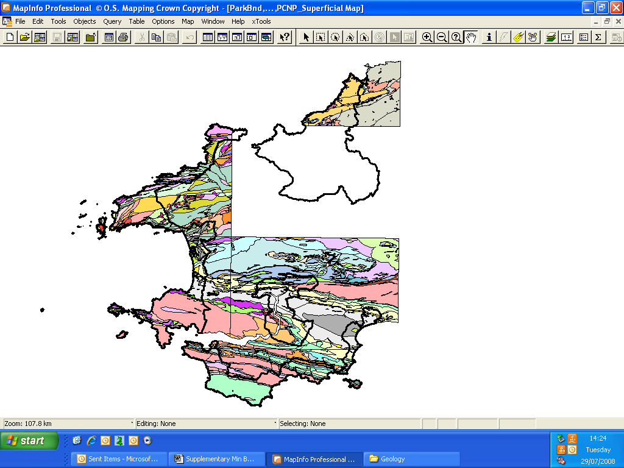

Principles of Safeguarding
The safeguarding areas do not indicate areas which can be worked. They are identified in order to ensure that areas of resource are not unnecessarily sterilised by permanent development. Any proposals for working within the lifetime of the Local Development Plan will be considered within the context of the preferred strategy for minerals and planning policy.

This has been framed by national and regional policy which advises that minerals within National Parks will only be worked in exceptional circumstances.

Areas where there is permanent existing development on top of the resources will be excluded from the safeguarding areas. Whilst environmental and landscape impact considerations have not been considered as part of this process, they will inevitably be a consideration in any future working, should individual proposals for local working come forward.

The resource identified has been safeguarded on the following basis

- That the safeguarding areas give no indication of the acceptability of working, and any working will be required to be in accord with National Guidance, including Minerals guidance, TANs and MTANs the Regional Technical Statement, November 2007 and the policies of the Local Development Plan.

These aim, in general, to reduce the level of mineral working in National Parks, in favour of working in more environmentally acceptable locations, and to allow working in exceptional circumstances only.

- No assessment has been made regarding the environmental acceptability of working. However it should be noted that very many of the safeguarding areas are either partly or entirely within areas of high environmental constraint, in addition to the National Park designation, including areas of international designation of Special Protection Areas, Special Area of Conservation, and national designations including Sites of Special Scientific Interest and Historic Landscapes.

- Minimum Size Safeguarding Areas of 1Ha. This relates to the polygon area identified within the BGS data for either a single site, or areas which adjoin each other and have been combined, even though there may be faulting or folds which in reality complicate this.

- Existing areas of Permanent Development are excluded. Areas are safeguarded so that they are not unnecessarily sterilised by permanent development. Resources under existing permanent development do not need to be safeguarded. This relates to centres identified within the LDP strategy, and other groups of dwellings. Existing isolated dwellings in the countryside are not excluded from safeguarding areas. Further, no buffer zone is indicated between existing development and the resource.

- Cross Boundary resource. Where the boundary of the resource extends into neighbouring authorities, only that part within the National Park has been safeguarded. Consultation with neighbouring authorities will take place to help achieve consistency.

- SAND AND GRAVEL
Sand and gravel occurs in several forms within the BGS data at RCS_D and other fields, and may be identified as blown sand and beach sand or alluvium. Safeguarding has only been undertaken where the description of the material is ‘sand and gravel’. In some cases this has been qualified as Diamicton, which in geological terms indicates that the material is poorly sorted. This can occur with glacial deposits, and indicates variation in lateral and vertical thickness, composition and texture. Such material is not considered suitable for safeguarding.

Resource Description (RCS_D)
CLAY, SILT, SAND AND GRAVEL
SAND AND GRAVEL
SAND, SILT AND CLAY
SAND
GRAVEL
DIAMICTON, SAND AND GRAVEL
CLAYEY GRAVEL

Not all of the above are considered viable safeguarding opportunities. Alluvium and beach deposits have been excluded as well as material containing clay and silt or diamicton material .This is to ensure that the most viable deposits are safeguarded. Areas over 1Ha have been considered. Sand and gravel under existing permanent development has been excluded.

The sand and gravel deposits for safeguarding are generally found in the north and west of the National Park.

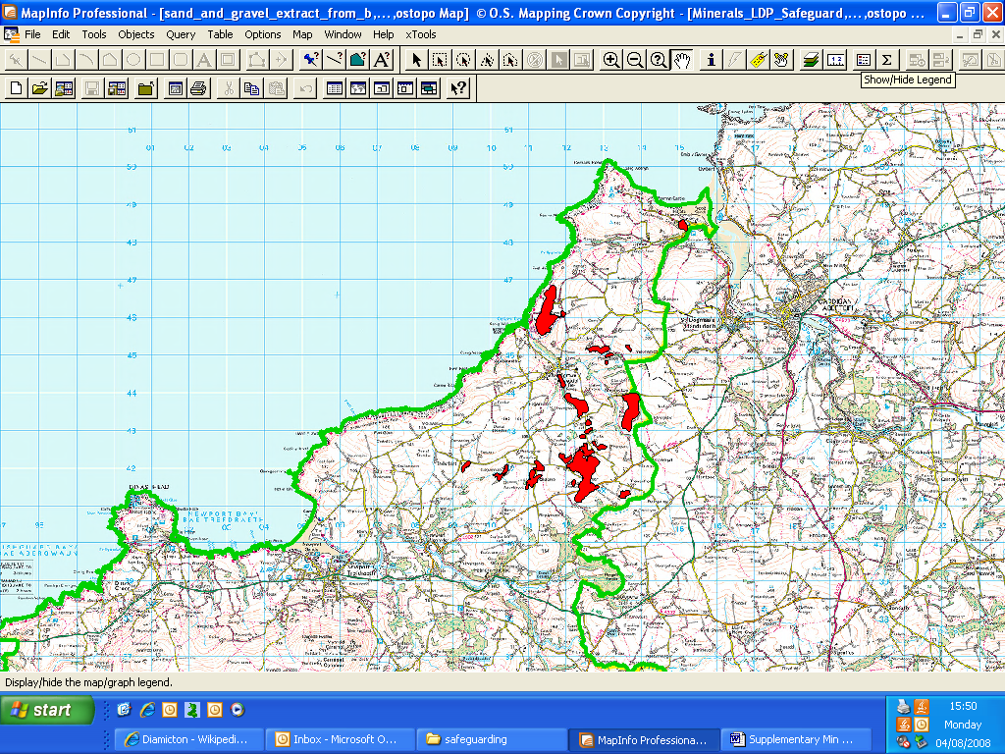

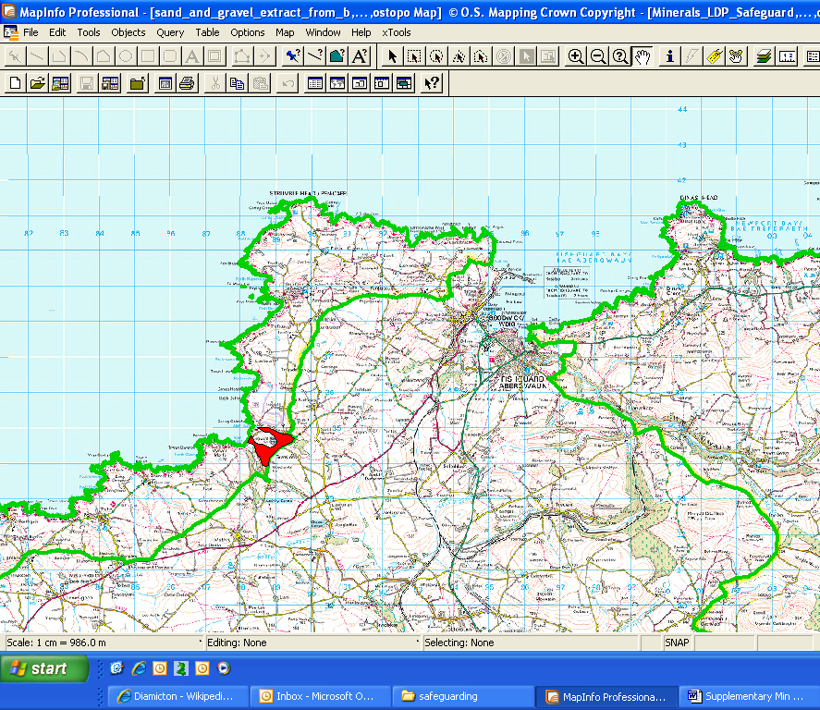

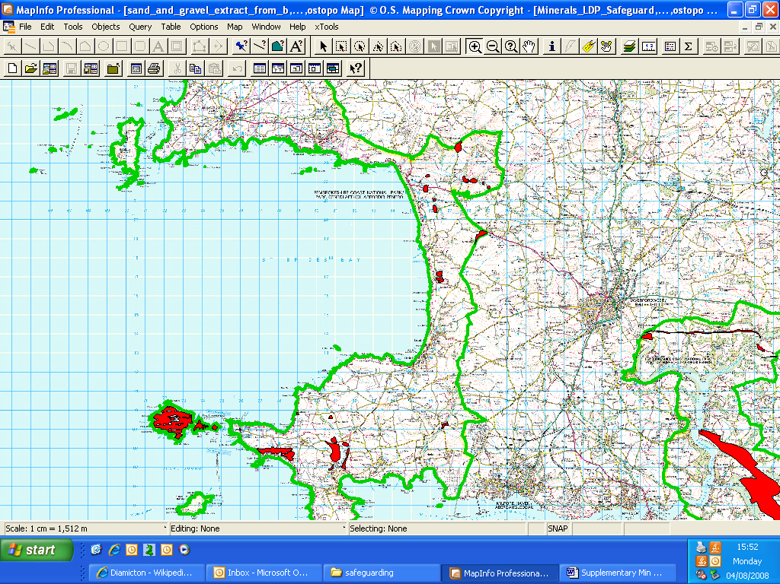

- Limestone
Limestone appears in Pembrokeshire in the following forms in RCS_D and other fields.

Resource Description
LIMESTONE
LIMESTONE, ARGILLACEOUS ROCKS AND SUBORDINATE SANDSTONE, INTERBEDDED
LIMESTONE AND MUDSTONE, INTERBEDDED

For the purposes of Safeguarding Limestone interbedded with other material has been excluded.

For the area of the National Park, the following is the resultant picture of limestone

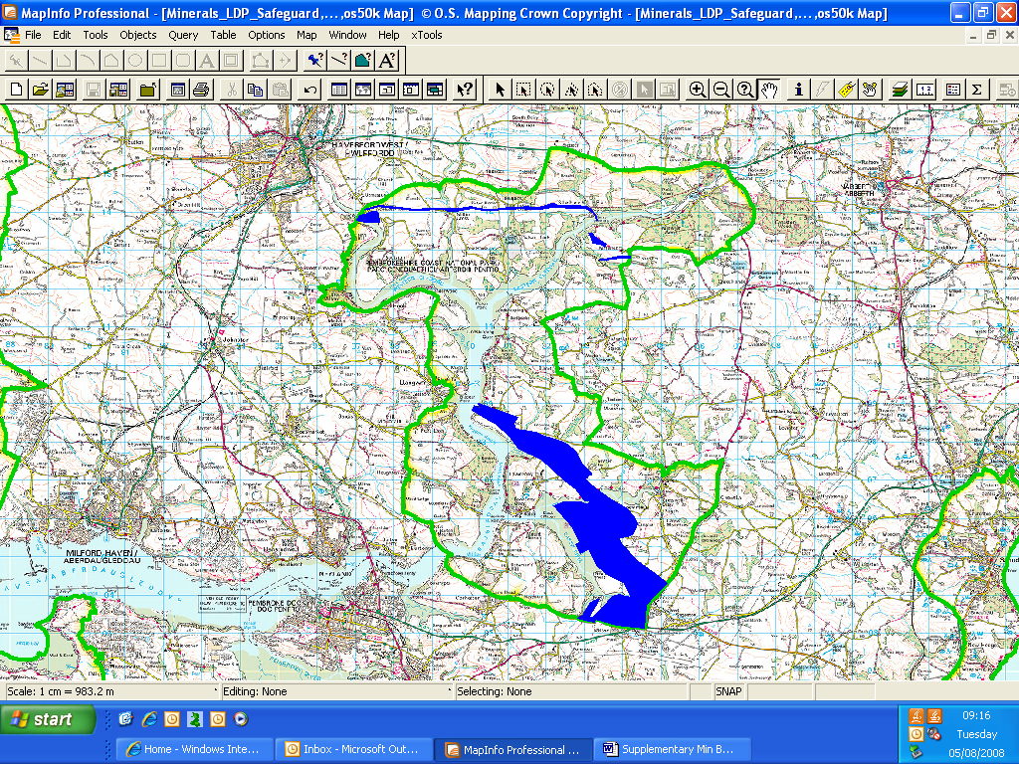

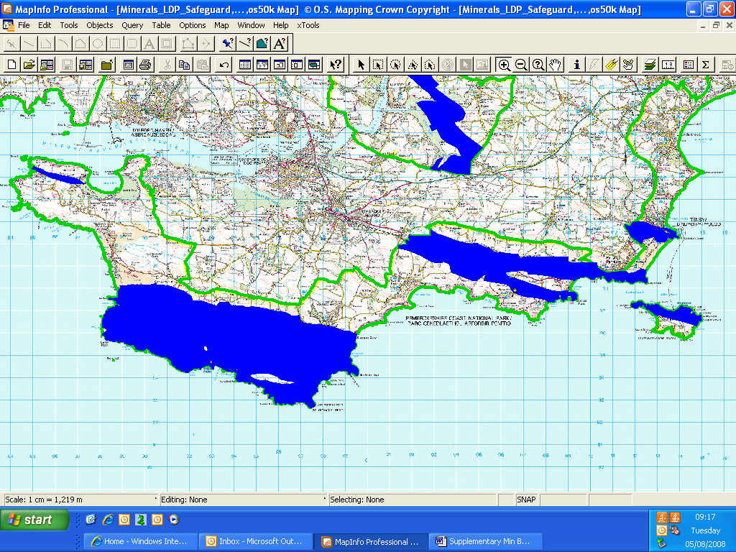

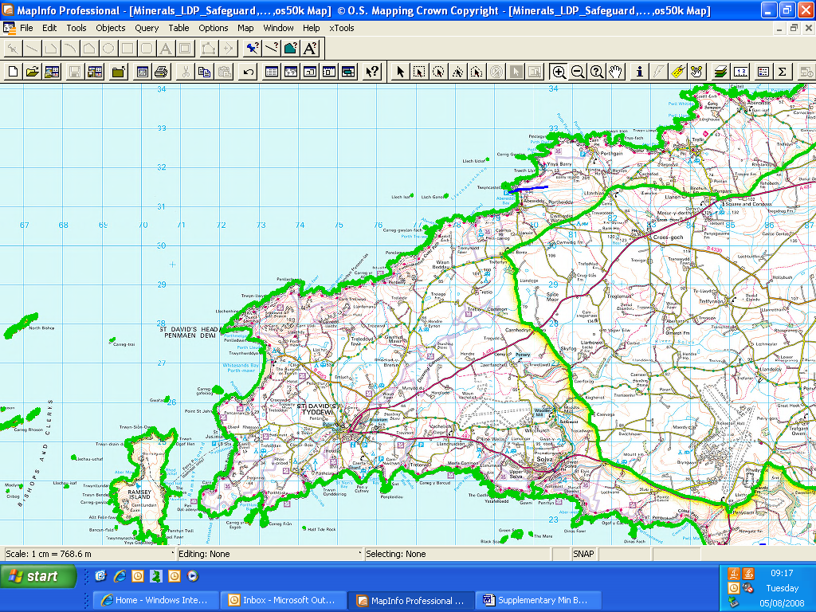

Gray Group Sandstone
This material is identified as a ‘high specification aggregate resource’ . It has been safeguarded within the following areas, which occur within the National Park.

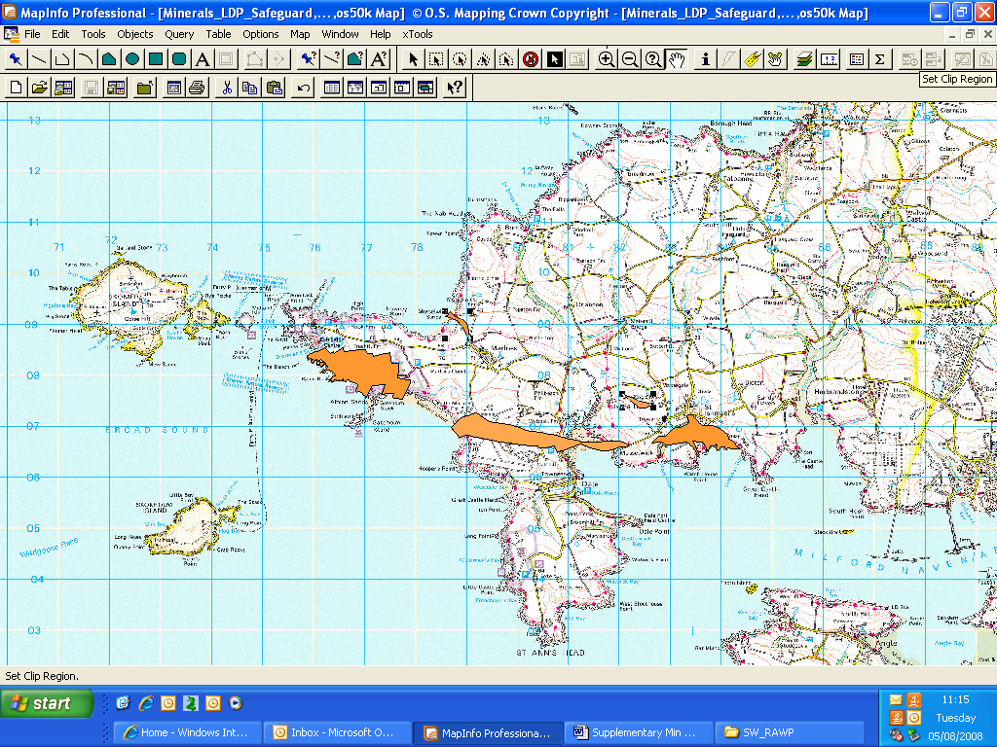

Welsh Assembly Government Safeguarding Research
The Welsh Assembly Government have commissioned the British Geological Survey to undertake a study of the potential options for safeguarding mineral resources within Wales. A Steering Group has also been set up to assist this process, and comprises representatives of the Mineral Planning Authorities, the Coal Authority, the Environment Agency, CCW and the minerals industry. The first meeting of the Steering Group took place in December 2008, and potential options for safeguarding to be considered in forthcoming months.

A pilot area has been identified for the study, which will be Pembrokeshire. The study is anticipated to be completed in 2009/ 2010.
A consultation event was held at Newtown on the 19th May 2009. A report of the outcomes of the consultation event is available at
http://www.bgs.ac.uk/mineralsuk/downloads/mins_map_wales_report.pdf
Break-out groups were used to facilitate debate, with each considering the following questions -
1) What is your opinion of the safeguarding of mineral resources?
2) What criteria should be considered when safeguarding mineral resources?
3) What content should be included in the “Guide to Mineral Information and Safeguarding” booklet?
4) What are your thoughts and comments about the format and content of the GIS and paper copy outputs?
5) How do you see the development of a sustainable mineral policy in the future?
6) What other issues do you think should be considered?

Pilot study mineral resources maps of Pembrokeshire were used to stimulate discussion, and demonstrations of a desktop Geographical Information System (GIS) and web-based GIS were presented.

Guidance on the final approach for safeguarding mineral resources in Wales has yet to be issued.
The launch date for the Minerals Map of Wales is still scheduled for the 8 June 2010 at the Welsh Planning Conference,

Appendix 1 Extract from RTS October 2008.

APPENDIX 21 Policy Setting for Aggregates Provision in National Parks and AONBs

MPPW (2000 para m21.22) states that mineral working in National Parks and AONBs should only take place in exceptional circumstances and indicates a set of related criteria. Similarly paras 23-24 refer to protection given to European protected sites. Referring specifically to aggregates, MTAN1 (paras 51-53) indicates clearly that plan allocations or approval of proposed working in National Parks and AONBs should only take place where no alternative environmentally acceptable sites are available and where other exceptional circumstances prevail. MTAN1 goes on to require that the RTS process should discuss and record the agreement of other areas (ie other MPAs) in taking on board the contribution which National Parks ands AONBs are unable to make. Paragraphs 54-69 refer to the need to give particular protection to other natural and cultural assets, most of which although no less significant, are affected through National Parks or AONBS. Those last two categories however, have a regionally strategic significance.

PPW (2002) states that special considerations apply to major development proposals within National Parks and AONBs, and that major developments should not take place except in exceptional circumstances (para 5.5.6). In March 2007, the Welsh Assembly Government produced a policy statement for National Parks and National Park Authorities in Wales. It identifies two key issues for mineral working (i) old permissions and (ii) safeguarding mineral resources (page 12).

Response

At the moment the BBNP and PCNP have significant permitted rock reserves easily able to cater for future production at recently experienced rates. The same is the not necessarily the case in respect of sand and gravel in PCNP [detailed checking is required] and certainly not for BBNP. Concerning the Gower and Wye Valley AONBs, those again need some detailed examination.

Whereas neither sets of policies above state categorically that aggregates should not be worked in such areas, nor do they insist that current operations should be closed or planning permissions relinquished (except by implication, in the case of dormant sites via Prohibition Notices), it is clear that where feasible, there is a general underlying desire to reduce the level of production in these designated areas . Furthermore, it is also clear that where possible, there should be no new provision (i.e. allocations in plans) in National Parks and AONBs”.

There is probably therefore an implied obligation (coupled with applying the proximity principle) that the RTS should at least explore the extent to which other MPAs closer to the main market areas, are able to meet the demand currently met from National Parks and AONBs.

The later section on Guidance to MPAs considers the sustainability of these protected areas in terms of the permitted reserves but will also examine the feasibility of the share presently being contributed by such areas, being covered by neighbouring authorities.

Whereas this could take many years to effect, with the cooperation of MPAs and industry over the next five years a much more rapid outcome may be achievable.

References
Minerals Planning Policy Wales, December 2000
http://wales.gov.uk/topics/planning/policy/minerals/mineralsplanning?lang=en
Minerals Planning Policy Wales, Welsh Assembly Government, 2000; Minerals Technical Advice Note (MTAN) Wales 1: Aggregates . Minerals, Technical Advice Note (MTAN) Wales 2: Coal http://wales.gov.uk/topics/planning/policy/mineralstans/?lang=en
South Wales Aggregates Working Party Annual report, 2007
http://www.swrawp-wales.org.uk/Html/publications.html
Joint Unitary Development Plan for Pembrokeshire 2000-2016 http://www.pembrokeshire.gov.uk/content.asp?nav=109,141&parent_directory_id=646&id=5058
Pembrokeshire Coast National Park Management Plan 2009-2013
http://www.pcnpa.org.uk/website/default.asp?SID=1258&SkinID=5

Regional Technical Statement for Aggregates – SWRAWP, October 2008.
http://www.swrawp-wales.org.uk/Html/publications.html

Web links accessed 10th December 2009

Currently awaiting formal publication

