     | Pembrokeshire Visitor Survey
Report Prepared by



Research and Marketing Ltd
Trefor House
Ocean Way
CF24 5RE

(T) 029 2043 5800
(F) 029 2048 3540
(E) info@rmltd.net

December 2004 | Final Report

Table of Contents

Table of Contents 2

Table of Figures 3

Executive Summary 4

1.0 Introduction 10
1.1 Project Overview 10
1.2 The Research Objectives 10

2.0 Methodology 11
2.1 Introduction 11
2.2 Face-to Face Interviews 11
2.3 Self-Completion Questionnaires 12

3.0 Main Findings 13
3.1 Introduction 13
3.2 Visitor Characteristics 13
3.3 Holiday Characteristics 15
3.4 The Pembrokeshire Holiday Experience 16
3.5 Evaluation and Summary of the Holiday Experience 21

4.0 Self Completion Questionnaire 23

5.0 Summary and Conclusions 27

6.0 Appendices 28
6.1 Copy of Face-to-Face Questionnaire. 28
6.2 Copy of Self-Completion Questionnaire. 36

Table of Figures

Table 2.1 – The number of Face-to-Face interviews completed. 11
Table 2.2 – Self-Completion Questionnaires Returned. 12

Figure 3.1 – Age of Respondents 13
Figure 3.2 –Socio Economic Classification of the Visitor’s Group/ Party 14
Figure 3.3 – Average Size of Group/ Party 14
Figure 3.4 – Origin of Visitors 15
Figure 3.5 – Features and attractions of Pembrokeshire (Unprompted) 16
Figure 3.6 – Mode of transport used to travel to Pembrokeshire 16
Figure 3.7 – Importance attached to the holiday. 17
Figure 3.8 – Holiday activities taken part in. 18
Figure 3.9 – Places visited on the holiday 18
Figure 3.10 – Type of accommodation staying in (Total). 19
Table 3.11 – Total Overall Rating of Paid Accommodation (% Very Good) 19
Figure 3.12 – Time of booking accommodation. 20
Table 3.13 – Sources of Information used about Pembrokeshire 20
Figure 3.14 – Overall experience of Pembrokeshire (rated Very Good). 21
Figure 3.15 – Pembrokeshire rated for value for money 22
Figure 3.16 – Likelihood to return in next 12 months/ 5 years 22

Table 4.1: Factors Important to the Holiday 23
Table 4.2: Rate Experience of … 23
Figure 4.3: Activities Undertaken 24
Figure 4.4: Likelihood to return within 12 months or in Next 5 Years 24
Table 4.5: Sources of Information used about Pembrokeshire 25
Table 4.6: General Comments on Pembrokeshire 25
Table 4.7: Gender of Respondents 25
Table 4.8: Age Group of Respondents 26
Table 4.9: Socio Economic Group of Respondents 26
Table 4.10: Residency of Respondents 26

Crynodeb Gweithredol

Trosolwg o’r Prosiect

Comisiynwyd Research and Marketing Cyf gan Gyngor Sir Penfro mewn cysylltiad ag Awdurdod Parc Cenedlaethol Arfordir Penfro, Bwrdd Croeso Cymru, Awdurdod Datblygu Cymru a Phartneriaeth Twristiaeth De Orllewin Cymru i gynnal Arolwg Ymwelwyr ar draws Sir Benfro am gyfnod deuddeg-mis hyd fis Tachwedd 2004.

Prif nod yr ymchwil oedd datblygu gwell dealltwriaeth o ymwelwyr i ardal Sir Benfro er mwyn i’r Cyngor dargedu ei wasanaethau mewn ffordd addas ac i hybu gallu’r Cyngor i werthuso newid mewn agweddau at welliannau a datblygiadau.

- Casglu barn a sylwadau ymwelwyr i Sir Benfro.
- Penderfynu pa weithgareddau sydd fwyaf poblogaidd gydag ymwelwyr a pha weithgareddau sydd angen eu datblygu.
- Gwerthuso os yw’r cyfleusterau, digwyddiadau a gweithgaredd marchnata presennol yn ateb anghenion ymwelwyr i Sir Benfro.
- Dynodi dynesiadau i wneud Sir Benfro yn fwy deniadol i ddarpar ymwelwyr ac ymwelwyr gwirioneddol.
- Gwerthuso a graddio’r stoc llety sydd ar gael ar hyn o bryd.
- Dynodi disgwyliadau ymwelwyr a’u cymhellion wrth ddewis eu gwyliau
- Canfod lefel boddhad cyffredinol eu hymweliad.
- Mesur yr ymwybyddiaeth o atyniadau ymwelwyr lleol.
- Penderfynu pa mor debygol ydynt o ddychwelyd i Sir Benfro.

Methodoleg

Roedd y fethodoleg ymchwil a fabwysiadwyd yn cynnwys dau holiadur ar wahân, pob un yn anelu i fynd i’r afael â’r prif amcanion ac amcanion eilaidd a amlinellwyd yn flaenorol. Roedd y cyntaf yn gyfres o gyfweliadau wyneb-i-wyneb a gynhaliwyd ar draws Sir Benfro drwy gydol y flwyddyn a’r ail yn arolwg hunan-lenwi a ddosbarthwyd mewn nifer o safleoedd darparwyr gweithgareddau awyr agored.

Dechreuodd yr ymarferiad ymchwil wyneb-i-wyneb ym mis Rhagfyr 2003, gyda tharged wedi ei osod ar gyfer cyfweliadau am bob chwarter, i’w gwasgaru’n gymharol wastad ar draws y misoedd. Cwblhawyd cyfanswm o 1,446 o gyfweliadau dros y cyfnod 12 mis. Cynhaliwyd 96 yn fwy o gyfweliadau na’r cwota a dim ond mewn dau o’r misoedd y methwyd cyrraedd y cwota targed. Derbyniwyd cyfanswm o 193 holiadur hunan-lenwi.

Nodweddion Ymwelwyr

- Roedd 50.8% yn Wrywod a 49.2% yn Fenywod.
- Roedd y gyfran fwyaf o ymwelwyr yn 45 – 54 oed (21.0%), gyda tua un ym mhob pump o’r ymatebwyr yn 35-44 oed, 55 – 64 oed a 65 oed neu hŷn.
- Roedd 40.2% o’r ymwelwyr i Sir Benfro yn perthyn i grŵp economaidd gymdeithasol AB a 36.7% yn perthyn i grŵp C1.
- Maint cyfartalog y grŵp/parti yn ymweld â Sir Benfro oedd 3.33, gyda maint y parti yn amrywio drwy gydol y flwyddyn gan gyrraedd ei frig yn yr ail chwarter yn 3.57 o bobl a 3.49 o bobl yn y trydydd chwarter.
- Ymwelwyr i Sir Benfro o Gymru oedd y gyfran fwyaf o gyfanswm ymwelwyr (34.0%).

Nodweddion Gwyliau

- Ymwelodd naw allan o ddeg ymwelydd i Sir Benfro ar gyfer rhesymau ‘gwyliau neu hamdden’ a 8.4% i ymweld â ffrindiau.
- Y cyfnod arhosiad mwyaf poblogaidd oedd gwyliau o un wythnos (29.1%) a gwyliau byr o 1-3 noson (30.4%), gyda 14.2% o ymwelwyr yn ymweld ar drip dydd i Sir Benfro.
- Dywedodd mwyafrif yr ymatebwyr nad eu hymweliad i Sir Benfro oedd eu prif wyliau yn y flwyddyn.
- Y ddau brif reswm pam y dewisodd pobl ymweld â Sir Benfro oedd ei ‘harfordir deniadol’ (45.8%) a’u bod wedi ymweld o’r blaen (48.7%).
- Gofynnwyd i ymwelwyr ‘heb eu cymell’ hefyd am y nodweddion a’r atyniadau oedd wedi eu denu i Sir Benfro. Y prif resymau oedd y Traethau a’r Arfordir (91.1% o’r holl ymatebwyr), gyda’r rhesymau eraill yn cynnwys ‘Treftadaeth’, ‘Natur a Bywyd Gwyllt’ a ‘y Parc Cenedlaethol’.

Profiad Gwyliau Sir Benfro

- Teithiodd mwyafrif (91.1%) ymwelwyr i Sir Benfro gyda char. Dulliau eraill o drafnidiaeth a ddefnyddiwyd oedd bws/coets (3.0%) a thrên (2.5%).
- Y prif feysydd o bwysigrwydd a gysylltwyd â’r profiad cyn gwyliau oedd golygfeydd naturiol, diwylliant, heddwch a thawelwch, cyfeillgar i’r teulu a cherdded. Rhagorwyd ar yr holl ddisgwyliadau dechreuol yn nhermau’r profiad cyffredinol a chafodd yr holl ffactorau eu graddio mewn modd cadarnhaol yn ystod y gwyliau.
- Dinbych y Pysgod (28.1%) a Tyddewi (12.4%) oedd y lleoliadau mwyaf poblogaidd i aros ynddynt, roedd ardaloedd eraill yn cynnwys Saundersfoot (11.6%) ac Arberth (6.7%).
- Cymerodd y rhan fwyaf o bobl ran mewn ‘cerdded’ (69.7%), ‘tripiau cwch’ (14%) a 7.8% ‘adara’.
- Y tri lle yr ymwelwyd mwyaf â hwy yn Sir Benfro oedd ‘Arfordir a Thraethau’ (87.3%), ‘Cefn Gwlad’ (75.2%) a ‘Cestyll a Threftadaeth’ (60.2%).
- Y math o lety oedd orau gan ymwelwyr yn aros yn Sir Benfro oedd hunan-ddarpar (28%), gyda 16% yn aros mewn gwesty.
- Yn nhermau ymwelwyr a dalodd am eu llety h.y. heb fod yn aros gyda ffrindiau neu eu carafan neu eiddo eu hunain, graddiodd 88.9% o ymwelwyr y llety fel bod yn ‘dda iawn’ yn gyffredinol, gyda dim ond 1.2% yn ei raddio yn ‘Wael’ neu ‘Wael Iawn’.
- Carfanau sefydlog ar rent gafodd y graddiad mwyaf ffafriol ar gyfer llety yn gyffredinol (91.9% wedi eu graddio fel da iawn), gyda Gwely a Brecwast (91.5%) a llety Hunan-Ddarpar (90.6%) yn dilyn yn agos. Cafodd gwestai eu graddio’n llai ffafriol yn gyffredinol ac yn neilltuol o ran addurniad a gwerth am arian o gymharu gyda’r prif fathau eraill o lety.
- Roedd y cyfnod arweiniol yn nhermau pobl yn cynllunio eu hymweliad i Sir Benfro yn amrywio drwy gydol y flwyddyn, gyda’r gyfran yn archebu mwyaf ymlaen llaw yn y trydydd chwarter gyda 44.% yn archebu o leiaf dri mis ymlaen llaw.
- Y ffynhonnell mwyaf poblogaidd o wybodaeth ar Sir Benfro oedd ‘profiad blaenorol’ (55.9%) a’r Rhyngrwyd oedd yr ail ffynhonnell mwyaf poblogaidd (16.0%).

Gwerthusiad a Chrynodeb o’r Profiad Gwyliau

- Roedd mwyafrif yr ymwelwyr i Sir Benfro yn hapus iawn gyda’r profiad cyffredinol o ymweld â Sir Benfro. Yn neilltuol, roedd ymwelwyr yn gwerthfawrogi’r croeso cynnes a glanweithdra traethau fel y ddwy brif ffactor a raddiwyd yn dda iawn.
- Yn nhermau gwerth am arian, graddiodd y rhan fwyaf o’r ymatebwyr Sir Benfro fel un ai ‘Gwerth Da am Arian’ neu ‘Gwerth Da Iawn am Arian’ gyda tua thraean yr ymatebwyr yn ei raddio fel ‘Gwerth Da Iawn am Arian’.
- Dywedodd mwyafrif yr ymatebwyr eu bod yn debyg o ddychwelyd i Sir Benfro o fewn y 12 mis neu 5 mlynedd nesaf.

Executive Summary

Project Overview

Pembrokeshire County Council in association with Pembrokeshire Coast National Park Authority, Wales Tourist Board, Welsh Development Agency and South West Wales Tourism Partnership commissioned Research and Marketing Ltd to undertake a Visitor Survey across Pembrokeshire for a twelve-month period to November 2004.

The principal aim of the research was to develop a better understanding of visitors to the Pembrokeshire area, in order for the Council to target services appropriately and to enhance the Council’s ability to evaluate changing attitudes to improvements and developments.

- Ascertain the views and opinions of visitors to Pembrokeshire.
- Determine which activities are most popular with visitors and those that need to be developed.
- Evaluate whether the facilities, events and current marketing activity are meeting the needs of visitors to Pembrokeshire.
- Identify approaches to make Pembrokeshire more appealing to potential and actual visitors.
- Evaluate and rate the current available accommodation stock.
- Identify visitor expectations and motivations in the choice of their holiday.
- Establish the level of overall satisfaction of their visit.
- Measure the awareness of local visitor attractions.
- Determine the likelihood of returning to Pembrokeshire.

Methodology

The research methodology adopted consisted of two separate questionnaires, each aiming to address the principal and secondary objectives outlined previously. The first was a series of face-to-face interviews conducted across Pembrokeshire throughout the year and the second a self-completion survey distributed at a number of outdoor activity providers.

The face-to-face research exercise began in December 2003, with a target set for interviews for each quarter, to be spread relatively evenly across the months. In total 1,446 interviews were completed over the 12 month period and we exceeded the quotas by 96 interviews and only missed the target quota in two of the months. In total 193 self-completion questionnaires were returned.

Visitor Characteristics

- 50.8% were Male and 49.2% were Female.
- The largest proportion of visitors were aged 45 – 54 years (21.0%), with around one fifth of respondents aged 35-44 years, 55 – 64 years and 65 years or older.
- 30.2% of the visitors to Pembrokeshire were classified as socio economic group AB and 36.7% as C1.
- The average size of the group/party visiting Pembrokeshire was 3.33, the size of the party varied throughout the year, with it peaking in quarter two at 3.57 people and 3.49 people in quarter three.
- Visitors to Pembrokeshire from Wales accounted for the largest proportion of total visitors (34.0%).

Holiday Characteristics

- Nine out of ten visitors to Pembrokeshire visited for ‘holiday or leisure’ reasons and 8.4% to visit friends.
- The most popular length of stay was a holiday of one week (29.1%) and a short break of 1-3 nights (30.4%), with 14.2% of visitors visiting on a day trip to Pembrokeshire.
- The majority of respondents stated that their visit to Pembrokeshire was not their main holiday of the year.
- The two main reasons why people chose to visit Pembrokeshire were its ‘attractive coast’ (45.8%) and that they had visited before (48.7%).
- Visitors were also asked ‘unprompted,’ those features and attractions that had attracted them to Pembrokeshire. The main reasons were the Beaches and Coast (91.1% of all respondents), with the other reasons including ‘Heritage’, ‘Nature & Wildlife’ and ‘the National Park’.

The Pembrokeshire Holiday Experience

- The majority (91.1%) of visitors to Pembrokeshire travelled by Car. Other modes of transport used were the bus/coach (3.0%) and the train (2.5%).
- The main areas of importance attached to the pre holiday experience were those of unspoilt scenery, culture, peace & quiet, family friendly and walking. In terms of the overall experience all initial expectations were surpassed and all the factors were rated in a positive manner following the holiday.
- Tenby (28.1%) and St David’s (12.4%) were the most popular locations to stay; other areas included Saundersfoot (11.6%) and Narberth (6.7%).
- The majority of people took part in ‘walking’ (69.7%), ‘boat trips’ (14%) and 7.8% ‘bird watching’.
- The three most visited places in Pembrokeshire were ‘Coast and Beaches’ (87.3%), ‘Countryside’ (75.2%) and ‘Castles & Heritage sites’ (60.2%).
- The preferred type of accommodation for visitors staying in Pembrokeshire was self-catering (28%), with 16% staying in a hotel.
- In terms of visitors that had paid for their accommodation i.e. not staying with friends or own caravan or property, 88.9% of visitors rated the accommodation ‘very good’ overall, with only 1.2% rating it as ‘Poor’ or ‘Very Poor’.
- Rented static caravans received the most favourable overall rating of accommodation (91.9% rated as very good), closely followed by Bed and Breakfast (91.5%) and Self Catering accommodation (90.6%). Hotels were rated less favourably overall and in particular in terms of décor and value for money in comparison to the other main types of accommodation.
- The lead time in terms of people planning their visit to Pembrokeshire varied throughout the year, with the proportion booking the most in advance in quarter three with 44.8% booking at least three months in advance.
- The most popular source of information on Pembrokeshire was that of ‘previous experience’ (55.9%) and the second most popular source was the Internet (16.0%).

Evaluation and Summary of the Holiday Experience

- The majority of visitors to Pembrokeshire were very happy with the overall experience of visiting Pembrokeshire. In particular, visitors rated the warmth of welcome and the cleanliness of beaches as the two main factors rated as very good.
- In terms of value for money, the majority of respondents rated Pembrokeshire as either ‘Good Value’ or ‘Very Good Value’, with around one third of respondents rating it as ‘Very Good Value’.
- The majority of respondents stated that they were likely to return to Pembrokeshire within the next 12 months or 5 years.

1.0 Introduction

1.1 Project Overview

Pembrokeshire County Council in association with Pembrokeshire Coast National Park Authority, Wales Tourist Board, Welsh Development Agency and South West Wales Tourism Partnership commissioned Research and Marketing Ltd to undertake a Visitor Survey across Pembrokeshire for a twelve-month period to November 2004.

This report provides an overview of the results for the full year and includes sub analysis of the results for each of the quarters.

1.2 The Research Objectives

The principle aim of the research was to develop a better understanding of visitors to the Pembrokeshire area, in order for the council to target services appropriately and to enhance the Council’s ability to evaluate changing attitudes to improvements and developments and address the following objectives:

- Identify visitor expectations and motivations in the choice of their holiday.
- Establish the level of overall satisfaction of their visit.
- Ascertain the views and opinions of visitors to Pembrokeshire.
- Determine which activities are most popular with visitors and those that need to be developed.
- Evaluate whether the facilities, events and current marketing activity are meeting the needs of visitors to Pembrokeshire.
- Identify approaches to make Pembrokeshire more appealing to potential and actual visitors.
- Evaluate and rate the current available accommodation stock.
- Measure the awareness of local visitor attractions.
- Determine the likelihood of returning to Pembrokeshire.

2.0 Methodology

2.1 Introduction

The research methodology adopted consisted of two separate questionnaires, each aiming to address the principal and secondary objectives outlined previously. The first was a series of face-to-face interviews conducted across Pembrokeshire throughout the year and the second was a self-completion survey distributed at a number of outdoor activity providers.

2.2 Face-to Face Interviews

The face-to-face research exercise began in December 2003, with a target set for interviews for each quarter, to be spread relatively evenly across the months. As can be seen from Figure 2.1 below, over the 12 month period we exceeded the quotas by 96 interviews and only missed the target quota in two of the months.

Table 2.1 – The number of Face-to-Face interviews completed.

 | Month | Target Number of Interviews | Interviews Achieved | +/ - Target
WINTER | January | 75 | 46 | -29
WINTER | February | 75 | 112 | 37
WINTER | March | 75 | 97 | 22
WINTER | SUB TOTAL | 225 | 255 | 30
SPRING | April | 150 | 157 | 7
SPRING | May | 150 | 161 | 11
SPRING | June | 150 | 160 | 10
SPRING | SUB TOTAL | 450 | 478 | 28
SUMMER | July | 150 | 161 | 11
SUMMER | August | 150 | 160 | 10
SUMMER | September | 150 | 160 | 10
SUMMER | SUB TOTAL | 450 | 481 | 31
AUTUMN | October | 75 | 88 | 13
AUTUMN | November | 75 | 69 | -6
AUTUMN | December (2003) | 75 | 75 | 0
AUTUMN | SUB TOTAL | 225 | 232 | 7
TOTAL |  | 1,350 | 1,446 | 96

The questionnaire comprises the following sections:

- Holiday Expectations.
- Accommodation.
- Travel and Public Transport Services.
- Overall attitude and experience of Pembrokeshire.
- Visitor Demographics.

A copy of the questionnaire used by our fieldworkers is contained within section 6.1.

2.3 Self-Completion Questionnaires

Table 2.2 – Self-Completion Questionnaires Returned.

Month Visited | Questionnaires
December | -
January | -
February | -
March | -
SUB TOTAL | -
April | 12
May | 13
June | 17
SUB TOTAL | 42
July | 57
August | 68
September | 24
SUB TOTAL | 149
October | -
November | -
 | 193

We distributed questionnaires to the following sites across Pembrokeshire:

- PCNPA Newport Visitor Centre - Newport.
- Haverfordwest TIC – Haverfordwest
- Pembroke TIC – Pembroke
- Pen-y-Cwm Youth Hostel (Solva) - St Davids.
- Manorbier Youth Hostel – Tenby
- East Nolton Riding Stables - Nolton, Haverfordwest,
- West Wales Wind, Surf and Sail, Dale, Haverfordwest
- Welsh Wildlife Centre, Cilgerran

In total 193 self-completion questionnaires were returned. A copy of the questionnaire is enclosed in Appendix 6.2. We visited each of the sites on a monthly basis to ensure that were enough copies on display and that the material was displayed in a prominent position.

3.0 Main Findings

Introduction

The following section provides an overview of the key findings. This is the final report on the Pembrokeshire Visitors Survey. The report contains where relevant, trend comparisons between all four quarters, as well as the total responses to date.

Detailed tables are provided as additional reports.

3.2 Visitor Characteristics

As indicated in Table 2.1, 1,446 face-to-face interviews were completed over the twelve month period and of those surveyed 50.8% were Male and 49.2% were Female.

The largest proportion of visitors were aged 45 – 54 years (21.0%), around one fifth of respondents were each aged 35-44 years, 55 – 64 years or 65 years or older. In quarter four the age distribution was skewed toward the older age cohorts with 71.5% of respondents aged 45 years or older (Figure 3.1).

Figure 3.1 – Age of Respondents
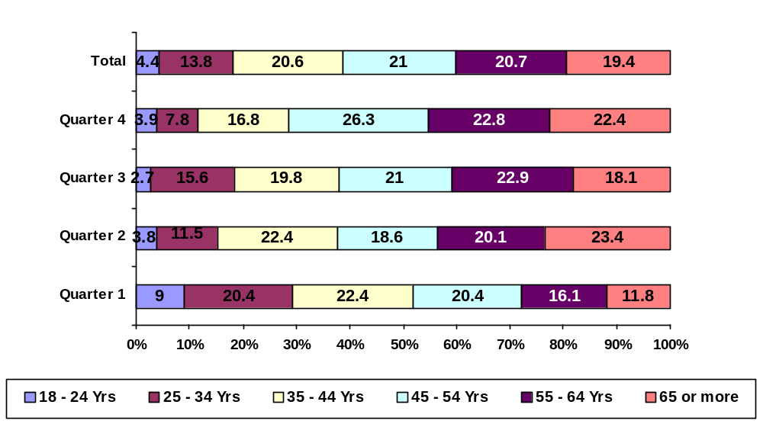
Base – 1466 Respondents

In terms of socio - economic grouping, 30.2% of the total visitors to Pembrokeshire were classified as AB and 36.7% as C1, indicating that two thirds of the visitors were from a high socio economic background (Figure 3.2). However, during the year, the proportion of AB and C1 visitors declined from the initial proportions identified in quarter one, but increased in quarter four, with them accounting for 66.9% of the population.

Figure 3.2 –Socio Economic Classification of the Visitor’s Group/ Party
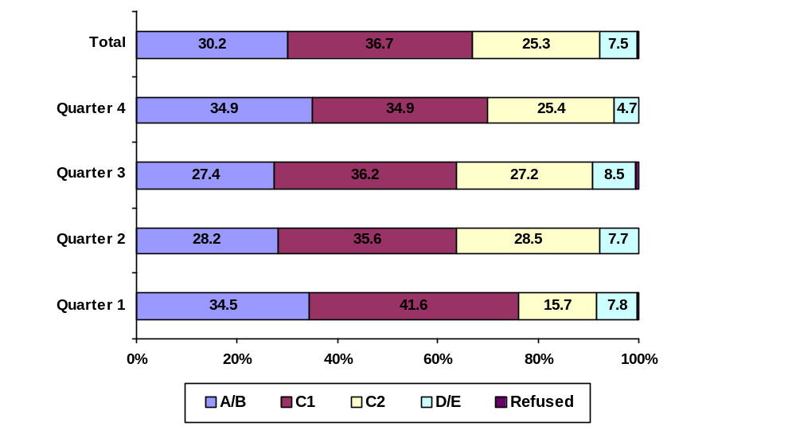
Base – 1,446 Respondents

The average size of the group/party visiting Pembrokeshire was 3.33, the size of the party varied throughout the year with it peaking in quarter two at 3.57 people and 3.49 people in quarter three. Within the different age groups, the size of the party varied, with those aged 18-24 years and 35-44 years typically in a larger group compared to those aged 55 years or more (Figure 3.3).

Figure 3.3 – Average Size of Group/ Party

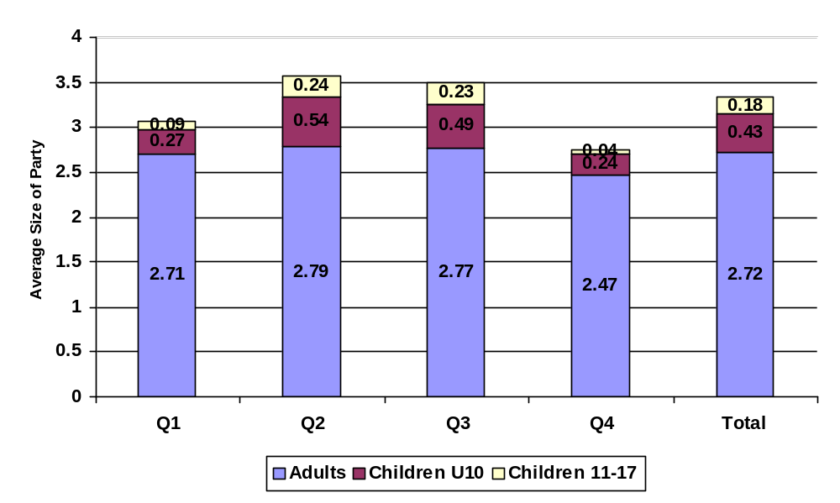
Base – 1,466 Respondents

The proportion of visitors to Pembrokeshire from Wales declined from 42.4% in quarter one to 29.5% in quarter three, but overall visitors from Wales accounted for the largest proportion of total visitors (34.0%). Interestingly, the distribution amongst the other proportions of visitors remained fairly consistent over the twelve months.

(Refer to http://www.statistics.gov.uk/geography/downloads/uk_gor_cty1.pdf for a map of UK Regions and Local Authority areas)

Figure 3.4 – Origin of Visitors
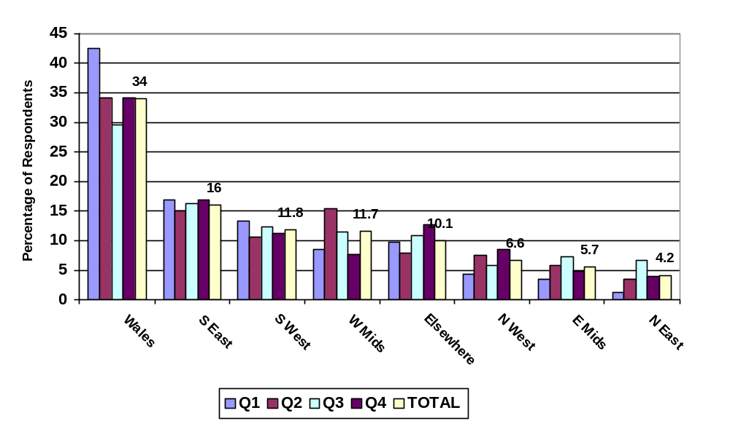
Base – 1,466 Respondents

3.3 Holiday Characteristics

Nine out of ten visitors to Pembrokeshire visited for ‘holiday or leisure’ reasons and 8.4% to visit friends. In terms of the length of stay on holiday, the most popular period was a holiday of one week (29.1%) and a short break of 1-3 nights (30.4%), with 14.2% of visitors visiting on a day trip to Pembrokeshire. The majority of respondents stated that their visit to Pembrokeshire was not their main holiday of the year.

The two main reasons why people chose to visit Pembrokeshire were its ‘attractive coast’ (45.8%) and that they had visited before (48.7%). The other reasons people chose to visit Pembrokeshire included its ‘Attractive Countryside’; ‘Peacefulness’ and ‘Heritage’.

Visitors were also asked ‘unprompted,’ those features and attractions that had attracted them to Pembrokeshire. The main reason was that of the Beaches and Coast (91.1% of all respondents), with the other reasons including ‘Heritage’, ‘Nature & Wildlife’ and ‘the National Park’.

Figure 3.5 – Features and attractions of Pembrokeshire (Unprompted)
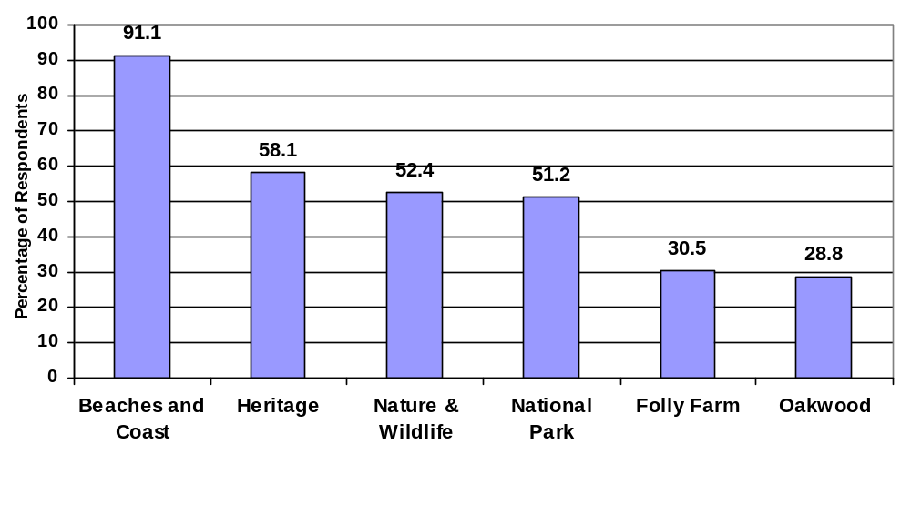
Base – 1,466 Respondents

The Pembrokeshire Holiday Experience

The majority (91.1%) of visitors to Pembrokeshire travelled by Car, with 93.3% in quarter three, the largest proportion. Other modes of transport used were the bus/coach (3.0%) and the train (2.5%).

Figure 3.6 – Mode of transport used to travel to Pembrokeshire
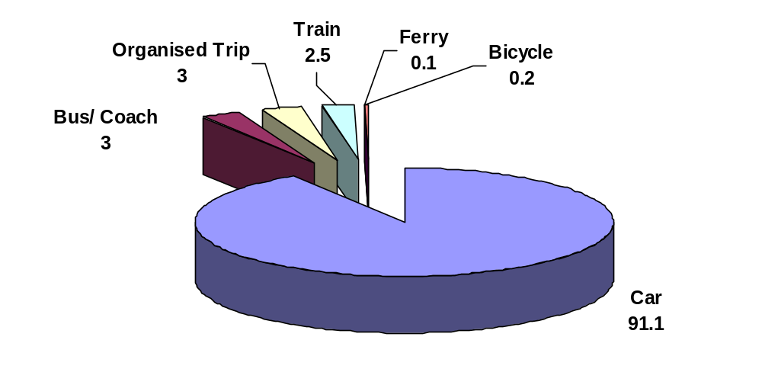
Base – 1,466 Respondents

Figure 3.7 provides a comparison of the anticipated holiday and that actually experienced. Each of the factors is rated on a ‘sliding positive to negative scale’ of between +2 (very important/very good) to –2 (very unimportant/ very poor). As can be seen from the graph the main areas of importance attached to the pre holiday experience were those of unspoilt scenery, culture, peace & quiet, quality accommodation, with the remaining factors deemed as of very little importance to the overall holiday. In terms of the overall experience of the holiday all initial expectations were surpassed and all the factors were rated in a positive manner following the holiday.

Figure 3.7 – Importance attached to the holiday.
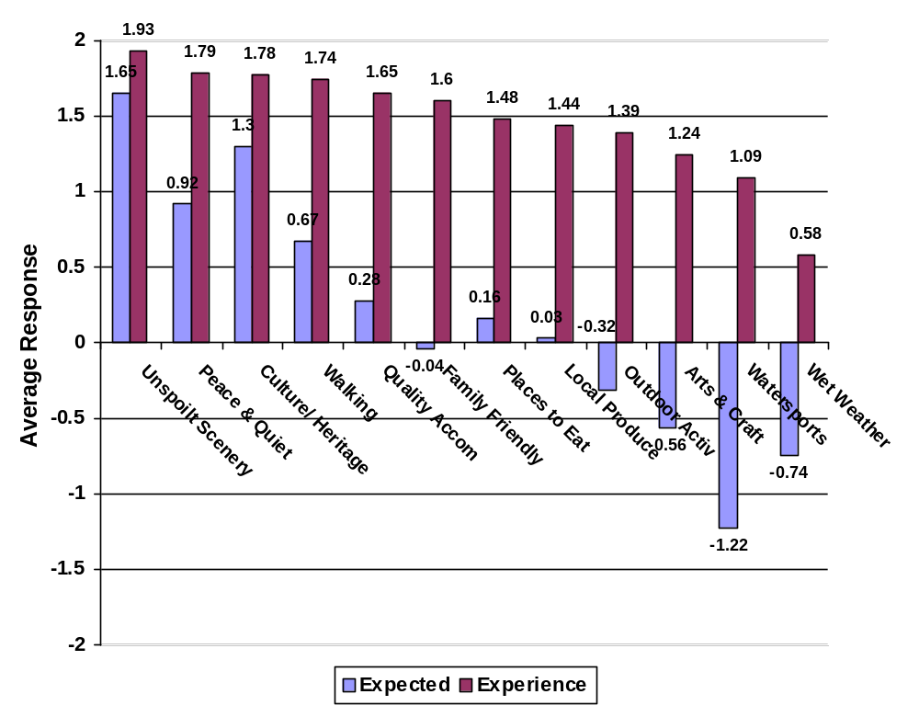Base – 1,466 Respondents

Visitors were asked where they were staying during their visit to Pembrokeshire. The results identified that Tenby (28.1%) and St David’s (12.4%) were the most popular locations; other areas included Saundersfoot (11.6%) and Narberth (6.7%).

Figure 3.8 illustrates that there has been greater participation in activities over the year, with seasonal activities increasing in particular within quarter three e.g. with one in four visitors taking part in a boat trip compared to only one in twenty in quarter one. Overall, the majority of people took part in ‘walking’ (69.7%), ‘boat trips’ (14%) and 7.8% ‘bird watching’.

The three most visited places in Pembrokeshire were ‘Coast and Beaches’ (87.3%), ‘Countryside’ (75.2%) and ‘Castles & Heritage sites’ (60.2%) (Figure 3.9).

Figure 3.8 – Holiday activities taken part in.
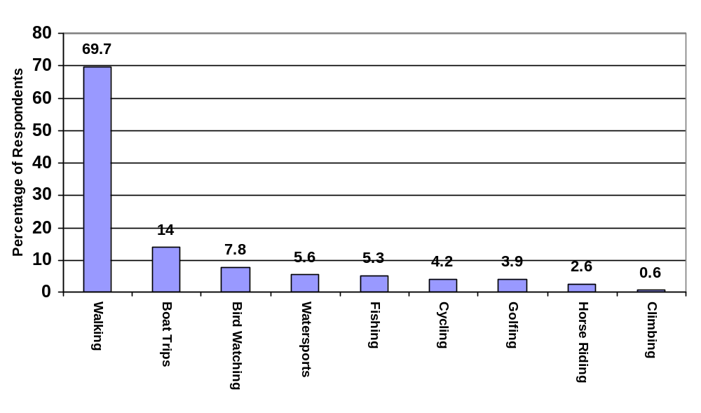
Base – 1,466 Respondents

Figure 3.9 – Places visited on the holiday
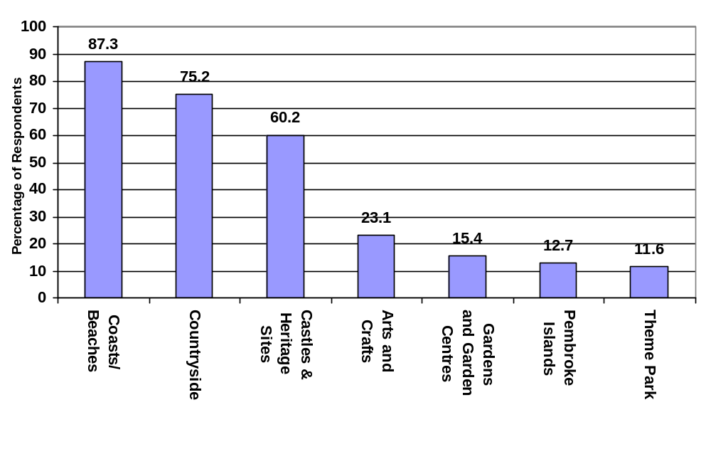
Base – 1,466 Respondents

The preferred type of accommodation for visitors staying in Pembrokeshire was self-catering (28%), with 16% staying in a hotel. The preferred type of accommodation varied throughout the year, with seasonal variations in occupancy e.g. ‘touring’ increased in quarter three above the proportions in quarter one and two (2.7% and 9.8% respectively).

Figure 3.10 – Type of accommodation staying in (Total).
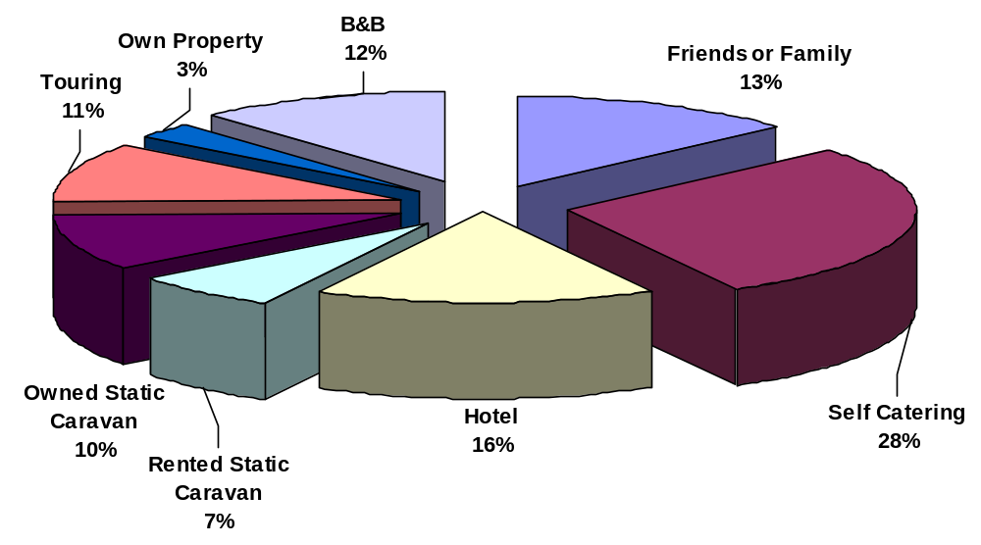
Base – 1,466 Respondents

In terms of visitors that had paid for their accommodation i.e. not friends or own caravan or property, 88.9% of visitors rated the accommodation ‘very good’ overall, with only 1.2% rating it as ‘Poor’ or ‘Very Poor’ (Table 3.11)

As can be seen in Table 3.11 the differences in the levels of satisfaction of the accommodation varied amongst the different types, with rented static caravans receiving the most favourable overall rating (91.9% rated as very good), closely followed by Bed and Breakfast (91.5%) and Self Catering accommodation (90.6%). Hotels were rated less favourably overall and in particular in terms of décor and value for money in comparison to the other main types of accommodation.

Table 3.11 – Total Overall Rating of Paid Accommodation (% Very Good)
 | Cleanliness | Quality of Decor | Value for Money | Location | Overall
Self Catering | 92.3% | 87.8% | 90.1% | 92.0% | 90.6%
Hotel | 90.3% | 84.2% | 85.2% | 91.8% | 88.3%
Rented Static Caravan | 90.7% | 87.2% | 90.7% | 89.5% | 91.9%
Bed & Breakfast | 91.5% | 92.3% | 91.5% | 93.0% | 91.5%
Total | 88.3% | 84.7% | 87.5% | 90.5% | 88.9%
Base – 771 Respondents

The lead time in terms of people planning their visit to Pembrokeshire varied throughout the year, with the proportion booking the greatest in advance was quarter three with 44,8% booking at least three months in advance. The highest proportion of people that booked a couple of weeks before they visited were typically in the ‘off season’ (quarters one and four), with 39% and 32% respectively.

Figure 3.12 – Time of booking accommodation.
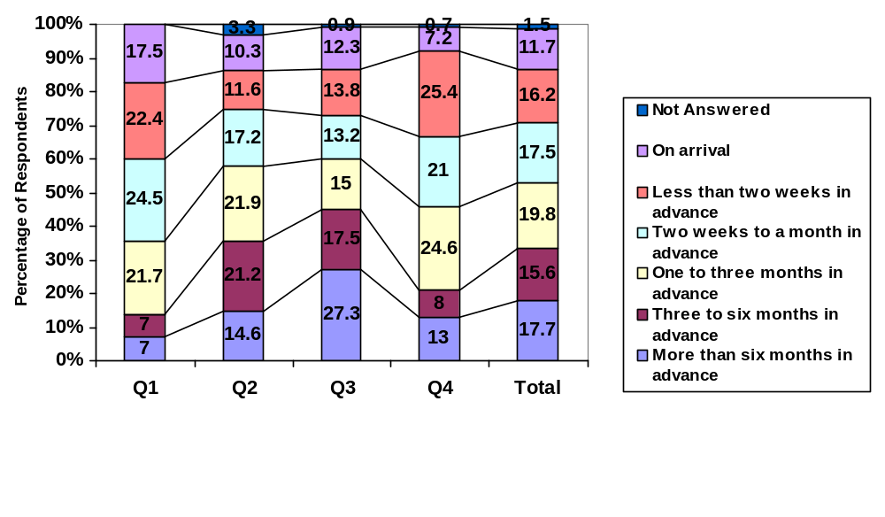
Base – 1,466 Respondents (Legend Top to Bottom)

When visitors were asked how they obtained information on Pembrokeshire (Table 3.13) the most popular source of information was that of ‘previous experience’ (55.9%) and the second most popular source was the Internet (16.0%). These two sources of information have been consistently cited over the four quarters, with other sources including ‘recommended by friends/ family’ and the ‘Pembrokeshire Guide’ referred to.

Table 3.13 – Sources of Information used about Pembrokeshire
Information Source | Q1 | Q2 | Q3 | Q4 | Total
Previous experience | 60.4 | 57.5 | 57.6 | 43.5 | 55.9
Internet/ Web search | 14.1 | 14.0 | 16.4 | 21.6 | 16.0
Recommended by friends/ family | 8.6 | 5.9 | 8.1 | 8.6 | 7.6
Pembrokeshire Guide | 3.1 | 6.3 | 6.2 | 6.0 | 5.7
Wales Brochure | 3.5 | 3.3 | 3.7 | 2.6 | 3.4
Organised package | 1.6 | 2.1 | 0.6 | 7.3 | 2.4
Holiday brochure | 1.6 | 4.0 | 1.2 | 1.3 | 2.2
Tourist information centre | 1.6 | 2.1 | 1.2 | 0.9 | 1.5
Directories | 1.6 | 1.9 | 0.2 | 1.3 | 1.2
Activity Magazine | - | 1.5 | 1 | 0.9 | 1.0
Newspaper article | 1.2 | 0.2 | 0.6 | 3.4 | 1.0
Coast to Coast | 0.8 | 0.4 | 0.2 | - | 0.3
Television advert | 1.2 | 0.2 | - | - | 0.3
Agency | 0.4 | - | - | 0.9 | 0.2
Leaflets | - | 0.2 | 0.2 | - | 0.1
Base – 1,466 Respondents

Evaluation and Summary of the Holiday Experience

The majority of visitors to Pembrokeshire were very happy with the overall experience of visiting Pembrokeshire. In particular, visitors rated the warmth of welcome and the cleanliness of beaches as the two main factors rated as very good. It can be seen from Figure 3.14 below that respondents increasingly rated the factors higher throughout the four quarters with the exception of Bus Services, which peaked in quarter three with 6.9% of respondents. (Figure 3.14).

Figure 3.14 – Overall experience of Pembrokeshire (rated Very Good).
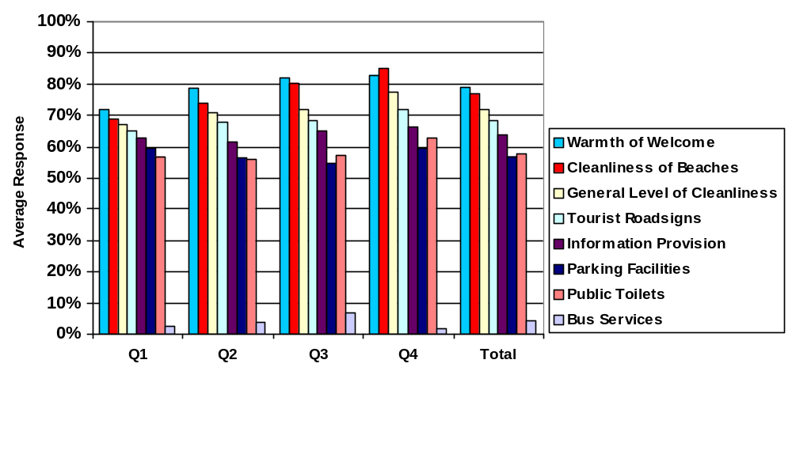
Base – 1,466 Respondents (Legend Left to Right)

In terms of value for money, the majority of respondents rated Pembrokeshire as either ‘Good Value’ or ‘Very Good Value’, with around one third of respondents rating it as ‘Very Good Value’. Overall, 82.5% rated it as either good or very good value for money, but the proportion that rated it as ‘very good value’ declined between quarter one and quarter four.

Figure 3.15 – Pembrokeshire rated for value for money
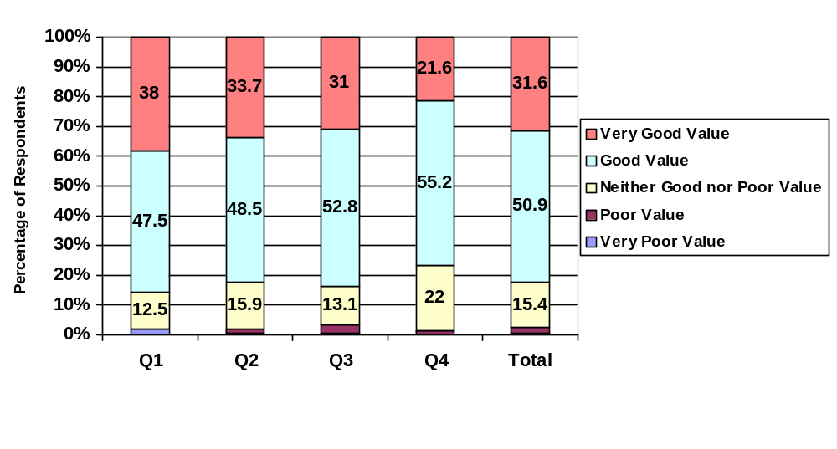
Base – 1,466 Respondents (Legend Top to Bottom)

In terms of whether visitors would return to Pembrokeshire within the next 12 months or indeed the next five years, the responses as in all the quarters were very positive with the majority of respondents stating that they were likely to return to Pembrokeshire within the next 12 months or 5 years (Figure 3.16).

Figure 3.16 – Likelihood to return in next 12 months/ 5 years
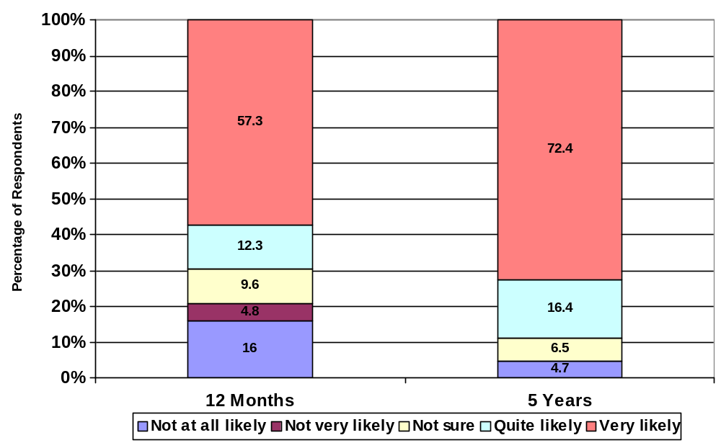
Base – 1,466 Respondents

Self Completion Questionnaire

In total 193 self-completion questionnaires were returned and this section provides a summary of the key findings. The questions asked within the self-completion survey have been considered as a separate sample due to the way in which they were distributed.

Table 4.1: Factors Important to the Holiday
Information Source | Very Impt | Impt | Neither Impt nor Unimpt | Not Very Impt | Not at all Impt | Not Ans
Unspoilt scenery | 78.2 | 20.7 | 0.5 | - | - | 0.5
Peace & quiet | 64.8 | 27.5 | 3.1 | 1.6 | 0.5 | 2.6
Walking | 64.8 | 21.8 | 7.8 | 2.1 | 1.0 | 2.6
Good quality accommodation/facilities | 51.8 | 36.8 | 7.3 | 1.6 | 0.5 | 2.1
Good range of places to eat | 32.6 | 35.8 | 22.3 | 4.7 | 2.1 | 2.6
Culture, Heritage and History | 32.1 | 49.7 | 15.0 | 1.6 | 1.0 | 0.5
Local produce at places you eat | 29.5 | 37.3 | 22.3 | 6.2 | 1.3 | 3.1
Family friendly places to visit | 27.5 | 25.4 | 20.2 | 8.8 | 14.5 | 3.6
Lots of outdoor activities available | 22.8 | 35.2 | 18.7 | 11.4 | 7.3 | 4.7
Art & Crafts | 10.4 | 25.4 | 35.2 | 18.7 | 6.2 | 4.1
Water sports | 10.4 | 12.4 | 28.5 | 16.6 | 29.0 | 3.1
Wet weather activities | 8.8 | 33.7 | 31.6 | 14.0 | 8.8 | 3.1
Base – 193 Respondents

Table 4.2: Rate Experience of …
Experience | Very Good | Good | Neither Good nor Poor | Poor | Very Poor | Not Ans
Unspoilt scenery | 82.9 | 15.5 | 1.0 | - | - | 0.5
Walking | 74.6 | 17.6 | 2.6 | 1.0 | 1.0 | 3.1
Peace & quiet | 71.5 | 18.5 | 2.6 | 1.0 | - | 3.1
Good quality accommodation/facilities | 47.2 | 36.8 | 11.4 | 2.1 | 0.5 | 2.1
Culture, Heritage and History | 39.9 | 48.2 | 8.3 | 0.5 | - | 3.1
Lots of outdoor activities available | 31.6 | 37.8 | 18.1 | 1.6 | 1.0 | 9.8
Family friendly places to visit | 24.4 | 39.4 | 25.9 | - | 1.6 | 8.8
Water sports | 20.7 | 22.8 | 39.9 | 2.1 | 2.6 | 11.9
Local produce at places you eat | 18.7 | 42.5 | 26.9 | 5.2 | 0.5 | 6.2
Good range of places to eat | 17.6 | 40.9 | 23.8 | 10.4 | 1.6 | 5.7
Art & Crafts | 17.6 | 39.4 | 31.1 | 3.1 | 0.5 | 8.3
Wet weather activities | 7.3 | 27.5 | 45.1 | 6.7 | 3.1 | 10.4
Base – 193 Respondents

Figure 4.3: Activities Undertaken
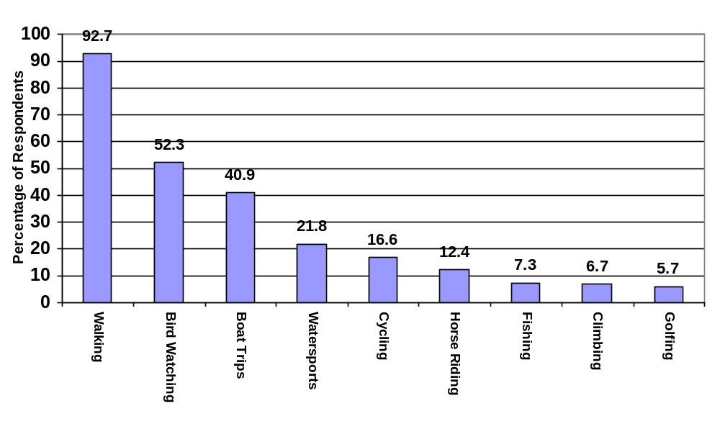
Base – 193 Respondents

Figure 4.4: Likelihood to return within 12 months or in Next 5 Years
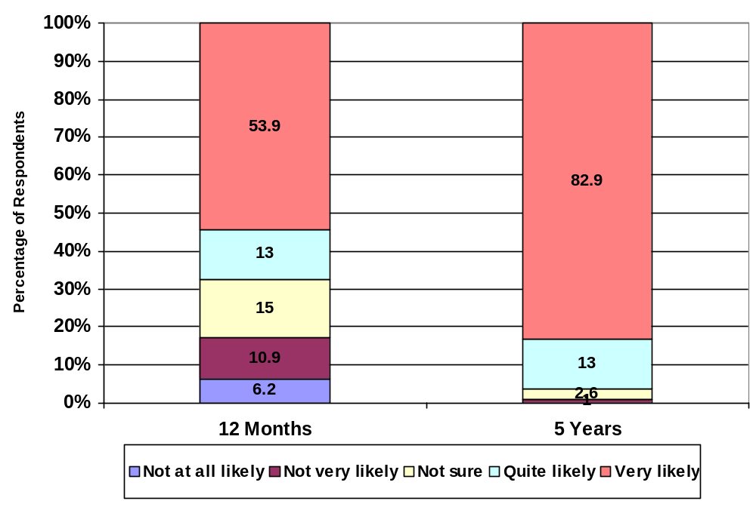
Base – 193 Respondents

Table 4.5: Sources of Information used about Pembrokeshire
Information Source | Total
Previous experience | 60.1
Pembrokeshire Guide | 40.9
Internet/ Web search | 34.7
Tourist information centre | 31.6
Coast to Coast | 28.5
Wales Brochure | 22.8
Holiday brochure | 11.4
Recommended by friends/ family | 8.3
Activity Magazine | 4.1
Agency | 1.0
Directories | 0.5
Base – 193 Respondents

Table 4.6: General Comments on Pembrokeshire
Comment | % Of Respondents
Beautiful countryside/ walks/ wildflowers | 22.8
Excellent/ very interesting/ enjoyable | 10.4
Preserve Pembrokeshire the way it is/ unspoilt | 9.8
Friendly, helpful people | 8.8
Come here every year/ never disappointed | 7.3
Coastal path well maintained | 5.7
Restaurants disappointing - poor value for money | 5.2
Miscellaneous | 4.7
Excellent reasonably priced days out - Wildlife Centre etc. | 4.6
Area very clean | 4.1
When weather good, one of best holiday destinations in UK | 3.6
Beautiful beaches | 3.6
Beaches should be dog-free | 3.1
Very peaceful - not too crowded/ busy | 3.1
Many footpaths unmarked/ blocked/ land under MOD control | 2.1
Good roads - very clear | 2.1
B/B and YHA accommodation excellent | 2.1
Base – 193 Respondents

Table 4.7: Gender of Respondents
 | Percentage
Male | 36.3
Female | 63.7
Total | 100.0
Base – 193 Respondents

Table 4.8: Age Group of Respondents
 | Percent
18 - 24 years | 5.7
25 - 34 years | 11.4
35 - 44 years | 23.3
45 - 54 years | 21.2
55 - 64 years | 24.4
65 years or more | 13.5
Total | 100.0
Base – 193 Respondents

Table 4.9: Socio Economic Group of Respondents
 | Percent
A/B | 33.7
C1 | 35.8
C2 | 7.8
D/E | 2.6
Refused | 20.2
Total | 100.0
Base – 193 Respondents

Table 4.10: Residency of Respondents
 | Percent
SE England | 26.9
W Midlands | 17.6
SW England | 16.1
NW England | 11.9
Wales (not Pembrokeshire) | 11.4
E Midlands | 8.8
Scotland | 2.6
NE England | 2.6
Elsewhere | 2.1
Total | 100.0
Base – 193 Respondents

Summary and Conclusions

The twelve month study of visitors to Pembrokeshire has provided the funding partners with a number of important baseline figures that can be used in subsequent years to track numbers, characteristics and evaluate the tourist offering that Pembrokeshire currently provides.

The information collated identified that visitors to Pembrokeshire vary in characteristics throughout the year in terms of not only demographics, but also activities taken part in and place/ type of accommodation stayed in. This poses a number of problems and issues to those involved within the tourist industry as it would appear that the tourists visiting are extremely diverse and this requires bespoke and targeted marketing activity to encourage and facilitate them.

It can be determined from the results obtained that the vast majority of visitors to Pembrokeshire are very happy with the destination and the facilities and activities available. However, a balance needs to be struck between encouraging increased numbers of visitors and remembering the main reason why people visit Pembrokeshire i.e. not impacting on the peace and quiet and the natural environment.

Although the findings are very positive a number of areas can be identified as areas for further improvement:

- A raising of standards amongst all accommodation suppliers to achieve a rating of more than 90% (very good) across all accommodation types.
- Increasing awareness of specific attractions and activities so that people explore other areas of the county rather than just the natural environment.
- Encourage people to use alternative forms of transport travelling to and whilst in the county other than the car.
- Create demand for attractions and activities throughout the year rather than during seasonal periods of the year.
- Ensure that website and internet resources are up-to-date and comprehensive in provision, with around one sixth of visitors using it at present and the number potentially increasing in the coming years.
- Capitalise on the fact that the majority of visitors are intent on returning to the area by ensuring that information is collected on visitors (at hotels and attractions etc), so that brochures and information can be targeted to encourage them to return. This exercise should build on existing partnerships between the local authority and the business community to ensure mutual benefit.

It is our opinion that the figures should be revisited in one or two years time to ensure that a baseline tracking exercise is undertaken, with a similar level of reporting and analysis undertaken on a quarterly basis.

Appendices

Copy of Face-to-Face Questionnaire.

Trefor House Ocean Park Cardiff CF24 5RE
Tel: 029 204 358 00 Fax: 029 204 835 40
http://www.rmltd.net e-mail: research@rmltd.net
 | 6 | 1 | 3 | 1
 | Job No: |  |  |  |  | Seq. No |  | Area

VISITOR SURVEY - We will be using a scanner to collect data from these questionnaires – scanners work best if you use a black pen and mark the appropriate box with an x rather than a tick. If you make a mistake, shade out the box and correctly enter the answer into another box.
Good morning/afternoon/evening, My name is ... from Research & Marketing Ltd. we are conducting a short survey amongst Visitors about the Pembrokeshire area. Could you answer a few questions for me please?

Day of interview: | Location of Interview: |  |  |  |  | Month
Monday |  | 1 | Tenby |  | 1 | January |  | 1
Tuesday |  | 2 | Saundersfoot |  | 2 | February |  | 2
Wednesday |  | 3 | Narberth |  | 3 | March |  | 3
Thursday |  | 4 | Pembroke |  | 4 | April |  | 4
Friday |  | 5 | Milford Haven & Dale Peninsula |  | 5 | May |  | 5
Saturday |  | 6 | Haverfordwest |  | 6 | June |  | 6
Sunday |  | 7 | Newgale and the Havens (St Brides Bay) |  | 7 | July |  | 7
Time of Interview |  |  | St Davids and Peninsula |  | 8 | August |  | 8
9 a.m. – 12 p.m. |  | 1 | Fishguard |  | 9 | September |  | 9
12 p.m. – 2 p.m. |  | 2 | Newport and Preseli Hills |  | 10 | October |  | 10
2 p.m. - 5 p.m. |  | 3 |  |  |  | November |  | 11
5 p.m. - 9 p.m. |  | 4 |  |  |  | December |  | 12

QA | Do you live in Pembrokeshire? Mark ONE box only
 | Yes |  | 1 | CLOSE
 | No |  | 2 | CONTINUE

Q.B | Why have you come to Pembrokeshire? Mark ONE box only
 | Holiday or Leisure |  | 1 | CONTINUE
 | Visiting Friends |  | 2 | CONTINUE
 | Business/Holiday |  | 3 | CONTINUE
 | Business only |  | 4 | CLOSE
 | Other |  | 5 | CLOSE

1. EXPECTATIONS OF HOLIDAY

Q.1 | Which of the following best describes your visit to Pembrokeshire?  Mark ONE box only
 | Holiday of more than 1 week |  | 1
 | Holiday of 1 week |  | 2
 | Short Holiday of 4 – 6 nights |  | 3
 | Short break of 1 – 3 nights |  | 4
 | Day trip |  | 5
 | Other |  | 6

Q.2 | Is this your main holiday of the year? Mark ONE box only
 | Yes |  | 1
 | No |  | 2
 | Not sure |  | 3

Q.3 | Why did you choose to visit Pembrokeshire? SHOW CARD Q3  Mark as many boxes as apply
 | Attractive Coast |  | 1
 | Attractive Countryside |  | 2
 | Haven for wildlife |  | 3
 | Friends & Relatives in the area |  | 4
 | Heritage |  | 5
 | Outdoor activities (riding, cycling etc.) |  | 6
 | Walking |  | 7
 | Peacefulness |  | 8
 | Previous visit |  | 9
 | Recommendation / Word of mouth |  | 10

Q.4a | What features and attractions are you aware of in Pembrokeshire that have attracted you to the area? UNPROMPTED Mark as many boxes as apply in first column
Q.4b | Which of these attractions are you aware of? SHOWCARD Q4B  Mark as many boxes as apply in first column
 |  | Spontaneous |  | Prompted
 | Beaches and coast |  | 1 |  | 1
 | National Park |  | 2 |  | 2
 | Nature and Wildlife |  | 3 |  | 3
 | Oakwood |  | 4 |  | 4
 | Folly Farm |  | 5 |  | 5
 | Heritage - Castles/Cathedrals |  | 6 |  | 6
 | Other spontaneous (Please write in below) | 

Q.5 | How important to your holiday overall are each of the following . …  Please mark ONE box only in each row
 |  | Very Important |  | Important |  | Neither important nor Unimportant |  | Not very important |  | Not at all important
Unspoilt scenery |  |  | 1 |  | 2 |  | 3 |  | 4 |  | 5
Culture, Heritage and History |  |  | 1 |  | 2 |  | 3 |  | 4 |  | 5
Lots of outdoor activities available |  |  | 1 |  | 2 |  | 3 |  | 4 |  | 5
Family friendly places to visit |  |  | 1 |  | 2 |  | 3 |  | 4 |  | 5
Peace & quiet |  |  | 1 |  | 2 |  | 3 |  | 4 |  | 5
Good quality accommodation/facilities |  |  | 1 |  | 2 |  | 3 |  | 4 |  | 5
Art & Crafts |  |  | 1 |  | 2 |  | 3 |  | 4 |  | 5
Wet weather activities |  |  | 1 |  | 2 |  | 3 |  | 4 |  | 5
Local produce at places you eat |  |  | 1 |  | 2 |  | 3 |  | 4 |  | 5
Good range of places to eat |  |  | 1 |  | 2 |  | 3 |  | 4 |  | 5
Walking |  |  | 1 |  | 2 |  | 3 |  | 4 |  | 5
Water sports |  |  | 1 |  | 2 |  | 3 |  | 4 |  | 5

Q.6 | How would you rate your experience in Pembrokeshire for each of the following. …  Please mark ONE box only in each row
 |  | Very Good |  | Good |  | Neither Good nor Poor |  | Poor |  | Very Poor |  | Don’t know/ not applicable
Unspoilt scenery |  |  | 1 |  | 2 |  | 3 |  | 4 |  | 5 |  | 6
Culture, Heritage and History |  |  | 1 |  | 2 |  | 3 |  | 4 |  | 5 |  | 6
Lots of outdoor activities available |  |  | 1 |  | 2 |  | 3 |  | 4 |  | 5 |  | 6
Family friendly places to visit |  |  | 1 |  | 2 |  | 3 |  | 4 |  | 5 |  | 6
Peace & quiet |  |  | 1 |  | 2 |  | 3 |  | 4 |  | 5 |  | 6
Good quality accommodation/facilities |  |  | 1 |  | 2 |  | 3 |  | 4 |  | 5 |  | 6
Art & Crafts |  |  | 1 |  | 2 |  | 3 |  | 4 |  | 5 |  | 6
Wet weather activities |  |  | 1 |  | 2 |  | 3 |  | 4 |  | 5 |  | 6
Local produce at places you eat |  |  | 1 |  | 2 |  | 3 |  | 4 |  | 5 |  | 6
Good range of places to eat |  |  | 1 |  | 2 |  | 3 |  | 4 |  | 5 |  | 6
Walking |  |  | 1 |  | 2 |  | 3 |  | 4 |  | 5 |  | 6
Water sports |  |  | 1 |  | 2 |  | 3 |  | 4 |  | 5 |  | 6

Q.7 | Which of the following activities have you taken part in, or do you intend to take part in, during your stay? SHOW CARD Q7 Mark as many boxes as apply
 | Walking |  | 1
 | Cycling |  | 2
 | Horse-riding |  | 3
 | Bird-watching |  | 4
 | Fishing |  | 5
 | Golfing |  | 6
 | Boat trips |  | 7
 | Climbing |  | 8
 | Water sports |  | 9
 | Other (Please write in below)

Q.8 | Which of the following places have you visited, or do you intend to visit during your stay? SHOW CARD Q8 Mark as many boxes as apply
 | Arts & Crafts Centres |  | 1
 | Countryside |  | 2
 | Coast/Beaches |  | 3
 | Castles and Heritage sites |  | 4
 | Pembrokeshire Islands |  | 5
 | Theme Park |  | 6
 | Gardens and Garden Centres |  | 7
 | Other (Please write in below)

INTERVIEWER: IF RESPONDENT IS ON A DAY TRIP, PLEASE GO TO Q.13

2. ACCOMMODATION

Q.9 | Where are you staying? Mark ONE box only
 | Tenby |  | 1
 | Saundersfoot |  | 2
 | Narberth |  | 3
 | Pembroke |  | 4
 | Milford Haven |  | 5
 | Haverfordwest |  | 6
 | Newgale and the Havens |  | 7
 | St Davids |  | 8
 | Fishguard |  | 9
 | Newport/Preseli Hills |  | 0
 | Other (Please write in below)

Q.10 | What type of accommodation are you staying in?  Mark as many boxes as apply
 | With Friends or Family |  | 1 | Go to Q.13
 | Self-catering |  | 2
 | Hotel |  | 3
 | Rented static caravan |  | 4
 | Owned static caravan |  | 5 | Go to Q.13
 | Touring Caravanning/Camping |  | 6
 | Own Property |  | 7 | Go to Q.13
 | Bed and Breakfast/Farmhouses/Guesthouse |  | 8
 | Other (Please write in below)

Q.11 | How would you rate your accommodation for each of the following . …  Please mark ONE box only in each row
 |  | Very Good |  | Good |  | Neither good nor poor |  | Poor |  | Very poor
Cleanliness |  |  | 1 |  | 2 |  | 3 |  | 4 |  | 5
Quality of décor / facilities |  |  | 1 |  | 2 |  | 3 |  | 4 |  | 5
Value for money |  |  | 1 |  | 2 |  | 3 |  | 4 |  | 5
Location |  |  | 1 |  | 2 |  | 3 |  | 4 |  | 5
Overall |  |  | 1 |  | 2 |  | 3 |  | 4 |  | 5

Q.12 | When did you book your accommodation? Mark ONE box only
 | More than six months in advance |  | 1
 | Three to six months in advance |  | 2
 | One to three months in advance |  | 3
 | Two weeks to a month in advance |  | 4
 | Less than two weeks in advance |  | 5
 | On arrival |  | 6

Q.13 | How did you find out information about Pembrokeshire ? Mark ONE box only
 | Wales Brochure |  | 1
 | Pembrokeshire Guide |  | 2
 | Coast to Coast |  | 3
 | Previous experience |  | 4
 | Internet/Web search |  | 5
 | Tourist Information Centre |  | 6
 | Specialist Activity Magazines |  | 7
 | Holiday Brochure |  | 8
 | Organised package |  | 9
 | Directories |  | 10
 | Agency |  | 11
 | Other (Please write in below)

3. INFRASTRUCTURE

Q.14 | How did you travel to Pembrokeshire ? Mark ONE box only
 | Car |  | 1
 | Bus/Coach |  | 2
 | Coach as part of organised trip |  | 3
 | Train |  | 4
 | Ferry |  | 5
 | Other (Please write in below)

Q.15 | Have you used Public transport since you have been in Pembrokeshire ? Mark ONE box only
 | Yes |  | 1
 | No |  | 2

Q.16 | Have you used a Tourist Information Centre in Pembrokeshire ? Mark ONE box only
 | Yes |  | 1
 | No |  | 2

Q.17 | How would you rate Pembrokeshire for each of the following . …  Please mark ONE box only in each row
 |  | Very Good |  | Good |  | Neither good nor poor |  | Poor |  | Very poor |  | Not applicable
Bus Services |  |  | 1 |  | 2 |  | 3 |  | 4 |  | 5 |  | 6
Parking facilities |  |  | 1 |  | 2 |  | 3 |  | 4 |  | 5 |  | 6
Information provision |  |  | 1 |  | 2 |  | 3 |  | 4 |  | 5 |  | 6
Cleanliness of beaches |  |  | 1 |  | 2 |  | 3 |  | 4 |  | 5 |  | 6
Tourist road signs |  |  | 1 |  | 2 |  | 3 |  | 4 |  | 5 |  | 6
General level of cleanliness |  |  | 1 |  | 2 |  | 3 |  | 4 |  | 5 |  | 6
Public Toilets |  |  | 1 |  | 2 |  | 3 |  | 4 |  | 5 |  | 6
Warmth of welcome/Friendliness |  |  | 1 |  | 2 |  | 3 |  | 4 |  | 5 |  | 6

4. OVERALL ATTITUDE TO PEMBROKESHIRE

Q.18 | Having spent some time in Pembrokeshire, how would you rate it as value for money?
 | Very good value for money |  | 1
 | Good value for money |  | 2
 | Neither good nor poor value for money |  | 3
 | Poor value for money |  | 4
 | Very poor value for money |  | 5

Q.19a | How likely are you to return to Pembrokeshire within the next 12 months?  Mark ONE box only in the first column
Q.19b | How likely are you to return to Pembrokeshire within the next 5 years?  Mark ONE box only in the second column
 |  | Next 12 months |  | Next 5 years
 | Very likely |  | 1 |  | 1
 | Quite Likely |  | 2 |  | 2
 | Not sure |  | 3 |  | 3
 | Not very likely |  | 4 |  | 4
 | Not at all likely |  | 5 |  | 5

Q.20 | Is there anything you would like to say about your overall experience of Pembrokeshire?  INTERVIEWER: PLEASE PROBE

5. DEMOGRAPHIC QUESTIONS

Q.21 | Gender of respondent? | Male |  | 1
 |  | Female |  | 2

Q.22 | Which of the following age bands do you fall into?
 | 18 – 24 years |  | 1
 | 25 – 34 years |  | 2
 | 35 – 44 years |  | 3
 | 45 – 54 years |  | 4
 | 55 – 64 years |  | 5
 | 65 or more |  | 6

Q.23 | What is the occupation of the chief wage earner in your household?  Please write in below:
 | INTERVIEWER: PLEASE CODE
 | AB |  | 1
 | C1 |  | 2
 | C2 |  | 3
 | DE |  | 4

Q.24 | How many people are in your holiday party? Please write in number, including respondent
 | Adults
 | Children under 10 years
 | Children 11 - 17 years

Q.25 | How many holidays have you taken in the past 12 months (include any trip away from home of more than 1 night)?

Q.26 | How would you describe your working status?
 | Working full-time (29 hours or more per week) |  | 1
 | Working part time (less than 29 hours per week) |  | 2
 | Non-working (e.g. full time housewife) |  | 3
 | Student (full time education) |  | 4
 | Retired |  | 5
 | Unemployed |  | 6

Q.27     | Which of the following best describes your life stage? Mark one box only  (Categorise family based on age of YOUNGEST child)
 | Single |  | 1
 | Married / Living with Partner no children |  | 2
 | Family with children under 5 years |  | 3
 | Family with children 5 – 10 years |  | 4
 | Family with children 11 – 15 years |  | 5
 | Family with children aged 16+ years living at home |  | 6
 | Family - children left home |  | 7

Q.28 | Where are you from? SHOWCARD Q28
 | Wales (Not Pembrokeshire) |  | 1
 | NW England |  | 2
 | NE England |  | 3
 | E Midlands |  | 4
 | W Midlands |  | 5
 | SW England |  | 6
 | SE England |  | 7
 | Northern Ireland |  | 8
 | Republic of Ireland |  | 9
 | Europe outside UK |  | 10
 | Elsewhere |  | 11

Interviewer’s declaration:
I declare that this interview was conducted in accordance with your instructions and within the code of conduct of the Market Research Society.

Date _____/_____/ 2004 Signed ___________________________

Back-checking information:
Name:

Address:

Postcode
e.g. | C | F | 2 | 4 |  | 5 | R | E
 | Std Code |  |  |  |  |  | Telephone Number
Tel. No:

Copy of Self-Completion Questionnaire.

PEMBROKESHIRE VISITOR QUESTIONNAIRE  Have your say and WIN £100!!! |  | 

Pembrokeshire County Council and the Pembrokeshire Coast National Park Authority are constantly striving to improve services for visitors. Please can you take a few minutes to complete this questionnaire about your visit.
All completed surveys have a chance of winning £100!!!

Q1 Month of visit:
Q2 Duration of Stay in Pembrokeshire |  | DAYS
Q3a In which town are you staying?
Q3b Where did you pick up this leaflet?

Q4. How important to your holiday are each of the following…?
Please mark ONE box only in each row
 | Very Important |  | Important |  | Neither important nor Unimportant |  | Not very important |  | Not at all important
Unspoilt scenery |  | 1 |  | 2 |  | 3 |  | 4 |  | 5
Culture, Heritage and History |  | 1 |  | 2 |  | 3 |  | 4 |  | 5
Lots of outdoor activities available |  | 1 |  | 2 |  | 3 |  | 4 |  | 5
Family friendly places to visit |  | 1 |  | 2 |  | 3 |  | 4 |  | 5
Peace & quiet |  | 1 |  | 2 |  | 3 |  | 4 |  | 5
Good quality accommodation/facilities |  | 1 |  | 2 |  | 3 |  | 4 |  | 5
Art & Crafts |  | 1 |  | 2 |  | 3 |  | 4 |  | 5
Wet weather activities |  | 1 |  | 2 |  | 3 |  | 4 |  | 5
Local produce at places you eat |  | 1 |  | 2 |  | 3 |  | 4 |  | 5
Good range of places to eat |  | 1 |  | 2 |  | 3 |  | 4 |  | 5
Walking |  | 1 |  | 2 |  | 3 |  | 4 |  | 5
Water sports |  | 1 |  | 2 |  | 3 |  | 4 |  | 5

Q5. How would you rate your experience in Pembrokeshire for each of the following. …
Please mark ONE box only in each row
 | Very Good |  | Good |  | Neither Good nor Poor |  | Poor |  | Very Poor
Unspoilt scenery |  | 1 |  | 2 |  | 3 |  | 4 |  | 5
Culture, Heritage and History |  | 1 |  | 2 |  | 3 |  | 4 |  | 5
Lots of outdoor activities available |  | 1 |  | 2 |  | 3 |  | 4 |  | 5
Family friendly places to visit |  | 1 |  | 2 |  | 3 |  | 4 |  | 5
Peace & quiet |  | 1 |  | 2 |  | 3 |  | 4 |  | 5
Good quality accommodation/facilities |  | 1 |  | 2 |  | 3 |  | 4 |  | 5
Art & Crafts |  | 1 |  | 2 |  | 3 |  | 4 |  | 5
Wet weather activities |  | 1 |  | 2 |  | 3 |  | 4 |  | 5
Local produce at places you eat |  | 1 |  | 2 |  | 3 |  | 4 |  | 5
Good range of places to eat |  | 1 |  | 2 |  | 3 |  | 4 |  | 5
Walking |  | 1 |  | 2 |  | 3 |  | 4 |  | 5
Water sports |  | 1 |  | 2 |  | 3 |  | 4 |  | 5



Q6. Which of the following activities have you taken part in, or do you intend to take part in, during your stay? Mark as many boxes as apply
Walking |  | 1
Cycling |  | 2
Horse-riding |  | 3
Bird-watching |  | 4
Fishing |  | 5
Golfing |  | 6
Boat trips |  | 7
Climbing |  | 8
Water sports |  | 9
Other (Please write in below) |  | 10
…………………………………………… | OFFICE USE ONLY

Q7A. How likely are you to return to Pembrokeshire within the next 12 months?
Mark ONE box only in the first column
Q7B. How likely are you to return to Pembrokeshire within the next 5 years?
Mark ONE box only in the second column
 |  | Next 12 months |  | Next 5 years
 | Very likely |  | 1 |  | 1
 | Quite Likely |  | 2 |  | 2
 | Not sure |  | 3 |  | 3
 | Not very likely |  | 4 |  | 4
 | Not at all likely |  | 5 |  | 5

Q8. How did you find information about Pembrokeshire? Mark as many boxes as apply
Wales Brochure |  | 01
Pembrokeshire Guide |  | 02 | Specialist Activity Magazines |  | 09
Coast to Coast |  | 03 | Holiday Brochure |  | 10
Previous experience |  | 04 | Organised package |  | 11
Internet/Web search |  | 05 | Directories |  | 12
Tourist Information Centre |  | 06 | Agency |  | 13
Specialist Activity Magazines |  | 07 | Other (Please write in below) |  | 14
 |  |  | ………………………………………………

Q9. Do you have any comments on your visit to Pembrokeshire?

For office use

Q10. Are you? (Please tick one box)
 |  | Male |  | 1
 |  | Female |  | 2


Q11. Can you please state which of the following age bands you fall into:
 | 18 – 24 years |  | 1
 | 25 – 34 years |  | 2
 | 35 – 44 years |  | 3
 | 45 – 54 years |  | 4
 | 55 – 64 years |  | 5
 | 65 or more |  | 6
Q12. What is the occupation of the chief wage earner in your household? Please write in below:
 | FOR OFFICE USE

Q13. Which of the following best describes your life stage? Mark one box only
✪  
(Choose the family category that matches the age of youngest child)
 | Single |  | 1
 | Married / Living with Partner no children |  | 2
 | Family with children under 5 years |  | 3
 | Family with children 5 – 10 years |  | 4
 | Family with children 11 – 15 years |  | 5
 | Family with children aged 16+ years living at home |  | 6
 | Family - children left home |  | 7

Q14. Where are you from?
Wales (Not Pembrokeshire) |  | 01 | SE England |  | 07
NW England |  | 02 | Northern Ireland |  | 08
NE England |  | 03 | Republic of Ireland |  | 09
E Midlands |  | 04 | Europe outside UK |  | 10
W Midlands |  | 05 | Elsewhere |  | 11
SW England |  | 06

Details for Prize Draw
Name
Address
Telephone No.

Thank you for completing the survey.
Good Luck in the Prize Draw!!!

Two Questionnaires were returned with no month stated.

