Pembrokeshire Coast National Park LPA

PLANNING ANNUAL PERFORMANCE REPORT (APR) – 17-18

PREFACE

I have the pleasure of introducing the fourth Planning Annual Performance Report (APR) for the Pembrokeshire Coast National Park Authority (PCNPA).

APRs have been introduced as part of Welsh Government’s proposals, embodied with the Planning (Wales) Act 2015, to modernise the planning system and improve local
delivery of planning services. I hope that this document succinctly tells the story of how we are performing our planning function.

National Parks are special places and we are charged with the task of ensuring that this precious landscape is held for future generations. We are conscious that we are endeavouring through our planning function to maintain a healthy balance as required under the Wellbeing of Future Generations Act.

Chair of Pembrokeshire Coast National Park Authority
.

CONTEXT

- This section sets out the planning context within which the local planning authority operates.
  - The Pembrokeshire Coast National Park Authority is charged with delivering the planning services within the Pembrokeshire Coast National Park area. The National Park area runs in a ribbon around the Pembrokeshire Coast and includes the lower sections of the Cleddau rivers, it also includes the Preseli hills and Gwaun valley. It is the only UK National Park designated primarily for its coastline, and the Pembrokeshire islands are included within it.
  - The National Park covers an area of 614km² and is one of the more densely populated of the UK’s National Parks, with almost 22,000 people living in 49 Community, Town and City Council areas (2010 census figures). Most of the National Park is privately owned; however about a quarter lies in the public realm or in charitable ownership.
  - The National Park itself was designated in 1952, with the following purposes:
  - to conserve and enhance the natural beauty, wildlife and cultural heritage of the National Park; and
  - to promote opportunities for the understanding and enjoyment of the special qualities of the National Park by the public.
- Planning background, including previous adopted or abandoned development plans.
  - The Pembrokeshire Coast National Park Authority Local Development Plan (LDP) was adopted in 2010 and covers the period between 2010 and 2021. This plan replaced the Joint Unitary Development Plan for Pembrokeshire (2000-2016). The Authority has produced a range of Supplementary Planning Guidance (‘SPG’) which supports and provides guidance to the implementation of policies contained within the LDP. The Authority is now working on a review of its adopted LDP.

- Place and fit within the community strategy and/or wider strategic and operational activity of the authority.
  - The Authority has a National Park Management Plan (2015-2019) which sets out a coordinated approach in managing the purposes of the National Park. The Plan gives people a clear line of sight between National Park purposes and management policies in which the NPA explains what the National Park is, how it is managed, and why it is proposed to manage it in one way rather than another. It is for partner organisations, residents, auditors and anyone with a more detailed interest in the National Park and the NPAs role in its management. The Authority is currently working on a review of the Management Plan and is hoping that all stakeholders will play a part in this important review.
- Existing and previous major influences on land use (e.g. heavy industrial, agricultural, energy, transport).
  - Pembrokeshire Coast National Park is known for its outstanding landscapes, the influences on these, currently and in the future will be the agricultural practices which have shaped and will heavily influence the quality of the landscape. The refining industries around the Haven will also impact on this. The major other land users are defence ranges and tourism.

- Historic/landscape setting of the area, including AONBs, conservation areas etc.

5.1. The Pembrokeshire Coast National Park has 285 Scheduled Ancient Monuments, and over 7500 sites in the Historic Environment Record. There are over 1200 listed buildings and 13 designated Conservation Areas. Nine Historic Landscape areas are wholly or partly within the National Park, and there are 15 Historic Parks & Gardens in the National Park.

- Urban/Rural Mix and Major Settlements
  - The National Park is predominantly rural by the very nature of its designation with smaller pockets of development and Local Centres in coastal locations. An estimated third of all households in the National Park are living in the countryside which are scattered through smaller villages, hamlets, sporadic dwellings and farms.
  - The LDP sets out Towns and Villages as Tier 2 or 3 Centres based upon the Pembrokeshire Haven containing strategic hubs known as Tier 1 Centres – these include larger centres such as Haverfordwest, Milford Haven/Neyland, Pembroke/Pembroke Dock and Carmarthen Town.
  - The key urban areas within the National Park include Tenby (Tier 2 Centre) and Newport, Saundersfoot and St Davids (Tier 3 Centres). There are 19 Rural Centres (Tier 4) throughout the National Park including Amroth, Angle, Bosheston, Broad Haven, Dale, Dinas Cross, Felindre Farchog, Herbrandston, Jameston, Lawrenny, Little Haven, Manorbier, Manorbier Station, Marloes, Newgale, Pontfaen, Solva, St Ishmaels and Trefin. There are an additional 10 Rural Centres which are positioned partly within the National Park.

  - The total number of households identified in the 2011 Census in the National Park is 13,700 and self-catering accommodation makes up just over 12% of the overall stock.

- Population change and influence on LDP/forthcoming revisions.

  - Household projections identified in 2008 Welsh Government figures for this National Park shows an increase in households from 10,490 to 11,516 (just over 1000 for the period 2011 to 2031). Recently published population figures show a decline in population.

  - For the revision of the Local Development Plan, population projection figures will be taken account of in considering the housing provision needed for the life of the replacement Plan (2031). It is also noted that the welsh language statistics for welsh language being spoken in Pembrokeshire has shown an increase in recent years and this will be a consideration for the replacement Plan too.

8. PLANNING SERVICE

- The Authority is organised into three key service areas which include Park Direction/Planning, which comes within the remit of the Director of Planning.
- The Planning Policy function of the National Park is under the direction of the Head of Park Direction. The post holder is also responsible for the National Park Management Plan, Biodiversity, Archaeology, Coast path and footpaths, health and wellbeing, environmental matters and statistical and data information.
The Development Management (DM) and Enforcement functions are under the direction of the Team Leader: Development Management, the post holder is also responsible for the conservation of historic buildings, planning ecology, trees and landscape matters.

- The out turn for development management in 2017/18 was £517,061 with the budget for 2018/19 set at £479,973 a reduction of 30% over 6 years with a reduction in staffing levels of 2 fte – made up in the main with some post holders working reduced hours during this financial year. The 30% reduction relates to the budget figure of £687,000 in 2013/14 and £479,973 in 2018/19. Planning policy and other Direction functions is at about £190,000 each year.

- The Planning function has had a year with some vacancies which have had a knock on effect. Maternity leave for one officer plus a fte vacancy in Enforcement and latterly a fte vacancy in DM has required an innovative way of addressing these voids. The PCNPA continues to use the very flexible arrangement of using consultants to reduce pressure points – this meant that existing planners were able to backfill some enforcement matters with DM workload been dealt with by consultants . There are service level agreements to cover minerals planning with Carmarthenshire County Council (CCC), and one which covers planning ecology work with Pembrokeshire County Council (PCC).

- Looking to the future the PCNPA is keen to plan for planning expertise and capacity to continue to deliver a good planning service. To this end it continues to put a high priority on training of staff at all levels in the planning department. With limited take up of vacant positions, PCNPA is seeking to grow its own planners and enforcement officers offering on the job training to candidates from other disciplines who have been able to demonstrate life skills and attitudes which we would seek to find in the planning professions.

- PCNPA has a commitment to ensure staff are trained for their roles and therefore all planning officers are Royal Town Planning Institute (RTPI) members and subscriptions to this professional body are paid for by the Authority. Enforcement in the Authority is given a high profile and therefore all enforcement officers are members of National Association of Planning Enforcement (NAPE) and subscriptions to this professional body are paid for by the Authority. Planning staff play an active role in sharing good practise with other organisations and they are actively put forward to attend meetings and seminars to widen their own experiences too.

- The Authority expects its planners and enforcement officers to complete and comply with the RTPI’s/NAPE’s continuing professional development (CPD) requirements and these are assessed through its own staff annual performance appraisals.

- A local and relevant planning training programme is delivered in house and planners (and others including members) are invited to attend these sessions. The 2017/18 schedule is set out below along with a sample of training undertaken externally– showing the huge diversity of topics which are considered appropriate for planners to be involved in, especially given the National Park status. This programme includes some of the organisation’s other training programmes for managers etc. which have a bearing on the delivery of the planning service by the Authority.

Date | Training
9.5.17 | Conservation work
15.5.17 | EIA introduction,
31.5.17 | Jed Planning for members
8.6.17 | RTPI Conference
26.06.17 | Academi Wales Summer school
3.7.17 | Community Council Training
5.7.17 | Energy seminar
29.09.17 | Town Centre Regeneration Seminar
19.10.17 | Enforcement Conference
18.11.17 | Archaeology
8.2.18 | Light Training
23.3.18 | PPW/NDF Training

  - PCNPA together with Pembrokeshire County Council has continued to deliver an Agents’ Forum. The forum meets quarterly and is intended not only to inform agents of planning related information which is relevant to their work in Pembrokeshire, but also offers the opportunity for agents to put forward their views on how both local planning authorities are working to take their needs into account. These events are well attended by local planning agents

  - Collaboration is an important part of PCNPA’s culture – and this is probably largely due to the small size of the organisation. Joint working allows us to share good practice, and also makes the Authority more resilient.

  - We have a good working relationship with our neighbouring authorities, Ceredigion, Carmarthenshire and particularly Pembrokeshire. We use the resources of PCC for monitoring of section 106 arrangements and also use its legal team with regard to the drafting and use of templates for planning legal agreements. We also buy in to its planning ecology service – ensuring a consistency of approach throughout the whole of Pembrokeshire with regard to biodiversity which takes no notice of administrative boundaries. Both Authorities – Pembrokeshire CC and PCNPA have a delegation from Cadw to deal with most listed building applications – the agreement allows for the professional officers to work across the boundaries – again to assist with consistency and resilience.

  - We are in the process of implementing an effective document management system, upgrade the planning information available throughout our Website and promote a customer friendly approach to our planning surgery and pre-application service. This is taking much longer than originally anticipated. We will continue to collaborate with the Planning Departments at Brecon Beacons National Park Authority and Snowdonia National Park Authority and make contributions to POSW (Planning Officers Society Wales) sharing best practice work.

THE AUTHORITY’S LOCAL STORY

- The Authority is preparing a replacement Local Development Plan. This work is proceeding as planned and is on target.

- The 2016-17 Local Development Plan Annual Monitoring Report is available and a copy of the report is published on the Authority’s website. The 2017-18 Monitoring Report will be available by the 31st October 2018.

- The Local Development Plan identifies 17 key outcomes by the end of the Plan period (i.e. 2021) and 36 indicators in the Monitoring Report are grouped beneath these outcomes to test the performance of the Plan (2018 report).

- In summary the majority of the Plan’s targets and objectives are being met. There are issues with 7. The key issues relate to effectively available housing land supply; employment land being brought forward and affordable housing delivery.

- The planning application process is becoming increasingly complex and the duty officer approach whereby potential applicants can book a half hour slot with a planner to go through the planning process and what information is required to be submitted with their application is proving popular this year. There is currently no charge for this service. It may well be that the charging for pre-application service has displaced queries to the duty officer. The situation will continue to be monitored. Clearly there is a balance to be struck between being helpful and charging for advice.

- Current projects

- Land Implementation Study for the Deposit Local Development Plan
- Green Infrastructure Project with Pembrokeshire County Council
- Preparation of the Deposit Local Development Plan
- Implementation of Document Management System
- Web access to planning applications

- Local pressures

- Major agricultural applications and unauthorised agricultural buildings
- Monitoring caravan and campsites and ‘28’ day rule sites

- Service improvement

Working towards the corporate well-being objectives of:

PCNPA Well-being Objectives | Contribution to Well-being Goals
- To encourage and support the development of sustainable employment and businesses, particularly in tourism & recreation. | Contributes to a ‘Prosperous Wales’ and a ‘Resilient Wales’ by encouraging the development of new and existing businesses and increasing the number of jobs while discouraging unsustainable use of the natural resources. Increased employment should support ‘More Equal Wales’ and also to a ‘Healthier Wales’
- To improve the health of the National Park’s ecosystems, | Using ecosystems management is a key technique in preparing the Well-being Assessment for the PSB in ensuring a ‘Resilient Wales’ and in preparing any future National Park Management Plan and Local Development Plan.
- To enable and encourage more people to improve their well-being by making a greater use of the National Park regardless of their circumstances | Activity in the outdoors, such as walking, can improve the feeling of well-being, reduce stress and be inspirational By promoting more regular use of the outdoors whether it is on people’s doorstep or within the National Park, encouraging volunteers and removing barriers to access this objective contributes to both a ‘Healthier Wales’ and a ‘More Equal Wales’
- To continue to ensure equality is embedded within the work and culture of the NPA | The Authority encourages the less able to become engaged and involved and promotes equality and diversity in both its staff and Members and through training opportunities.
- To Work alongside communities to help them make the most of the NPA | Already many communities and local groups are engaged with and contribute to the work of the National Park Authority from consultation responses to local environmental improvement projects. By increasing the scale and scope of this, taking a co-production approach and developing our work to engage new audiences that are representative of society wewill add to a ‘Wales of cohesive communities’
- To protect and promote the local culture of language, arts and heritage of the area | Pembrokeshire has a rich culture in the arts, heritage and language. This is recognised as part of the area’s distinctiveness contributing to a ‘Wales of vibrant culture and thriving Welsh language’.
- To ensure our work makes a positive contribution to global well-being. | By continually reducing our carbon footprint, supporting the green growth agenda through SDF projects and educating people about the special purposes of the Park the Authority contributes to a ‘Globally Responsible Wales’. The Well-Being Objectives support a globally responsible Wales byprotecting the natural and historic environment, our support for the local economy and through our education provision..

- Planning performance measures are included within the Corporate Plan and reported to Members via Operational Review Committee and Audit and Corporate Services Committee during the year.

- Performance actions carried through to 2018/19 Corporate Plan include the implementation of new online document management facility, under Well-being Objective 1 and clearing the backlog of historical enforcement cases under Objective 5. It is recognised that clearing the backlog of historical enforcement cases will have a negative impact on time taken to take enforcement action in days in the short term, but should have a positive long term impact.

- The planning teams in both DM and Planning Policy are focused on service delivery, efficiency and public perception as drivers for their work programming. Within Development Management the key targets were:

- Improve speed of determining applications to an average of 66 days
- Review pre-application processes and planning surgery processes
- Clear the backlog of historic enforcement files
- Set up a formal system for monitoring enforcement cases
- Continue with Conservation Area reviews
- Continue with focussed enforcement projects
- Commence work to improve public perception of the planning service through greater community and town/community council engagement
- To install document management project

- The performance figures for PCNPA speak for themselves in the tables at the end of this document. A Document Management System has been acquired and is currently in the process of being implemented, all applications will be available on the website once the document management system is implemented. The system has taken longer than anticipated to implement due to technical reasons around the hosted environment migration and the migration of the supplier’s server. The system is programmed to be implemented by the end of 2018.

- Housing Land Supply: The Authority is required to demonstrate a five year effectively available housing land supply.

- The continuing fall in the calculated land supply is caused by a variety of factors, the most common being a lack of interest by landowners in wishing to develop their land in the short and medium term. Interest in developing sites allocated in the Local Development Plan has shown a marked increase in recent years with a number of pre-application enquiries and planning applications made to the Authority. This has not been sufficient, however, to meet the cumulative shortfall of sites coming forward in the first few years of the Plan adoption and is now a matter for the Local Development Plan revision.

- A Joint Housing Land Availability Study was finalised in July 2018 and showed a 1.4 year land supply. The Plan will end part-way through the Joint Housing Land Availability Study period (2021 Plan end date) and so the method of calculation takes this into account (as set out in Table 4 of Technical Advice Note 1). The report uses the residual method to calculate the land supply.

- To help bring sites forward the National Park Authority is continuing with the following actions:

a) Approving planning applications for housing developments provided all relevant policy considerations are met. The majority of applications submitted to the Authority in the past few years have been on small sites which are not listed in the land supply.
b) The updated Supplementary Planning Guidance on Affordable Housing adopted by the Authority in November 2014 has re-examined viability assessments for allocated sites. It has also streamlined the process for applicants and emphasised that the requirements are a basis for negotiation. There has been an increase in the number of landowners of allocated sites making contact with the Authority with a view to bringing sites forward for development since the adoption of the guidance.
c) The Authority has a continuing dialogue with owners of many of the land allocations in the Park. Several of the landowners are undertaking preparatory work to start bringing sites forward for development.
d) The Authority is reviewing site allocations through the Local Development Plan review to address the shortfall in effectively available land.

- For Local Development Plan revision this has meant revisiting the overall housing land requirements and consequently the Plan’s housing provision and acknowledging uncertainties in the housing market in setting annual targets.

10. WHAT SERVICE USERS THINK
10.1 In 2017-18 we conducted a customer satisfaction survey aimed at assessing the views of people that had received a planning application decision during the year.
10.2 The survey was sent to 186 people, 17% of whom submitted a whole or partial response. The majority of responses (56%) were from members of the public. 0% of respondents had their most recent planning application refused.
10.3 We asked respondents whether they agreed or disagreed with a series of statements about the planning service. They were given the following answer options:
- Strongly agree;
- Tend to agree;
- Neither agree not disagree;
- Tend to disagree; and
- Strongly disagree.
10.4 Table 1 shows the percentage of respondents that selected either ‘tend to agree’ or ‘strongly agree’ for each statement for both our planning authority and Wales.
Table 1: Percentage of respondents who agreed with each statement, 2017-18

10.5 We also asked respondents to select three planning service characteristics from a list that they thought would most help them achieve successful developments. Figure 1 shows the percentage of respondents that chose each characteristic as one of their three selections. For us, 'the availability to talk to a duty planner before submitting an application' was the most popular choice.
Figure 1: Characteristics of a good planning service, 2017-18
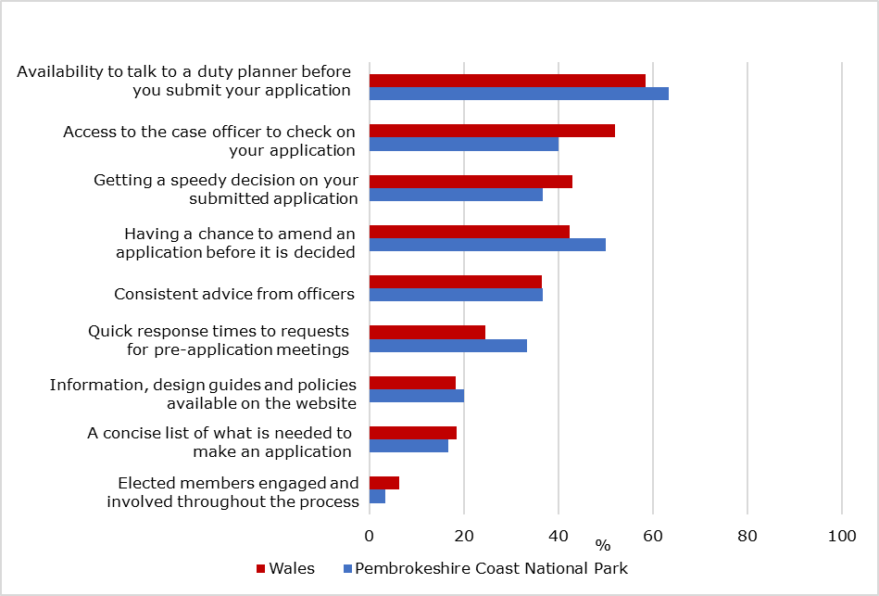
10.6 Comments received include:
- “Its a pleasure to work with the team of planning officers at PCNPA.”
- “No - it is a good service.”
- "It would be better if they had more staff in development control they all seem to be run off their feet.”

11. OUR PERFORMANCE 2017-18
11.1 This section details our performance in 2017-18. It considers both the Planning Performance Framework indicators and other available data to help paint a comprehensive picture of performance. Where appropriate we make comparisons between our performance and the all Wales picture.
11.2 Performance is analysed across the five key aspects of planning service delivery as set out in the Planning Performance Framework:
- Plan making;
- Efficiency;
- Quality;
- Engagement; and
- Enforcement.
12. Plan making
12.1 As at 31 March 2018, we were one of 22 LPAs that had a current development plan in place. We are required to submit an Annual Monitoring Report in October 2018. This document has been prepared.
12.2 During the APR period we had 1.2 years of housing land supply identified, making us one of 18 Welsh LPAs without the required 5 years supply.
13. Efficiency
13.1 In 2017-18 we determined 512 planning applications, each taking, on average, 71 days (10 weeks) to determine. This compares to an average of 81 days (12 weeks) across Wales. Figure 2 shows the average time taken by each LPA to determine an application during the year.
Figure 2: Average time taken (days) to determine applications, 2017-18
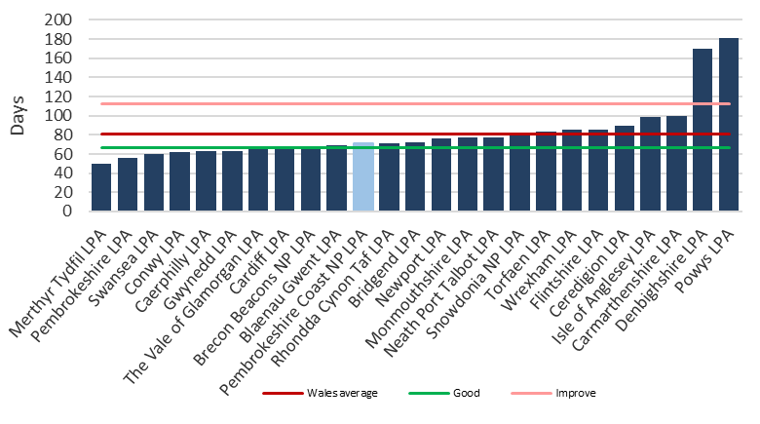

13.2 85% of all planning applications were determined within the required timescales. This compared to 89% across Wales and we were one of 22 LPAs that had reached the 80% target.
13.3 Figure 3 shows the percentage of planning applications determined within the required timescales across the main types of application for our LPA and Wales. It shows that we determined 92% of householder applications within the required timescales. There has to be a point whereby we cannot continue to achieve further gains in reducing time on planning application processing. This is because there are times when the applicant is responsible ie. Delivery of additional information, clarification, site visit scheduling. We also determined 79% of Listed Building Consent applications within the required timescales. We process most of the listed building applications under a scheme of delegation from Cadw, which means we can offer applicants a more time sensitive process. It should be noted that the figure of listed building consent applications is incorrect due to an administrative error where they were being categorised as ‘other’. The percentage figure is over 90%. This error will be rectified for next year’s report.
Figure 3: Percentage of planning applications determined within the required timescales, by type, 2017-18
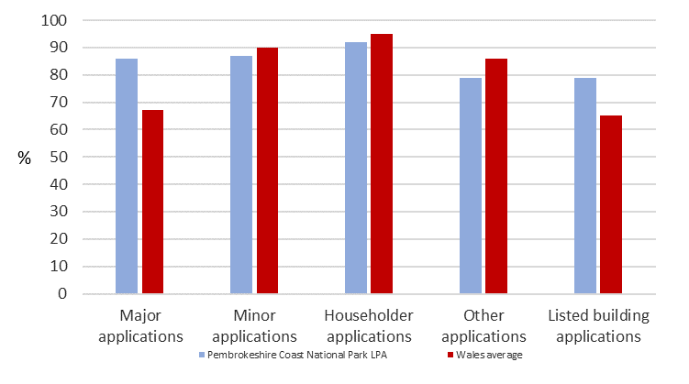
13.4 Between 2016-17 and 2017-18, as Figure 4 shows, the percentage of planning applications we determined within the required timescales increased from 80%. Wales also saw an increase this year.

Figure 4: Percentage of planning applications determined within the required timescales
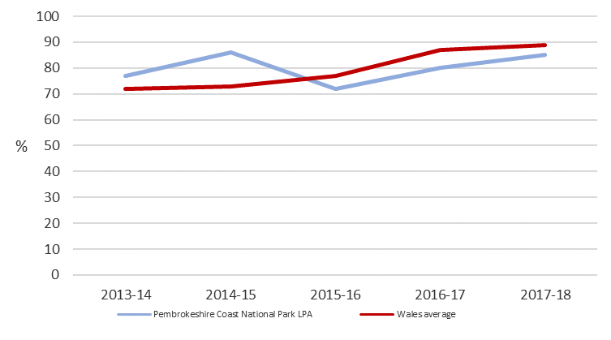
13.5 Over the same period:
- The number of applications we received increased;
- The number of applications we determined increased; and
- The number of applications we approved increased.
14. Major applications
14.1 We determined 7 major planning applications in 2017-18, none of which were subject to an EIA. Each application took, on average, 162 days (23 weeks) to determine. As Figure 5 shows, this was shorter than the Wales average of 240 days (34 weeks). The efficient progressing of an application through the planning process is often determined by the amount of upfront and pre-application work that has been done before submission.
Figure 5: Average time (days) taken to determine a major application, 2017-18
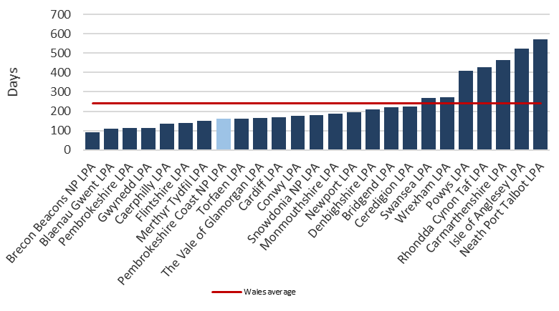
14.2 86% of these major applications were determined within the required timescales, compared to 69% across Wales.
14.3 Figure 6 shows the percentage of major applications determined within the required timescales by the type of major application. 14% of our ‘standard’ major applications i.e. those not requiring an EIA, were determined within the required timescales during the year.
Figure 6: Percentage of Major applications determined within the required timescales during the year, by type, 2017-18
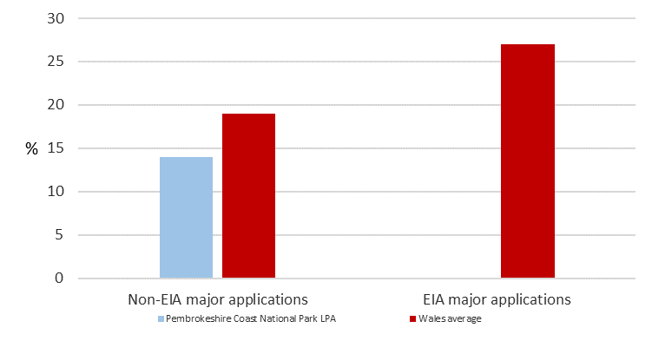
14.4 Since 2016-17 the percentage of major applications determined within the required timescales had increased from 0%. Similarly, the number of major applications determined increased while the number of applications subject to an EIA determined during the year stayed the same.
14.5 Figure 7 shows the trend in the percentage of major planning applications determined within the required timescales in recent years and how this compares to Wales.
Figure 7: Percentage of major planning applications determined within the required timescales
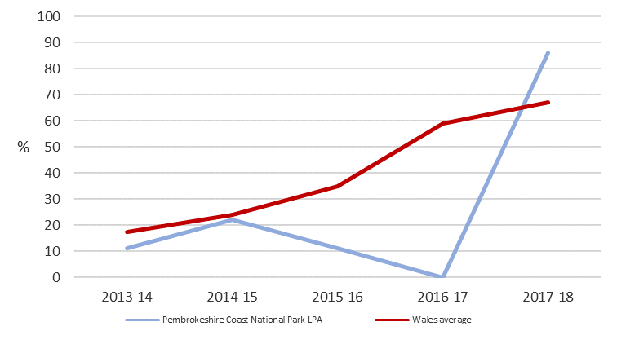
14.6 Over the same period:
- The percentage of minor applications determined within the required timescales increased from 79% to 87%;
- The percentage of householder applications determined within the required timescales increased from 86% to 92%; and
- The percentage of other applications determined within required timescales decreased from 85% to 79%.
15. Quality
15.1 In 2017-18, our Development Management Committee made 41 planning application decisions during the year, which equated to 8% of all planning applications determined. Across Wales 7% of all planning application decisions were made by planning committees.
15.2 In PCNPA only 2% of these member-made decisions went against officer advice. This compared to 9% of member-made decisions across Wales. This equated to 0.2% of all planning application decisions going against officer advice; 0.6% across Wales.
15.3 In 2017-18 we received 5 appeals against our planning decisions, which equated to 0.8 appeals for every 100 applications received. This was the second lowest ratio of appeals to applications in Wales. Figure 8 shows how the volume of appeals received has changed since 2016-17 and how this compares to Wales. The decision as to why applicants don’t go to appeal on refused applications varies considerable. However, the fact that we are planning for a National Park where there are clear policies for protection are probably a factor in applicant’s decisions. There may also be the possibility that the full reports that are written by planning officers clearly express the reasons for the refusal. Officers are conscious that refusal decisions have the ability to go to appeal and therefore time spent on a full report will usually mean that any appeal work is minimal.
Figure 8: Number of appeals received per 100 planning applications
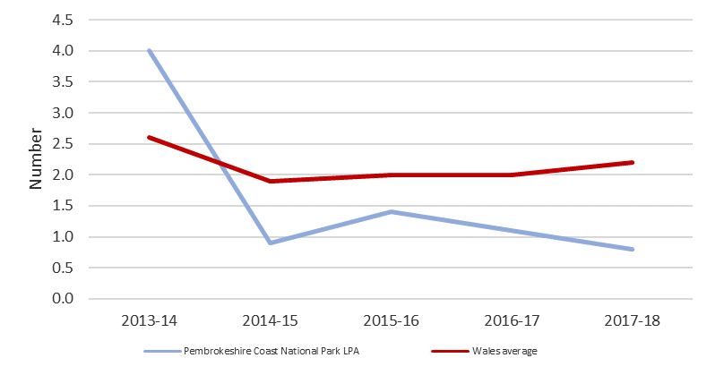
15.4 Over the same period the percentage of planning applications approved increased from 84% to 85%.
15.5 Of the 6 appeals that were decided during the year, 50% were dismissed. As Figure 9 shows, this was lower than the percentage of appeals dismissed across Wales as a whole and was below the 55% threshold. With such a small number of appeal it is difficult to attribute meaningful trends or percentages.
Figure 9: Percentage of appeals dismissed, 2017-18
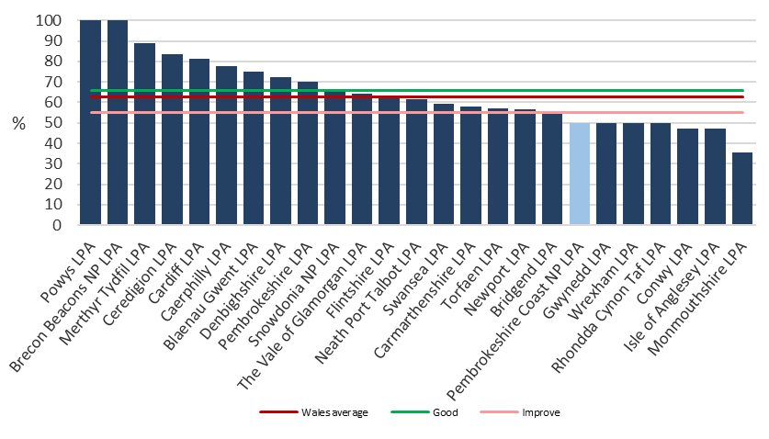
15.6 During 2017-18 we had 1 application for costs at a section 78 appeal upheld, making us one of the 8 LPAs to have at least one such application upheld in the year. This was a longstanding unauthorised agricultural buildings case whereby we had decided not to deal with a retrospective planning application as it was selective in scale and only partially covered the enforceable buildings and ancilliary areas. This was a judgement call, with the Inspector siding with the appellant’s legal definitions. Costs were awarded against PCNPA in this case.
16. Engagement
16.1 We are:
- one of 24 LPAs that allowed members of the public to address the Planning Committee; and
- one of 2 LPAs that only has a partial online register of planning applications. This is not the position that PCNPA would like to be in, and is addressing it with the introduction of a new ICT system.
16.2 As Table 2 shows, 67% of respondents to our 2017-18 customer survey agreed that the LPA gave good advice to help them make a successful application.
Table 2: Feedback from our 2017-18 customer survey
17. Enforcement
17.1 In 2017-18 we investigated 141 enforcement cases, which equated to 6.2 per 1,000 population. This was the highest rate in Wales. This is interesting when considering that PCNPA is probably one of the smallest areas with the lowest resident population.
17.2 We investigated 70% of these enforcement cases within 84 days. Across Wales 81% were investigated within 84 days. Figure 10 shows the percentage of enforcement cases that were investigated within 84 days across all Welsh LPAs.
Figure 10: Percentage of enforcement cases investigated within 84 days, 2017-18
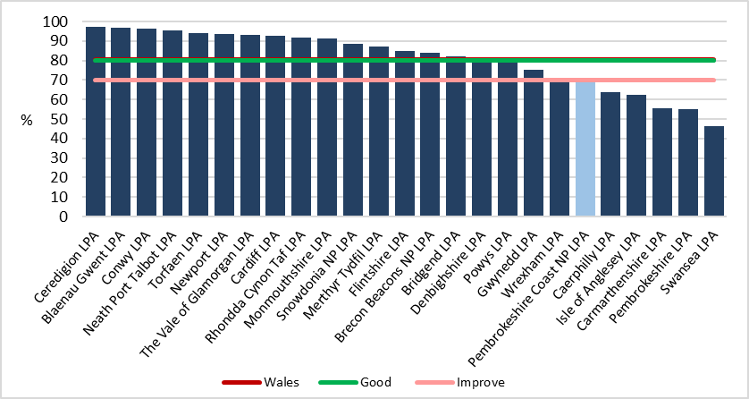
17.3 The average time taken to pursue positive enforcement action was 468 days.

ANNEX A - PERFORMANCE FRAMEWORK

OVERVIEW

MEASURE | GOOD | FAIR | IMPROVE |  | WALES AVERAGE | Pembrokeshire Coast National Park LPA  LAST YEAR | Pembrokeshire Coast National Park LPA  THIS YEAR
Plan making
Is there a current Development Plan in place that is within the plan period? | Yes |  | No |  | Yes | Yes | Yes
LDP preparation deviation from the dates specified in the original Delivery Agreement, in months | <12 | 13-17 | 18+ |  | 67 | N/A | N/A
Annual Monitoring Reports produced following LDP adoption | Yes |  | No |  | Yes | Yes | Yes
The local planning authority's current housing land supply in years | >5 |  | <5 |  | 7 of 25 | 2 | 1.2
Efficiency
Percentage of "major" applications determined within time periods required | >60 | 50-59.9 | <50 |  | 67.4 | 0 | 86
Average time taken to determine "major" applications in days | Not set | Not set | Not set |  | 240.1 | 448 | 162
Percentage of all applications determined within time periods required | >80 | 70-79.9 | <70 |  | 88.5 | 80 | 85
Average time taken to determine all applications in days | <67 | 67-111 | 112+ |  | 80.7 | 61 | 71
Percentage of Listed Building Consent applications determined within time periods required | Not set | Not set | Not set |  | 65.4 | - | 79
Quality
Percentage of Member made decisions against officer advice | <5 | 5-9 | 9+ |  | 8.6 | 9 | 2
Percentage of appeals dismissed | >66 | 55-65.9 | <55 |  | 62.6 | 83 | 50
Applications for costs at Section 78 appeal upheld in the reporting period | 0 | 1 | 2+ |  | 0 | 1 | 1
Engagement
Does the local planning authority allow members of the public to address the Planning Committee? | Yes |  | No |  | Yes | Yes | Yes
Does the local planning authority have an officer on duty to provide advice to members of the public? | Yes |  | No |  | Yes | Yes | Yes
Does the local planning authority’s web site have an online register of planning applications, which members of the public can access, track their progress (and view their content)? | Yes | Partial | No |  | Yes | Partial | Partial
Enforcement
Percentage of enforcement cases investigated (determined whether a breach of planning control has occurred and, if so, resolved whether or not enforcement action is expedient) within 84 days | >80 | 70-79.9 | <70 |  | 80.6 | 69 | 70
Average time taken to take positive enforcement action | Not set | Not set | Not set |  | 184.6 | 195 | 468

SECTION 1 – PLAN MAKING

Indicator | 01. Is there a current Development Plan in place that is within the plan period?
“Good” | “Fair” | “Improvement needed”
A development plan (LDP or UDP) is in place and within the plan period | N/A | No development plan is in place (including where the plan has expired)

Authority’s performance | Yes
The current adopted Local Development Plan is extant until 2021.

Indicator | 02. LDP preparation deviation from the dates specified in the original Delivery Agreement, in months
“Good” | “Fair” | “Improvement needed”
The LDP is being progressed within 12 months of the dates specified in the original Delivery Agreement | The LDP is being progressed within between 12 and 18 months of the dates specified in the original Delivery Agreement | The LDP is being progressed more than 18 months later than the dates specified in the original Delivery Agreement

Authority’s performance | N/A
Both the adopted Local Development Plan and the replacement Local Development Plan have progressed in accordance with the relevant Delivery Agreement.

Indicator | 03. Annual Monitoring Reports produced following LDP adoption
“Good” |  | “Improvement needed”
An AMR is due, and has been prepared |  | An AMR is due, and has not been prepared

Authority’s performance | Yes
The latest Report will be published by the 31st October 2018.

Indicator | 04. The local planning authority's current housing land supply in years
“Good” |  | “Improvement needed”
The authority has a housing land supply of more than 5 years |  | The authority has a housing land supply of less than 5 years

Authority’s performance | 1.2 years housing land supply
A Joint Housing Land Availability Study was finalised in July 2018 and showed a 1.4 year land supply. The Plan will end part-way through the Joint Housing Land Availability Study period (2021 Plan end date) and so the method of calculation takes this into account (as set out in Table 4 of Technical Advice Note 1). The report uses the residual method to calculate the land supply.

For Local Development Plan revision this has meant revisiting the overall housing land requirements and consequently the Plan’s housing provision and acknowledging uncertainties in the housing market in setting annual targets.

SECTION 2 - EFFICIENCY

Indicator | 05. Percentage of "major" applications determined within time periods required
“Good” | “Fair” | “Improvement needed”
More than 60% of applications are determined within the statutory time period | Between 50% and 60% of applications are determined within the statutory time period | Less than 50% of applications are determined within the statutory time period

Authority’s performance | 86%
The Authority determined 7 major applications within the determination period and performed well in comparison to the Wales average of 67.4%.

Statutory designation does not prohibit development, but proposals for development must be
carefully assessed for their effect on those natural heritage interests which the designation is
intended to protect. In National Parks, special considerations apply to major development
proposals which are more national than local in character.

Indicator | 06. Average time taken to determine "major" applications in days
“Good” | “Fair” | “Improvement needed”
Target to be benchmarked | Target to be benchmarked | Target to be benchmarked

Authority’s performance | 162 days
Although this figure has not been benchmarked, again the Authority performed well and was well below the all Wales average of 240.1 days. Some of major applications were subject to complex S106 agreements, which impacted on the length of time to final determination.

Indicator | 07. Percentage of all applications determined within time periods required
“Good” | “Fair” | “Improvement needed”
More than 80% of applications are determined within the statutory time period | Between 70% and 80% of applications are determined within the statutory time period | Less than 70% of applications are determined within the statutory time period

Authority’s performance | 85%
The Authority fell into the ‘Good’ category for the performance in terms of determination of applications within the determination period. The ‘time periods required’ refers to agreed extensions of time, the Authority has reviewed processes in terms of determination periods and has introduced a more robust system to ensure that extensions of times are agreed on applications which exceed the original determination period.

Indicator | 08. Average time taken to determine all applications in days
“Good” | “Fair” | “Improvement needed”
Less than 67 days | Between 67 and 111 days | 112 days or more

Authority’s performance | 71 days
Whilst the Authority fell into the ‘Fair’ Category, in comparison to the rest of Wales the Authority performed well. The Authority’s performance compares well against the Wales Average of 80.7 days. A target has been set for the forthcoming year to achieve an average time for determination of all applications of 66 days.

Indicator | 08a. Percentage of Listed Building Consent applications determined within time periods required
“Good” | “Fair” | “Improvement needed”
Target to be benchmarked | Target to be benchmarked | Target to be benchmarked

Authority’s performance | 79%
Whilst this indicator has not yet been benchmarked, the Authority’s performance compares extremely well against the Wales average of 65.4%. The Authority have delegation from Cadw to determined listed building application for works to Grade II listed buildings and offer a pre-application service, which greatly assists in the performance of the Authority and the quality and suitability of the application submissions.

SECTION 3 - QUALITY

Indicator | 09. Percentage of Member made decisions against officer advice
“Good” | “Fair” | “Improvement needed”
Less than 5% of decisions | Between 5% and 9% of decisions | 9% or more of decisions

Authority’s performance | 2%
We take a higher percentage of planning applications to DM committee than the average percentage taken by Wales’ planning authorities. One would therefore expect that with the opportunity arising to determine more applications there would be a similar increase in the decisions going against officer advice. This is not the case, in fact there are very few member decisions that go against professional advice. This means that the lpa overall is able to be satisfied that it gives a consistent and transparent decision process to all applicants. These figures indicate that during the year there is no bias for example in favour of progressing applications to be determined by members.

Indicator | 10. Percentage of appeals dismissed
“Good” | “Fair” | “Improvement needed”
More than 66% (two thirds) of planning decisions are successfully defended at appeal | Between 55% and 66% of planning decisions are successfully defended at appeal | Less than 55% of planning decisions are successfully defended at appeal

Authority’s performance | 50%
The Authority’s performance in this indicator fell into the ‘Improvement needed’ category.
During the reporting period 11 appeals were determined and 4 of those appeals were dismissed and one partly dismissed.

The 4 appeals dismissed were:-

- Retrospective log cabin at Land at Villa St Helens, Wisemans Bridge

- New Dwelling at Keeping Stone, Newport

- Change of use to A3 at South Parade, Tenby

- Certificate of Lawfulness for Slurry Lagoon and Silage Clamps at Trewern Farm

The appeal that was partly dismissed was against an enforcement notice, where the only part the Inspector did not uphold was the timescale for the unauthorised works to be amended.

Of the appeals dismissed , two were decision made by Members against officer recommendation and the other two appeals have been reviewed and discussed by officers at team meetings.

Indicator | 11. Applications for costs at Section 78 appeal upheld in the reporting period
“Good” | “Fair” | “Improvement needed”
The authority has not had costs awarded against it at appeal | The authority has had costs awarded against it in one appeal case | The authority has had costs awarded against it in two or more appeal cases

Authority’s performance | 1
During 2017-18 we had 1 application for costs at a section 78 appeal upheld, making us one of the 8 LPAs to have at least one such application upheld in the year.
This was a longstanding unauthorised agricultural buildings case whereby we had decided not to deal with a retrospective planning application as it was selective and only partially covered the enforceable buildings and ancilliary areas. This was a judgement call, with the Inspector siding with the appellant’s legal definitions. Costs were awarded against PCNPA in this case. This case highlights the difficulties in continuous monitoring of buildings in rural areas. With immunity granted after four year of completion there is little hope of planning authorities to be in a position to monitor all unauthorised buildings which are in rural areas often obscured by other buildings.

SECTION 4 – ENGAGEMENT

Indicator | 12. Does the local planning authority allow members of the public to address the Planning Committee?
“Good” |  | “Improvement needed”
Members of the public are able to address the Planning Committee |  | Members of the public are not able to address the Planning Committee

Authority’s performance | Yes
Members of the public are able to address committee – the time allocated for this has been amended from 3 minutes to a maximum of 5 minutes. Chair of the meeting also invariable requests the applicant remains available to answer any questions/queries from members regarding their presentation.

Indicator | 13. Does the local planning authority have an officer on duty to provide advice to members of the public?
“Good” |  | “Improvement needed”
Members of the public can seek advice from a duty planning officer |  | There is no duty planning officer available

Authority’s performance | Yes
We have a duty officer day – Thursdays. This is for members of the public generally to speak with a planning officer to obtain advice on planning queries. This is a free service which is appreciated. Most of the half hour slots are booked in advance. Takers can either come into the office to have a face-to-face meeting or reserve the slot for a telephone conference call. The duty officer service is what respondents to the survey valued most.

Indicator | 14. Does the local planning authority’s web site have an online register of planning applications, which members of the public can access track their progress (and view their content)?
“Good” | “Fair” | “Improvement needed”
All documents are available online | Only the planning application details are available online, and access to other documents must be sought directly | No planning application information is published online

Authority’s performance | Partial
The Authority has the online facility whereby the details, including description, case officer,
decision and other details, of the application can be viewed online. The Development
Management Committee report is made available online and contains images of the relevant
plans for each application being considered. The limitation of the system is that the documents
that support an application are not available for viewing online. On major applications the
Authority uploads the key application plans and documents to the website.

The Authority is addressing this limitation and is in the process of implementing a document
management system which will be an extremely useful to the general public, the applicant,
agent, other interested parties and the Authority.

The implementation of the system has taken considerably longer that the Authority had anticipated, in the main due to technical difficulties in respect of the hosted environment and changes made by the supplier during the course of the implementation process. The implementation date has been programmed and it is anticipated that web access to documents
will be available by the end of 2018.

SECTION 5 – ENFORCEMENT

Indicator | 15. Percentage of enforcement cases investigated (determined whether a breach of planning control has occurred and, if so, resolved whether or not enforcement action is expedient) within 84 days
“Good” | “Fair” | “Improvement needed”
More than 80% of enforcement cases are investigated in 84 days | Between 70% and 80% of enforcement cases are investigated in 84 days | Less than 70% of enforcement cases are investigated in 84 days

Authority’s performance | 70
The Authority fell into the ‘Fair’ category for this indicator. This is due in part to the fact that the Development Management section only had one enforcement officer for a period of 4 months of the reporting period and also reflects the positive work undertaken in respect of clearing the historic backlog of cases.

Indicator | 16. Average time taken to take positive enforcement action
“Good” | “Fair” | “Improvement needed”
Target to be benchmarked | Target to be benchmarked | Target to be benchmarked

Authority’s performance | 468
The target here has not been benchmarked however the number of days to take positive action
is significantly higher than the wales average of 184 days. This is due in the main to the fact that
the Enforcement section have made positive steps to reducing the historic caseload, some of which dated back to 2011. Once the historic caseload has been cleared there should be a significant improvement in respect of the time periods taken to take positive action.

SECTION 6 – SUSTAINABLE DEVELOPMENT INDICATORS

The purpose of the Sustainable Development Indicators is to measure the contribution the planning system makes to sustainable development in Wales.

The Sustainable Development Indicators will be used to measure the progress against national planning sustainability objectives, set out in Planning Policy Wales, and can be used to demonstrate to our stakeholders the role and scope of the planning system in delivering wider objectives. The information will also be useful to local planning authorities to understand more about the outcomes of the planning system and help inform future decisions.

Indicator | SD1. The floorspace (square metres) granted and refused planning permission for new economic development on allocated employment sites during the year.

Granted (square metres)
Authority’s data | 0

Refused (square metres)
Authority’s data | 0

In terms of the current Local Development Plan (adopted 2010) the target was to have 33% of the land allocations with permission by the end of the financial year 2014/15 or at the end of the 2015-16 financial year. 3 sites are allocated and they are not progressing.

Reasons include lack of interest by the landowner, lack of developer interest and issues around the viability of bringing employment sites forward where there is a lack of public funding. This issue is being addressed as part of the Local Development Plan Review.

This does not however mean that no employment activities are approved in the National Park. By way of example 773 applications were approved for employment related uses in the Plan period (as at end of April 2017) but these were not on allocated sites. No planning permissions were refused on allocated sites.

Indicator | SD2. Planning permission granted for renewable and low carbon energy development during the year.

Granted permission (number of applications)
Authority’s data | 2

Granted permission (MW energy generation)
Authority’s data | 32

2017-2018 Annual Monitoring Report: Electricity Generation Gwh (estimate) equals an estimated 7.85 Gwh/year if all the permissions granted since 2006 are implemented. This is an increase of 0.057 Gwh from the previous monitoring period. The proposals in this monitoring period are primarily for small scale solar photovoltaics that have been incorporated into general building design. There was also one stand alone 4Kw domestic array approved.

Heat Generation per annum Gwh (estimate) equals an estimated 4.239 Gwh/year, this is an increase of 0.0035 Gwh from the previous monitoring period from two domestic solar thermal systems. The anticipated applications for example for larger biomass boilers to schools have not been forthcoming. However, a positive policy framework remains in place.

Indicator | SD3. The number of dwellings granted planning permission during the year.

Market housing (number of units)
Authority’s data | 61

Affordable housing (number of units)
Authority’s data | 9

Overall Completions: Overall completions for housing (market and affordable) since 2007 have totalled 619 (i.e. until April 2018), 62% of the overall target which was 90 per annum over 11 years (1000). There are however issues with site deliverability (allocations in particular) which has been recognised and are being addressed in the emerging Local Development Plan 2.

Affordable Housing: The target of 530 affordable dwellings over the Plan period was based on contributions anticipated from housing land allocations and windfall sites as set out in the adopted Local Development Plan.

The adoption of supplementary planning guidance on affordable housing means that the target is not attainable taking account of the lowered affordable housing numbers achievable as a result of what was considered viable as at 2014.

Completions of affordable dwellings totalled 90 by the end of the financial year 2017 to 2018.
On affordable housing contributions these are held and administered by Pembrokeshire County Council. Current earmarked projects include Tenby, St Davids and Newport.

Conclusion: The Authority’s Review Report for the Local Development Plan and the draft replacement Deposit Local Development Plan identifies the emerging changes.

Indicator | SD4. Planning permission granted and refused for development in C1 and C2 floodplain areas during the year.

Number of residential units (and also hectares of non-residential units) which were GRANTED permission
Authority’s data | 1 unit

Number of residential units (and also hectares of non-residential units) which were REFUSED permission on flood risk grounds
Authority’s data | No data available

One application seeking the intensification of an existing residential use at a property in Amroth was considered by the National Park Authority in January 2018. The Development Management Committee was minded to grant planning permission contrary to Officer recommendation – this was confirmed at the March 2018 Planning Committee meeting. The site is wholly within a C2 flood zone and based on the information contained in the South Wales Shoreline Management Plan is also at risk from inundation from the sea – a risk which is predicted to increase in the future due to climate change and sea-level rise. Members’ reasons for granting permission were that the accommodation would house the same number of people and they felt that the alterations to the property would be more likely to reduce risk rather than increase it. Greater weight was placed on the well-being of the existing business, considering the financial risk was with the applicant.
Conclusion: The need to reduce risk and not maintain the existing risk nor increase it is an important issue to tackle, particularly in coastal areas where there is likely to be greater and more rapid change and increase in flood risk over time. The Authority is addressing this issue through the Replacement Local Development Plan process and additional policies are included in the Deposit Plan to address applications in flood risk areas.

Indicator | SD5. The area of land (ha) granted planning permission for new development on previously developed land and greenfield land during the year.

Previously developed land (hectares)
Authority’s data | Data in hectares not available. See below

Greenfield land (hectares)
Authority’s data | Data in hectares not available. See below

17.2% of residential units completed were on greenfield sites and 82.8% on brownfield sites when this target was considered at Plan Review. The Plan is well ahead of the target for residential development permitted. In the 2015/16 monitoring period 82.2% of housing completions were on brownfield sites and in 2016/17 85% were on brownfield sites, indicating a continuing positive trend. The 2017/18 figures show that 79% of housing completions were brownfield sites and 21% greenfield sites.

Employment related uses: During 2016/17 the proportion of applications approved on greenfield sites was 23% and 77% on brown field. The target has been met. During the 2017/18 monitoring period the proportion of applications approved on greenfield sites was 39% and 61% on brownfield sites. The Plan targets continue to be met.

Indicator | SD6. The area of public open space (ha) that would be lost and gained as a result of development granted planning permission during the quarter.

Open space lost (hectares)
Authority’s data | 0 hectares lost for the full financial year

Open space gained (hectares)
Authority’s data | Data not available.

Indicator | SD7. The total financial contributions (£) agreed from new development granted planning permission during the quarter for the provision of community infrastructure.

Gained via Section 106 agreements (£)
Authority’s data | £179,187.60 for the full financial year

Gained via Community Infrastructure Levy (£)
Authority’s data | N/A

Total contributions gained VIA Section 106 agreements | Amount
Affordable housing | £162,797.00
Transportation | £6,000.00
Education | £10,390.60
POS | £0.00
Community | £0.00
Total gained | £179,187.60
The affordable housing contribution figure excludes 2 planning permissions where the figure will be calculated at reserved matters stage. The figures relate to the whole financial year.

