Sponsor a Gate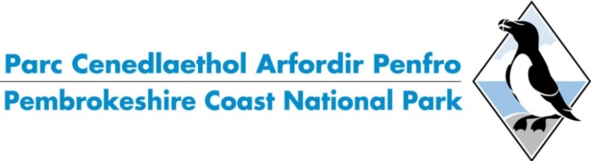**Your details**

Title……… Full Name………………………………………………………….

Address………………………………………………………………………………………………………………

…………………………………………………………………………………………….………………………….

…………………………………………………………………………..Postcode…………………………………

Email………………………………………………………………………………………………………………..

Tel ……………………………………………. Mobile………………………………………….………….…

Signed……………………………………………...  
  
Date…………………………………………...……

**Required plaque inscription**\*(please tick as applicable)   
 60mm

Dedicated to



Dedicated to  
John Davies

Sponsored by

Donated by

Name to be included on plaque…………………………………………………………………..

Plaque inscription to be within an area of 60mm x 40mm (1.5mm thick)

*Please note: the greater the number of letters, the smaller the letter size

* **I WISH TO DONATE** ……. (number of) gate/s
* **PREFERRED LOCATION/S**:………………………………………………………….

We will endeavour to find a gate as close as possible to your preferred location

My cheque is enclosed for £600 (per gate) made payable to   
‘**Pembrokeshire Coast National Park Authority’**

Please return this completed form with cheque to:

**Fundraising Team  
Pembrokeshire Coast National Park Authority  
Llanion Park  
Pembroke Dock  
Pembrokeshire  
SA72 6DY**

If you would like to make a payment via credit card, please call our customer services team on   
01646 624800.

**Terms and Conditions** By signing this form I agree to the following terms and conditions:

* My donation does not bestow upon me any right of ownership of the gate.
* Maintenance of the gate is the responsibility of and at the absolute discretion of the Pembrokeshire Coast National Park (PCNPA).
* Gate locations will be determined/agreed by PCNPA.
* Plaque installation will be included as soon as possible as part of the normal PCNPA programme as determined by the nature, quantity and location of all work to be carried out. We will look to affix your plaque within 3 months of payment being received.
* The fundraising team will contact the donor to confirm the installation has been completed and the location of the gate.
* PCNPA reserves the right to move a gate. Where this happens to a sponsored gate the plaque will be relocated to the nearest available gate and the sponsor informed.
* At the end of the 10 year sponsorship PCNPA will endeavour to contact the sponsor and ask if they would like to sponsor the gate again. It is therefore important for the sponsor to keep PCPNA informed of changes to contact information or contact PCNPA directly if they wish to sponsor the gate again. If PCNPA is unable to get in touch with the sponsor or the sponsor doesn’t wish to support again, the gate will then become available to the public for sponsorship.
* PCNPA will replace a plaque once, free of charge, if it has been damaged or stolen. Where a plaque is repeatedly being damaged or stolen, PCNPA will consult with the gate donor to discuss an alternative location for the plaque to be affixed.

**How the information you provide in this form is used**

The information provided in the form is collected and only used for the following reasons:

|  |  |  |
| --- | --- | --- |
| **What the personal information is used for** | **Our reasons** | **Our legitimate interests** |
| To administer Sponsor a Gate service | Contract Legitimate Interest Legal Obligation | Ensure Sponsor a Gate service is administered effectively, including contacting the sponsor at the end of the 10 year period to see if they would like to sponsor the gate again. |

Forms are stored securely for 6 years after the 10 year sponsorship has ended by the Authority under lawful basis of Contract and Legitimate Interest in case of a legal claim.

For further information on your rights please see Pembrokeshire Coast National Park Authority overarching privacy notice: <https://www.pembrokeshirecoast.wales/privacy>

Please contact Pembrokeshire Coast National Park Authority’s Data Protection Officer if you have any concerns at [DPO@pembrokeshirecoast.org.uk](mailto:DPO@pembrokeshirecoast.org.uk) or 01646 624800.