Pembrokeshire Coast National Park Authority
Pre-Application Planning Guidance
(Development Management)

Guide ds
Guidance to explain our Pre-Application Service
for Prospective Planning Applicants
Version 2: March 2016

www.pembrokeshirecoast.org.uk

contents

PRE-APPLICATION ADVICE SERVICE: AN INTRODUCTION 2
ADVANTAGES OF PRE-APPLICATION ADVICE 2
TYPES OF ADVICE AVAILABLE 3
PLANNING SURGERY 4
PRE-APPLICATION ADVICE - WHAT DO I SUBMIT? 5
PRE-APPLICATION CONSULTATION 6
Publicity before applying for planning permission 6
WHAT ADVICE WILL BE PROVIDED? 7
WHAT WE WILL DO 7
MEETINGS 8
TIMELINE FOR PRE-APPLICATION RESPONSE 8
DO I NEED PERMISSION? 9
Planning Permission 9
Listed Building Consent 9
Advertisement Consent 9
HOUSEHOLDER DEVELOPMENT QUERIES: DO I NEED PLANNING PERMISSION? 11
HOUSEHOLDER DEVELOPMENTS THAT WILL REQUIRE PLANNING PERMISSION 11
HOUSEHOLDER PERMITTED DEVELOPMENT QUERIES 12
FEES 12
IMPORTANT NOTE 14

PRE-APPLICATION ADVICE SERVICE: AN INTRODUCTION

The Pembrokeshire Coast National Park Authority is committed to providing an efficient, effective and customer focused planning service in order to ensure that quality developments can be delivered. To achieve these aims the Authority welcomes and encourages early discussions before a prospective developer or landowner submits a formal planning application for consideration. The Authority considers this will not only aid applicants in the information required to support an application but also give officer opinion of the likelihood of success.

ADVANTAGES OF PRE-APPLICATION ADVICE
The Development Management section is able to provide you with advice and information on a variety of matters that you will need to consider before you make an application for planning permission, listed building consent, advertisement consent or an application for a certificate of lawfulness. The Authority considers;

- It will establish the type and level of information required to support an application in order to avoid an incomplete or invalid submission.
- It will identify the relevant current and emerging planning policy framework and provide an opportunity to understand how our policies will be applied to your development.
- It can identify at an early stage where there may be a need for specialist input to a proposed development. For example about listed buildings, trees, landscape, noise, transport, contaminated land, ecology or archaeology.
- It will assist you in preparing proposals for an application which, providing you have taken our advice fully into account, will be handled more quickly.
- It may lead to a reduction in time spent by your professional advisors in working up proposals.
- It may indicate that a certain proposal is completely unacceptable therefore saving you the cost of pursuing an application.
- It can ensure an application is complete, comprehensive and to a satisfactory standard thus to avoid being invalid at registration stage or resulting in a refusal of permission based on a lack of/or insufficient information.

TYPES OF ADVICE AVAILABLE

Pre-application advice and information can be obtained from various ways before pursuing a formal proposal. Information can be found on our website and obtained over the telephone. The Authority has previously offered free pre-application advice for a number of years. Welsh Government has now introduced a requirement for all planning authorities to provide a statutory pre-application service and for a fee to be paid. The new statutory pre-application service is detailed within the following guidance. The Authority also offers a ‘Planning Surgery’ to assist with initial enquiries.

Advice can be obtained in the following ways:

PLANNING SURGERY
01/08/22 Update - Planning Surgeries are not currently taking place

PRE-APPLICATION ADVICE - WHAT DO I SUBMIT?

The Town and Country Planning (Pre-Application Services) (Wales) Regulations 2016 require all local planning authorities (LPAs) in Wales to provide a statutory pre-application service. The fees charged for statutory pre-application services are the same across Wales, although vary depending upon the size and scale of the proposed development:

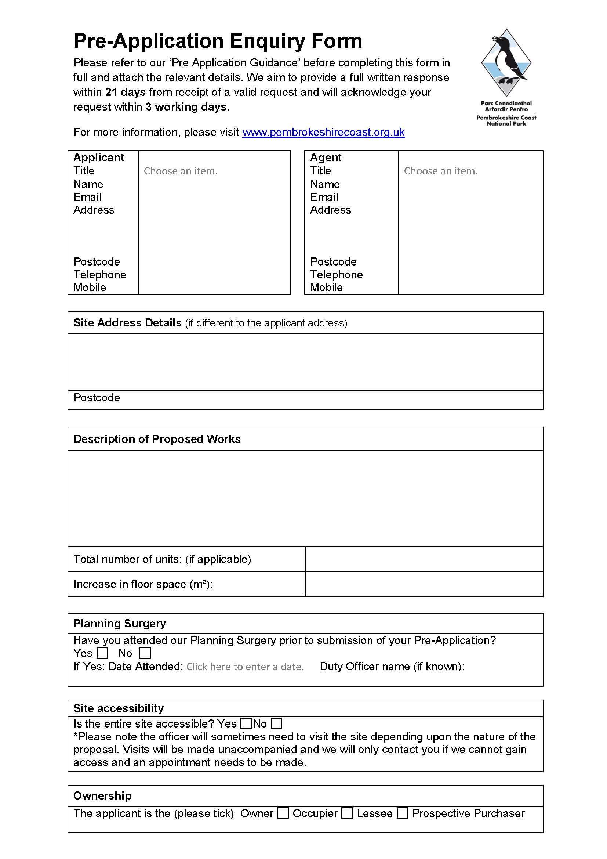
Householder - £25
Minor development - £250
Major development - £600
Large major development - £1000

Note: For more detailed information on fees, see the relevant section within this guidance.

In order to suitably manage the process all enquiries for pre-application advice shall be submitted on the ‘Pre-Application Enquiry Form’ together with any necessary supporting documents and plans. Please note that the level of information that should be submitted should be commensurate with the scale of the development that you are proposing. Plans and information about the existing site conditions, as well as specific details of your proposal are required so as to enable a desktop analysis to be carried out by officers. The more comprehensive the information supplied, the more detailed our response will be.

Applicants must submit a completed pre-application advice enquiry form containing information on their proposal to enable a response from the LPA. As a minimum they will be required to provide:
- Name, address and contact details
- Description of the proposal (including an indication of increase in floor space, and/or number of new units proposed)
- Site Address
- Location Plan
- Fee

You can download a copy of the form from our website at www.pembrokeshirecoast.org.uk under the ‘Planning’ and ‘Pre-Application’ links. Once completed your form and any necessary supporting information can be returned via email to DC@pembrokeshirecoast.org.uk or via post to:
Development Management
Pembrokeshire Coast National Park Authority
Llanion Park
Pembroke Dock
Pembrokeshire
SA72 6DY
Pre-Application Consultation
The requirement to undertake pre-application consultation applies to all applications for “major” development (full or outline) as defined in article 2 of the Town and Country Planning (Development Management Procedure) (Wales) Order 2012 (DMPWO) and applications for Developments of National Significance (DNS).

The requirement does not apply to proposed applications under section 73 or 73A of the Town and Country Planning Act 1990; reserved matters; non-material amendments or minor material amendments.

Publicity before applying for planning permission

The developer must undertake the following publicity/consultation procedures:

- Display a site notice in at least one place on or near the land to which the proposed application relates for a period of no less than 28 days before submitting an application for the proposed development
- Write to “any owner or occupier of any land adjoining the land to which the proposed application relates”
- Make the draft planning application information available publically
- Consult community and specialist consultees before applying for planning permission
- Consider if Environmental Impact Assessment (EIA) is required for the project
- Submit a pre-application consultation report (PAC) as part of the planning application

Further advice and guidance can be found under annex 1 pre-application consultation guidance within The Town and Country Planning (Development Management Procedure) (Wales) (Amendment) Order 2016 or by using the following link: http://gov.wales/docs/desh/publications/160129annex-1-pre-application-consultation-en.pdf

It is important to note that whilst the provisions contained within the DMPWO for pre-application consultation in respect of applications for major development will come into force in March 2016 the requirement for applicants to submit the pre-application consultation report (PAC) will not be a validation requirement for applications made before 1st August 2016.

This transition period will allow prospective applicants who will be submitting after the 1st August to undertake pre-application consultation, and will place a duty on statutory consultees to provide substantive responses within 28 days to these requests. However, it will not prejudice applicants who are due to imminently submit a planning application, and would find that it would not be valid because the statutory requirements of the pre-application process have not been undertaken.

Further advice on this subject can also be obtained by contacting our Planning Admin Team on 01646 624800 or email us at dc@pembrokeshirecoast.org.uk

WHAT ADVICE WILL BE PROVIDED?

As a minimum, applicants for householder developments should expect to receive the following information within their written response:
- The relevant planning history of the site
- The relevant development plan policies against which the development proposal will be assessed
- Relevant supplementary planning guidance (i.e. design, conservation etc.)
- Any other material planning considerations
- An initial assessment of the proposed development, based on the information above

For all other development proposals, applicants should receive all the information outlined above, as well as whether any Section 106 or Community Infrastructure Levy contributions are likely to be sought and an indication of the scope and amount of these contributions.

WHAT WE WILL DO

On receipt of your initial enquiry we will firstly check whether all the necessary information as detailed on the enquiry form has been submitted. If it has not, we will write to you confirming that we will not progress your enquiry until the relevant information has been submitted. We will set out in the letter the information required to progress your enquiry.

Once the relevant information to consider the pre-application has been received then the Head of Development Management or Senior Planner will allocate your enquiry accordingly to an officer (‘the Case Officer’).

An acknowledgement letter or email will be sent to you within 5 working days of a valid pre-application enquiry being received in the Section and the acknowledgement will confirm the details of the Case Officer handling it and the date you may expect to receive a written reply to your enquiry. The Authority aims to provide a full response within 21 working days of receipt, however, if, on researching the enquiry, we do not have enough information to answer your enquiry or if we consider further time will be needed to appraise the scheme then we will contact you advising of the time period needed to respond.

An officer may need to visit the proposed site of development in order to assess the nature of the site. Visits will be made on an unannounced basis, however, if access is likely to be restricted or an appointment is required please advise on your submitted form.

MEETINGS

If a meeting is requested, the Case Officer and Head of Development Management will decide whether a meeting is necessary or whether suitable advice can be provided by letter. If it is agreed that a meeting is appropriate, the enquiry will be checked to see whether the appropriate level of information has been submitted as set out above, and the Case Officer will contact you to arrange a suitable date for a meeting (normally within 10 working days of receipt of the request). However this will depend upon the complexity of the scheme and the amount of work that will be needed prior to a meeting including any time necessary to obtain initial views of other interested parties.

Attendance of other officers at the meeting, including specialist advisors, will be at the Case Officer’s discretion. Following the meeting, we will write to you confirming the Officers view. This will be within the 21 days set out unless the proposal is particularly complex, when an alternative timescale will be agreed at the earliest possible stage of the discussions. You may also take notes at the meeting and, if you wish, the Case Officer will check and amend these as necessary to produce an accurate account of the meeting itself.

Any meeting will normally take place at the Authority’s Headquarters at Llanion Park, Pembroke Dock unless an alternative is agreed with the Case Officer.

TIMELINE FOR PRE-APPLICATION RESPONSE
DO I NEED PERMISSION?
within 21
days or other agreed timescale
within 10
days
within 5 working
days
within 3
working days

Planning Permission

Planning permission is required for ‘development’ which includes both operational development and change of use to a new use.

The need for planning permission will be dependent on a number of factors and circumstances. Section 55 of the Town and Country Planning Act defines ‘development’ as:

"... 'development', means the carrying out of building, engineering, mining or other operations in, on, over or under land, or the making of any material change in the use of any buildings or other land ..."

Where works are defined as being ‘development’ planning permission will be required unless the works being undertaken are considered to be ‘permitted development’ by virtue of the Town and Country Planning (General Permitted Development) Order 1995 as amended in Wales.
If you require a legal confirmation whether or not planning permission is required for a development, you will need to submit an application for a Certificate of Lawfulness under sections 191 or 192 of the Town and Country Planning Act (1990).

Listed Building Consent
Listed Building Consent will be needed if you want to alter or extend a building (both externally and internally) as a building of special architectural or historic interest. Listed Building Consent may also be required for any works to separate buildings within the grounds of a Listed Building. It is a criminal offence to carry out works, which need listed building consent, without first obtaining it. The Authority’s Buildings Conservation Officer will be happy to assist by providing guidance.

Advertisement Consent
In Wales advertisements are controlled by statute through the Town and Country Planning (Control of Advertisements) Regulations 1992. In the Planning Act Advertisements are defined as being:
“any word, letter, model, sign, placard, board, notice, awning, blind, device or representation, whether illuminated or not, in the nature of, and employed wholly or partly for the purposes of, advertisement, announcement or direction, and (without prejudice to the previous provisions of this definition) includes any hoarding or similar structure used or designed, or adapted for use and anything else principally used, or designed or adapted principally for use, for the display of advertisements.”
There are 3 categories defined in the Regulations and these include (i) advertisements exempt from control, (ii) advertisements with ‘deemed consent’ and (iii) advertisements requiring express consent.
Advertisements exempt from control:
Provided certain conditions are met the following are specifically excluded from control by planning authorities:
- advertisements displayed in enclosed land,
- advertisements which are an integral part of a building’s fabric,
- advertisements in the form of price tickets or markers (such as petrol pumps or vending machines) which must not be illuminated or exceed 0.1 square metres in area
- advertisements relating specifically to a pending Parliamentary, European Parliamentary, National Assembly or local government elevation which must not be displayed 14 days after the close of the poll.
- Advertisements required by a Parliamentary Order, or any enactment.
- Any traffic sign (as defined in section 64(1) of the Road Traffic Regulation Act 1984) on land forming part of the highway.
- A national flag of any country (on a single vertical flagstaff, so long as it does not have anything added to the design of the flag or flagstaff).
- Advertisements displayed inside a building, which must not be illuminated and must be at least one metre from any window.
Advertisements with ‘deemed consent’

There are 14 classes of advertisement which are permitted as long as the conditions are fully met and an application will not be needed. The relevant limitations are listed in the Town and Country Planning (Control of Advertisements) Regulations 1992.

Advertisements requiring ‘express consent’

If an advertisement you wish to display does not fall within the two previous groups, you will need to submit an application for the National Park Authority’s express consent before you can display it. Examples of the types of advertisements requiring such consent are:

- Virtually all posters
- Virtually all directional signs
- Most illuminated signs
- Signs which exceed the limitations for the 14 classes of deemed consent
- Most advertisement on gable ends of buildings.

Please note that anyone who displays an advertisement or uses an advertisement site, or knowingly permits someone else to do so, without consent is acting illegally. It is open to the National Park Authority to bring a prosecution in the Magistrates’ Court for an offence under Section 224 of the Town and Country Planning Act 1990.

If you remain unsure as to the need for Advertisement Consent after having regard to the above Regulations please attend our Planning Surgery or submit a Pre Application Enquiry.

HOUSEHOLDER DEVELOPMENT QUERIES: DO I NEED PLANNING PERMISSION?
Changes to the legislation that sets out what requires planning permission within the curtilage of a dwellinghouse came into force on 30th September 2013 across Wales. These changes represent a fundamental change from the previous rights which had been in place since 1995.
Information on the need for planning permission can be found in the following guidance documents produced by Welsh Government which are available to view online by clicking on the below links:
- Planning: A Guide for householders (Version 2 – April 2014)
- Permitted development for householders: Technical Guidance (April 2014)
Where a legal view is required the Authority welcomes the submission of applications for a Certificate of Lawfulness under Section 192 (Proposed Development) of the Town and Country Planning Act 1990 (as amended).
Your application will need to be accompanied by;
- Completed application forms
- Site location plan to a scale of 1:1250 or 1:2500
- Block Plan
- Elevations/Floor Plans
Currently these applications (for householder proposals) are subject to a fee of £95 which is half the cost of a planning application fee which is £190 for a planning application.

HOUSEHOLDER DEVELOPMENTS THAT WILL REQUIRE PLANNING PERMISSION

In order to assist in clarifying the developments that will clearly require planning permission the National Park Authority has produced the below list. If you are proposing development which fits within any of these categories planning permission will be required. You are therefore advised to submit a pre-application in order for the Authority to provide feedback on your scheme of development or alternatively you can submit a householder planning application.
- Single storey rear extension more than 4m long (measured from rear wall of original house)
- Two storey extension
- Any extension more than 4m to ridge height
- Any extension more than 3m to eaves height
- Verandas, raised platforms, roof terraces, balconies, shutters
- Single storey side extension not set back from front wall by 1m and more than 3m in width
- Any extension to your roof
- Any roof lights
- Any buildings between the side elevation of your house and its side boundary
- Any outbuilding measuring more than 2.5m where it is within 2m of the curtilage of the dwelling
- Any outbuilding measuring more than 3m with a flat roof
- Any outbuilding measuring more than 4m with a pitched roof
- Removal, replacing or new chimney
Please note that this list is not exhaustive and where in doubt officers will advise the prospective developer to submit an application for a Certificate of Lawfulness for a Proposed Development.

HOUSEHOLDER PERMITTED DEVELOPMENT QUERIES
If, having consulted the above mentioned Guidance documents and information, you remain unsure as to the need for planning permission please complete a pre-application enquiry form and provide the necessary information and fee. Officers will consider the information provided having regard to the relevant legislation and advise whether planning permission is required for a proposed or existing development.

FEES
Where a request for pre-application services relates to a proposed householder application, the fee payable is £25.
Where, in respect of any category, the fee is to be calculated by reference to the site area, that area must be taken as consisting of the area of land to which the proposed application relates.

In relation to proposed development within category 2 or 3 below, the area of the gross floor space to be created by the proposed development must be ascertained by external measurement of the floor space, whether or not it is to be bounded (wholly or partly) by external walls of a building.

Where a request for pre-application services relates to proposed development within more than one category, a single fee is payable which is the higher or highest of the fees calculated in accordance with each such category.
1. The erection of dwellinghouses:
(a) Where—
(i) the number of dwellinghouses to be created by the proposed development is one to nine, £250,
(ii) the number of dwellinghouses to be created by the proposed development is 10 to 24, £600,
(iii) the number of dwellinghouses to be created by the proposed development exceeds 24, £1,000;
(b) where the number of dwellinghouses to be created is not known and—
(i) the proposed site area does not exceed 0.49 hectares, £250,
(ii) the proposed site area is 0.5 to 0.99 hectares, £600,
(iii) the proposed site area exceeds 0.99 hectares, £1,000.

2. The erection of buildings (other than dwellinghouses)
(a) Where—
(i) the area of the gross floor space to be created by the proposed development does not exceed 999 square metres, £250,
(ii) the area of the gross floor space to be created by the proposed development is 1,000 to 1,999 square metres, £600,
(iii) the area of the gross floor space to be created by the proposed development exceeds 1,999 square metres, £1,000;
(b) where the gross floor space to be created by the proposed development is not known and—
(i) the proposed site area does not exceed 0.49 hectares, £250,
(ii) the proposed site area is 0.5 to 0.99 hectares, £600,
(iii) the proposed site area exceeds 0.99 hectares, £1,000.

3. The making of a material change in the use of a building or land
(a) Where the request for pre-application services relates to a proposed application for permission for a material change in the use of a building and—
(i) the area of the gross floor space of the proposed development does not exceed 999 square metres, £250,
(ii) where the area of the gross floor space of the proposed development is 1,000 to 1,999 square metres, £600,
(iii) where the area of the gross floor space of the proposed development exceeds 1,999 square metres, £1,000;
(b) where the request for pre-application services relates to a proposed application for permission for a material change in the use of land and—
(i) the site area does not exceed 0.49 hectares, £250,
(ii) the site area is 0.5 to 0.99 hectares, £600,
(iii) the site area exceeds 0.99 hectares, £1,000.

4. The winning and working of minerals or the use of land for mineral-working deposits (1) £600
(1) For the definition of “mineral-working deposit” see section 336 of the 1990 Act.

5. Waste development £600

IMPORTANT NOTE

Officer Advice

We will always do our best to provide you with the best advice we can based on the information to hand. However, the planning system is a democratic process, and any advice provided by an officer of the Authority through a pre-application is an officer view only based upon the information provided in your query and is given entirely without prejudice to any future decision that may be made by the National Park Authority. Therefore a pre-application response does not constitute a formal decision by the Authority as a Local Planning Authority.

Decisions

Following receipt of an application the final decision on an application made will only be taken after the Authority has consulted the local community/town council, neighbours, statutory parties and any other interested parties. The final decision that is taken on any future application that the Authority may make will be made under delegated powers in accordance with the Authority’s approved Scheme of Delegation OR by the Development Management Committee, and will be based on all of the information available at that time. You should therefore be aware that officers cannot guarantee the final decision that will be made on your application(s).

Time Limited Advice

Please be aware that any pre-application advice given is restricted to a period of 6 months. This is on the basis that the weight given to pre-application advice will decline over time and pre-application advice can be superseded by new planning policies or new government guidance. However any pre-application advice that has been provided will be carefully considered in reaching a decision or recommendation on an application. The Authority has the right to decline a request to deal with any pre-application advice where it is not considered either appropriate or necessary.

Freedom of Information Act
Developers and applicants should be aware that information related to pre-applications may be subject to requests under the Freedom of Information Act 2000 and the Environmental Information Regulations 2004. The Act and the Regulations provide for some exemptions from the need to disclose commercially sensitive information and in cases where applicants consider that specific information is exempt from the requirements of the Act or the Regulations, the justification for their position should be provided to the local planning authority.

