GREEN INFRASTRUCTURE STATEMENT & BIODIVERSITY ENHANCEMENT SCHEME

Template for householder applications and other small developments.
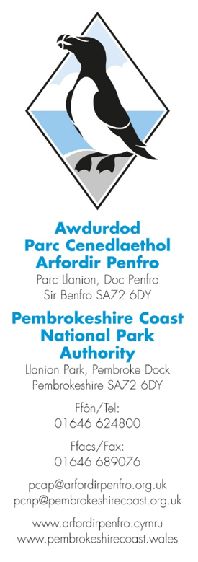
Complete the boxes in this form and include with your planning application.
Refer to the accompanying guidance note for site-specific information.
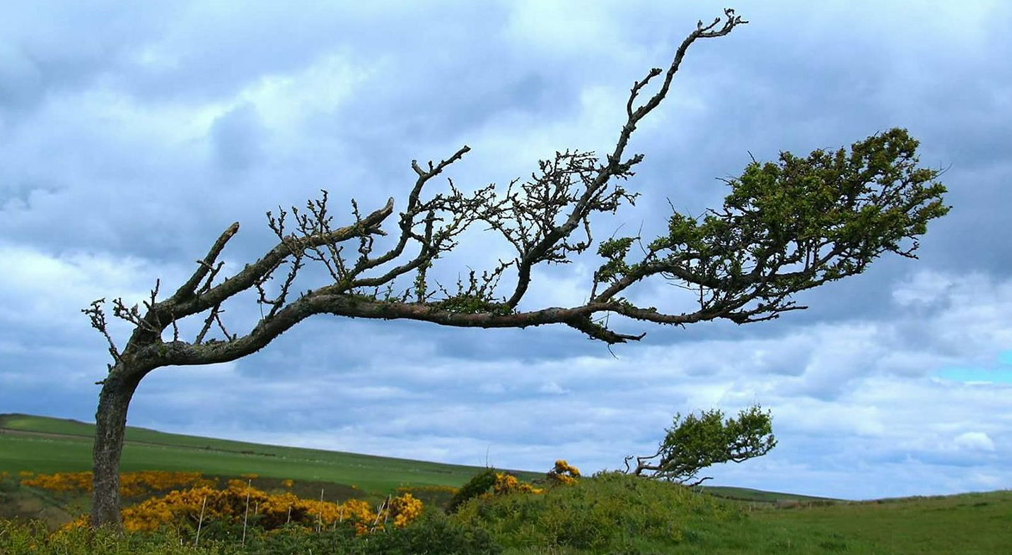

Q. What is a Green Infrastructure (GI) Statement?
A Green Infrastructure Statement describes how the green infrastructure of a site (trees, hedges, and SuDs) has been incorporated into the development proposal.

Q. Why do I need a Green Infrastructure Statement?
A GI Statement is required on all developments following PPW12, and the Environment (Wales) Act 2016 Section 6 duty to show that development has a net benefit to biodiversity and green infrastructure. This information is not appropriate to seek ‘retrospectively’ by way of a condition and must be provided as part of the planning application process.

Q. What detail is required in the Green Infrastructure Statement?
A Green Infrastructure Statement is to be proportionate to the scale and nature of the development, and in the case of minor development such as householder applications, PPW12 states that this should not be an onerous requirement for applicants.

Q. What is a Biodiversity Enhancement Scheme?
To comply with Section 6 of the Environment (Wales) Act 2016, this Authority requires that proposed developments also include details of biodiversity enhancement measures as well as Green Infrastructure enhancements.
These don’t need to be costly or large in scale, and could include bird boxes, insect boxes and the planting of native shrubs or flowers suitable for bees and other pollinations in the garden.

Q. How do I provide the information?
To assist in providing the information that this authority requires, the following form can be completed to provide the specific Green Infrastructure details that relate to each step your proposed development.
Form completed by:
Date:
Address of site:
Grid reference:
Description of Proposal:

- Details of all existing green infrastructure (trees, hedges and hedgebanks) on site:
Boundary 1:
Boundary 2:
Boundary 3:
Boundary 4:
Front Garden:
Rear Garden:
Other:

- What green infrastructure features have already been removed from site and/or require removal to facilitate the development?
Boundary 1:
Boundary 2:
Boundary 3:
Boundary 4:
Front Garden:
Rear Garden:
Other:

- How are the retained features being protected during development (i.e. BS5837:2012)?
Boundary 1:
Boundary 2:
Boundary 3:
Boundary 4:
Front Garden:
Rear Garden:
Other:

- What green infrastructure is being planted as mitigation for losses?
Boundary 1:
Boundary 2:
Boundary 3:
Boundary 4:
Front Garden:
Rear Garden:
Other:
- What Landscaping is being planted to enhance Green Infrastructure?
Boundary 1:
Boundary 2:
Boundary 3:
Boundary 4:
Front Garden:
Rear Garden:
Other:

- How will the new planting be managed and/or maintained?

- Biodiversity enhancements
These enhancements do not need to be directly attached to the proposed new construction; they can be attached to the host dwelling or placed within the garden, but they do need to be on land within the red or blue line. The principle is that these enhancements will lead to a ‘net benefit’ for biodiversity.

The following biodiversity enhancements have been added:
Type | Location | Info

- Conclusion
Based on the information provided above, this development will result in a Green Infrastructure Net Benefit upon completion.

- Sketch plan (Insert plan showing the features of the development site):

- Site photos (as required)

