GREEN INFRASTRUCTURE STATEMENT & BIODIVERSITY ENHANCEMENT SCHEME

Guidance note on Green Infrastructure to assist in providing site-specific information using the stepwise approach.

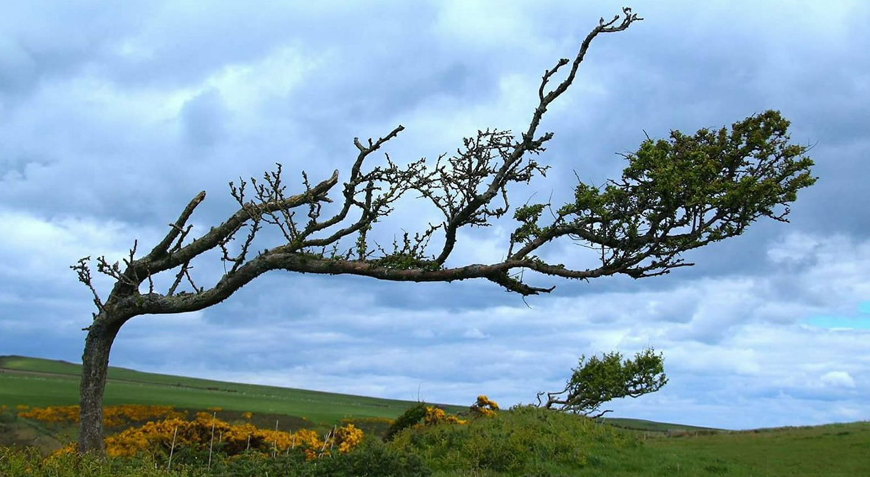

Q. What is a Green Infrastructure (GI) Statement?
A Green Infrastructure Statement describes how the green infrastructure of a site (trees, hedges, and SuDs) has been incorporated into the development proposal.

Q. Why do I need a Green Infrastructure Statement?
A GI Statement is required on all developments following PPW12, and the Environment (Wales) Act 2016 Section 6 duty to show that development has a net benefit to biodiversity and green infrastructuree. This information is not appropriate to seek ‘retrospectively’ by way of a condition and must be provided as part of the planning application process.

Q. What detail is required in the Green Infrastructure Statement?
A Green Infrastructure Statement is to be proportionate to the scale and nature of the development, and in the case of minor development such as householder applications, PPW12 states that this should not be an onerous requirement for applicants.

Q. What is a Biodiversity Enhancement Scheme?
To comply with Section 6 of the Environment (Wales) Act 2016, the Authority requires that proposed developments include details of biodiversity enhancement measures.
These don’t need to be costly or large in scale, and could include bird boxes, insect boxes, bee and invertebrate mounds, and the planting of native shrubs or flowers suitable for bees and other pollinations in the garden.

Q. How do I provide the information?
To assist in providing the information that this authority requires, the associated form can be completed to provide the specific Green Infrastructure details that relate to each step of your proposed development.

Example of completed Green Infrastructure Statement and Biodiversity Enhancement Form

Form completed by: | A. N Other
Date: | DD/MM/YYYY
Address of site: | 1 High Street, The Town, Anyshire, XX00 0XX
Grid reference: | XX12341234
Description of Proposal: | New extension to rear of property, requiring removal of one tree and translocation of hedge to facilitate new driveway.

- Details of all existing green infrastructure on site:
Boundary 1: | Privet hedge bordering adjacent woodland copse
Boundary 2: | Boarded fence
Boundary 3: | Non-native hedge, drainage ditch along opposite side, linked to neighbouring hedge
Boundary 4: | N/A Wall
Front Garden: | 2 no. trees (Apple and cherry)
Rear Garden: | 5 no. trees (Apple, Oak, Oak, Birch and Rowan)
Other: | Scattered shrubs in front and rear garden

- What green infrastructure features (trees, hedges, hedgebanks) have already been removed from site and/or require removal to facilitate the development?
Boundary 1: | None
Boundary 2: | N/A -Fence
Boundary 3: | Already removed - 3 metre section removed for new access –
Boundary 4: | N/A - Wall
Front Garden: | None
Rear Garden: | Requires removal - 1 no. Oak
Other: | Require removal in rear garden - 2 no. shrubs unknown

- How are the retained features being protected during development (BS5837:2012)?
Boundary 1: | 2 metre buffer zone from base of hedge using heras fencing (see below).
Boundary 2: | N/A
Boundary 3: | 2 metre buffer zone from base of hedge using heras fencing (See below).
Boundary 4: | N/A
Front Garden: | Majority of garden fenced off during development with heras fencing
Rear Garden: | Garden fenced off during development with heras fencing
Other: | Or - See attached BS5837 Tree Report

- What green infrastructure is being planted as mitigation for losses?
Boundary 1: | N/A
Boundary 2: | N/A
Boundary 3: | Translocated hedge in sections either side of new entrance
Boundary 4: | N/A
Front Garden: | N/A
Rear Garden: | 3 no. trees (Oak, Hazel, Willow)
Other: | or: See attached Landscape Plan
- What Landscaping is being implemented to enhance Green Infrastructure?
Boundary 1: | N/A
Boundary 2: | N/A
Boundary 3: | Translocated hedgebank in sections either side of new entrance
Boundary 4: | N/A
Front Garden: | N/A
Rear Garden: | New Pond, Green Roof, Water Butt, and the three trees as per the mitigation
Other: | or: See attached Landscape Plan

- How will the new planting be implemented, managed and/or maintained?
3 no. trees planted for every tree removed.
Trees will be planted in areas previously cleared of all weeds, grass, and vegetation.
The trees are to be of ‘Selected Standard’ size, 10-12 cm girth, 2.75-3.0 metres tall, bare-root or root-balled and healthy and vigorous.
Trees will be planted in planting holes 1.2m x 1.2m x 900mm deep, with the topsoil mixed with a minimum of 20 litres of suitable tree planting compost and replaced carefully around the roots and lightly compacted every 150mm layer.
Trees will be supported with a treated timber stake and rubber ties
Planting to be undertaken in first planting season following the implementation of the development.
Plants/trees/shrubs will be watered as necessary during periods of dry weather.
Any failures will be replaced on a like-for-like basis in the next available planting season.
Native hedges will have 6 plants per metre in two staggered rows about 25cm apart (or 40-60cm apart in each row).
Pembrokeshire hedgebank to be constructed in accordance with PCNPA guidance note.
Green roof to be implemented in accordance with PCNPA guidance note.
Pond implemented in accordance with Wildlife trust guidance.

- Biodiversity enhancements
The enhancements do not need to be directly attached to the proposed new construction; they can be attached to the host dwelling or placed within the garden, but they do need to be on land within the red or blue line. The principle is that the enhancements will lead to a ‘net benefit’ for biodiversity. The following biodiversity enhancements have also been added:

Type | Location | Info
Bat box | Side of house (gable 4m metres) from ground level | West Facing
Hedgehog hole | In fence along Boundary 2 | Agreed with neighbour
Bird Box | Back of house – under eaves | North Facing
Wildlife Pond | Side of rear garden | With native planting
Compost bin | Corner of rear garden | For garden arisings

- Conclusion
Based on the information provided above, this development will result in a Green Infrastructure and biodiversity Net Benefit upon completion.

- Sketch plan (showing the approximate plan of the features of the development site):
Retained trees (Green circle) | Bat box – (Blue cross)
Removed tree (Red circle) | Bird box (Green cross)
New trees (Orange circle) | Hedgehog hole in fence (pale blue cross)
Protective fencing (Purple line) | Hedge section translocation (Orange arrows)
Compost bin (blue spot) | water butt (green spot)
Wildlife pond (Pale blue oval)
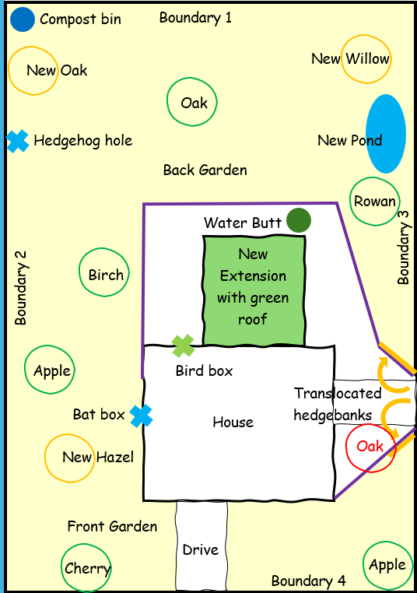

- Site photos (examples)
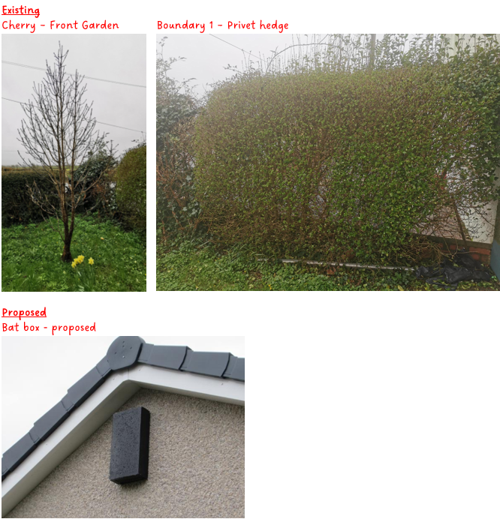

Q. What other advice is there to help me?
The following links relate to Green Infrastructure matters and Biodiversity Enhancements that can assist in providing details:
- Tree Preservation Order and Conservation Area interactive map
- Trees and Shrubs native to Pembrokeshire
- Advice note relating to Grass and Wildflower Seed Mixes.
- Green Roof guide
- Pembrokeshire hedgebanks
- Guidance on Selection of Trees and Shrubs in Pembrokeshire
- Boundary planting
- Implementing soft landscaping
- Apple varieties suited to West Wales
- PCNPA Supplementary Planning Guidance (Biodiversity)
- Pembrokeshire Green Infrastructure Statement
- Planning Policy Wales 12 (PPW 12)
- Environment (Wales) Act 2016
- Technical Advice Note 5 (TAN 5) – Nature Conservation and Planning
- Wildlife trusts – Pond advice

Q. How is the stepwise approach used to result in Net Benefit of Green Infrastructure and Biodiversity Enhancement?

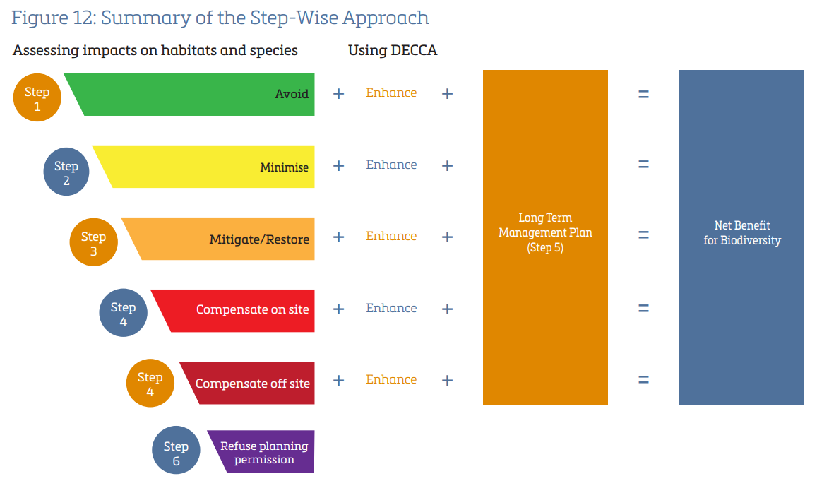

Q. What are examples of biodiversity enhancements in gardens?
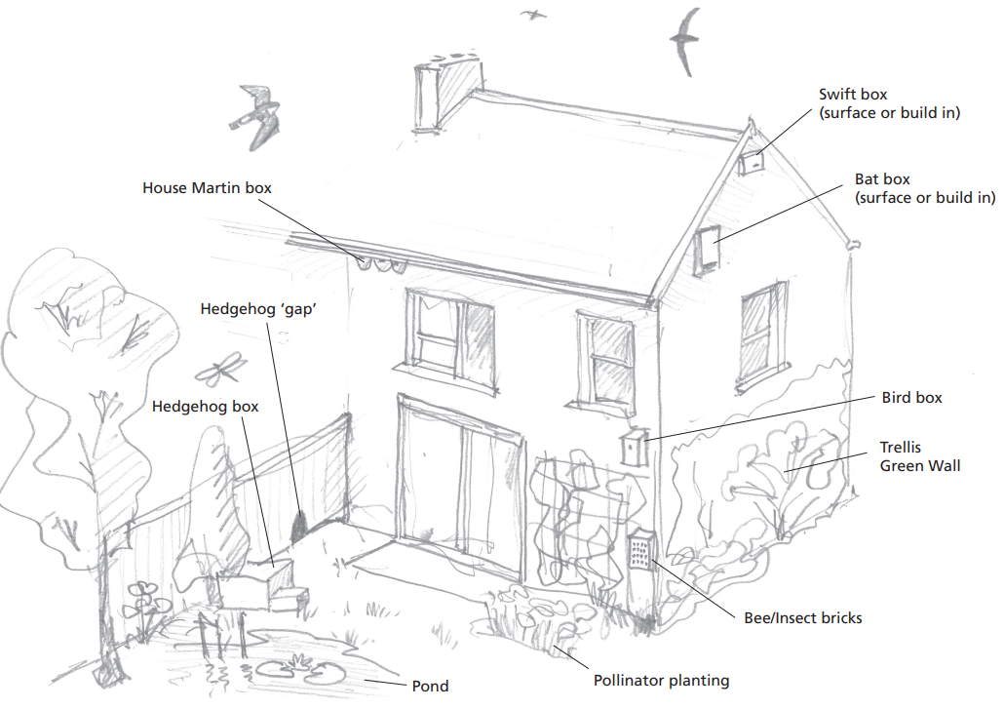

For more information please contact:

Development Management
Pembrokeshire Coast National Park Authority
Llanion Park
Pembroke Dock
Pembrokeshire
SA72 6DY

Email:
dc@pembrokeshirecoast.org.uk

Trees and Hedge Management:
https://www.pembrokeshirecoast.wales/planning/planning-advice/trees-and-hedge-management/

Figure 12 of PPW12
PCNPA Biodiversity SPG (Page 33) https://www.pembrokeshirecoast.wales/wp-content/uploads/2021/06/Post-Cons-Bio-SPG-Eng-1.pdf

