PEMBROKESHIRE COAST NATIONAL PARK AUTHORITY

TENDER FOR ST GOVANS CAR PARK ICE CREAM VAN CONCESSION for the Period 1st April – 31st October 2026

Name of Applicant:………………………………………………………

Address:………………………………………………………………….

………………………………………………………………….

Contact Telephone:………………………………………………………

E-Mail Address………………………………………………………….

In consideration of the Pembrokeshire Coast National Park (the Licensor) granting me (the Applicant and Prospective Licensee) the ice cream sales concession for one mobile ice cream van at St Govan’s Car Park on the conditions set out below and in accordance with the terms contained within the attached licence agreement, I hereby offer to pay the sum specified for the period 1st April – 31st October 2026:-

Amount of Tender (please state in words)

………………………………………………………………………….

NOTE: V.A.T is not charged on the above tender

Notes for prospective Licensees

- The terms as set out within the attached licence (2026 season specimen document) are non-negotiable. Any interested party must therefore satisfy themselves that they are willing and able to operate within the terms contained therein.

- Can we please draw your attention to clause 3.c of the attached licence which requires any Ice Cream Van operating from the site with its engine running to have a Euro Standard 4 (minimum) Emissions rating as evidenced by the DVLAs records for that vehicle.

- Can we please draw to your attention to the need for the successful applicant to complete a Pembrokeshire Coast National Park Authority approved online Safeguarding course and provide certification evidence of their successful completion of that course . Details of the Safeguarding course will be made available to the successful applicant and their failure to complete it will result in the concession offer being revoked.

- The attached aerial photograph shows the full extent of the permitted trading area edged red. For the avoidance of doubt the trading concession being offered is limited and restricted to within the boundary of the area shown edged red only

- The concession site lies within the Castlemartin military firing range. This is a busy operational firing range. For obvious safety reasons the public’s access to the concession site is limited to periods when the range is not in use. Published times for when the range is not in use can change at short notice. The Licensor has no control over any changes to the published firing times. Information on live firing times can be viewed via the DTE Pembrokeshire website. Live firing notices are also issued to the local police and the coastguard as well as being published in local newspapers and at the entrances and exits to the Range. Further information on live firing times is available from the Range Office on 01646 662336 (manned during firing), 01646 662367 (recorded message) or from the Range Gatehouse 01646 662280 (manned 24 hours a day).

- Applicants are strongly advised to familiarise themselves with the published firing times and satisfy themselves as to the possible impact that any unpublished changes might have to their operation of the concession during the licence period because in the event that the Licensee is unable to gain access to St Govan’s Car Park for any period of time and for any reason they will not be entitled to any compensation or refund of the licence fee by the Licensor.

- The successful applicant will be notified by the Licensor on the 11th March 2026

- Following notification by the Licensor that the applicants tender has been accepted, the applicant will be required to sign and return the licence on or before 18th March 2026 accompanied by payment of the licence fee in full, Safeguarding course completion certificate and a copy of their public liability insurance covering the entire period of the 2026 licence agreement. That public liability insurance must indemnify the Licensor from all risks claims and liabilities arising from the Licensees operation of the concession and provide a minimum cover of £5million.

- PLEASE NOTE THAT IF THE APPLICANT DOES NOT RETURN THE SIGNED LICENCE AGREEMENT ACCOMPANIED BY THE LICENCE FEE PAYMENT IN FULL, SAFE GUARDING COURSE COMPLETION CERTIFICATE AND COPY PUBLIC LIABILITY DOCUMENTS ON OR BEFORE THE 18th MARCH 2025 THE CONCESSION OFFER WILL BE REVOKED WITHOUT FURTHER NOTICE

I have read the above notes, visited the site to familiarise myself with the location and understand and accept the terms and conditions as detailed in the attached licence agreement. I also understand that the Pembrokeshire Coast National Park Authority is not bound to accept the highest or any tender received.

Signed: ……………………………………. Date: ………………………………………..

WHEN COMPLETED, THIS FORM MUST BE RETURNED BY EMAIL TO THE PEMBROKESHIRE COAST NATIONAL PARK AUTHORITY USING THE FOLLOWING EMAIL ADDRESS:-

tenders@pembrokeshirecoast.org.uk

TO ARRIVE NO LATER THAN 12 NOON ON 4th MARCH 2026

PLEASE NOTE: Tenders received by the Licensor in any other form will not be accepted

----------------------------------------------------------------------------------------------------------------

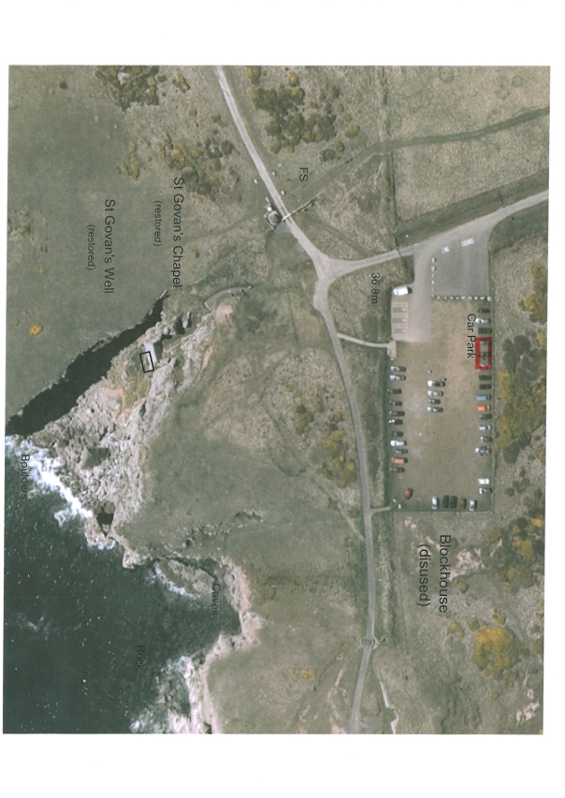

DRAFT

2026 Season Specimen
LICENCE AGREEMENT

THIS AGREEMENT is made the………….. day of ………………………Two thousand and …………………BETWEEN PEMBROKESHIRE COAST NATIONAL PARK AUTHORITY of Llanion Park Pembroke Dock Pembrokeshire SA72 6DY (“the Licensor”) (1) and ………………………………………………….. Of …………………………………………..
aforesaid (“the Licensee”) (2)

WHEREBY:
1.In this Licence the following terms shall have the meanings hereby given to them: -

“the Plan” means the plan annexed hereto

“ the land” means the land shown edged red on the attached plan at St Govans Car Park, Pembrokeshire

“the Licence period” means the period beginning on the 1st day of April 2026 until the 31st Day of October 2026 or such earlier date if the Licensees rights under clause 2 are terminated under the provisions of clause 4a.i or 4a.ii

“the Licence Fee” means £……………..

“the permitted use” means for the sale of ice creams and ice lollies from a single mobile ice cream van only to members of the public between the hours of 8am and 8pm and for no other purpose.

2. Subject to the provisions of clauses 3 and 4 the Licensor gives the Licensee the right (in common with the Licensor and all other authorised by the Licensor so far as is not in consistent with the rights hereby given) to use the land during the Licence Period for the permitted use

3. The Licensee agrees and undertakes as follows: -

- To pay the Licensor:

  - The Licence Fee in full in advance

  - On demand a fair and reasonable proportion (apportioned in respect of the Licence Period) of all National Non-Domestic Rates and other outgoings of a periodically recurring nature incurred in respect of the Premises

  - VAT on such payments referred to in this sub clause a. as carry VAT

- To display a Level 3 (minimum) certificate issued under the Food Hygiene Wales scheme at all times whilst exercising the permitted use

- Ensure that any Ice Cream Van operating from the land with its engine running has a Euro Standard 4 (minimum) Emissions rating as evidenced by the DVLA’s records for that vehicle

- Not to bring any goods or chattels on to the land other than those required for the reasonable enjoyment of the permitted use and to remove all such goods and chattels from the land between the hours of 8pm and 8am daily.

- To keep the land clean and tidy and clear of rubbish during the licence period and to leave the land in the same condition as existed immediately prior to the commencement of the licence period including the removal of all goods and chattels belonging to the Licensee

- In the event that the Licensee does not fully comply with the provisions of clause 3.c to the full satisfaction of the Licensor within 48 hours of the expiry of the licence period the Licensor will at its absolute discretion carry out such works as the Licensor considers necessary to reinstate the land and recover the cost of such works in full from the Licensee

- To display a prominent sign at the point of hire advising the public of the price of the ice cream and ice lollies being offered for sale and any conditions attached thereto

- To display at all times at the point of sale whilst exercising the permitted use an authority to trade notice which will be issued by the Licensor at the commencement of the licence period

- No signs or notices other than that referred to above at 3.e and 3.f are to be displayed upon the land.

- To at all times abide by the instructions of the Castlemartin Range Staff and vacate the concession site immediately at any time when so requested by a member of the Castlemartin Range to do so.

- Not to use the land in such a way as to cause any nuisance damage disturbance annoyance inconvenience or interference to the owners and occupiers of adjoining or neighbouring property

- To observe all statutory requirements affecting the land and not to do or permit or suffer to be done on the land anything which would or might constitute a breach of any such statutory requirement or which would or might vitiate in whole or in part any insurance affected in respect of the land

- To continuously hold public liability insurance for the use of the land in the sum of not less than Five million pounds

- To observe such reasonable rules and regulations as the Licensor may make and of which the Licensor shall notify the Licensee from time to time governing the Licensee’s use of the land

- Not to impede in any way the Licensor or its officers employees agents or contractors in the exercise of the Licensor’s rights of possession and control of the land

- To indemnify and keep indemnified the Licensor against all losses claims demands actions proceedings damages costs expenses or other liability arising in any way from any breach of any of the Licensees undertakings given in this clause or from the exercise or purported exercise of any of the rights given in clause 2

- Not to light any fires on the land

4a. The rights granted in clause 2 shall terminate (without prejudice to the Licensor’s rights in respect of any breach of the agreements and undertakings contained in clause 3):

- Immediately on notice given by the Licensor at any time following any breach by the Licensee of its agreement and undertakings contained in clause 3

- On not less than 28 days written notice given by the Licensor or the Licensee to the other party to expire on the last day of the month

4b. The benefit of this Licence is personal to the Licensee and the rights given in clause 2 may only be exercised by the Licensee

4c. The Licensor gives no warranty that the land is legally or physically fit for the purposes specified in clause 2 and the Licensee acknowledges that it is taking the occupying the land at its own risk

4d. The land lies within the Castlemartin military firing range. This is a busy operational firing range and for reasons of safety public access to the land is limited to periods when the range is not in use. Published times for when the range is not in use can change at short notice. The Licensor has no control over any changes to the published firing times. Information on live firing times can be viewed via the DTE Pembrokeshire website. Live firing notices are also issued to the local police and the coastguard as well as being published in local newspapers and at the entrances and exits to the Range. Further information on live firing times is available from the Range Office on 01646 662336 (manned during firing), 01646 662367 (recorded message) or from the Range Gatehouse 01646 662280 (manned 24 hours a day). The Licensee is responsible for familiarising themselves with the published firing times and the possible impact that any unpublished changes might have on their permitted use of the land during the licence period because in the event that the Licensee is unable to gain access to the land for any period of time and for any reason they will not be entitled to any compensation or refund of the licence fee by the Licensor

4e.The Licensor shall not be liable [save in the case of its proven negligence] for the death of or injury to or for damage to any property of or for any losses claims demands actions proceedings damages costs or expenses or other liability incurred by the Licensee or any person referred to in clause 4b in the exercise or purported exercise of the rights given by clause 2

4f. All notices given by either party pursuant to the provisions of this Agreement shall be in writing and shall be sufficiently served if delivered by hand or sent by recorded delivery or special delivery to the other party at its last known address which shall mean the following:

- In the case of the Licensor its Head Office for the time being

- In the case of the Licensee the Licensees address above written

AS WITNESS the hands of the parties hereto to the day and year first above written

SIGNED ON BEHALF OF THE
PEMBROKESHIRE COAST
NATIONAL PARK AUTHORITY

In the presence of;

SIGNED BY the said

In the presence of:

